**Course Design B Report**

**Title of the Project: Login Registration System**



|  |  |
| --- | --- |
| **Major :** | **Software Engineering** |
| **Class:** | **3rd Year 2019 Batch** |
| **Name:** | **HOSEN ARAFAT** |
| **ID No :** | **199076003** |

**School of Computer Science and Technology**

**Date: Sunday, May 15, 2022**

**Hudong road 59, Ma’anshan, Anhui, China, 243002**

CONTENTS

I. Environment configuration.......................................................................................8

1. Download and install Android studio (The whole process needs network)…………..8

1.1. Open the official website of Android studio, Click DOWNLOAD

ANDROID STUDIO to download.

([https://developer.android.google.cn/studio/) ...........................................................8](https://developer.android.google.cn/studio/)%20...........................................................8)

1.2. Confirm Download……………………………………………………………………………………..9

1.3. Run the installation package (in administrator mode)………………………………...9

1.4. Always click ‘next' to install………………………………………………………………………10

1.5. Choose Components “ Android” and “Android Virtual Device”

Then Click Next……………………………………………………………………………………………………11

1.6. Set Configuration Settings Install Locations. Then Click Next……………………12

1.7. Choose Start Menu Folder of the Android Studio shortcuts.

Then Click Next……………………………………………………………………………………………………...13

1.8. Android Studio being Installing. Then Click Next……………………………………….14

1.9. Installation Complete. Setup was Successfully completed.

Then Click Next………………………………………………………………………………………………………15

1.10. Select standard mode to install, download the

components (about 10 minutes), and keep clicking next………………………………………..16

1.11. Select Start Android studio. Click finish………………………………...17

2. Create a project………………………………………………………………………………………………….18

2.1. Open Android studio and click create new project to create

the project……………………………………………………………………………………………………….…..18

2.2. select Phone and Tablet. Then select basic activity and click

next………………………………………………………………………………………………………..………………18

2.3. Fill in the project name, save location, select language Java, minimum

SDK API 19: Android 4.4 (kitkat), and click Finish………………………………………………….19

2.4. The project has been created. You need to wait for a while to install

gradle (about 10 minutes). At this time, you can convert the structure type

of the directory to ‘project’………………………………………………………………………………….19

Ⅱ.Development design………………………………………………………………………………………….20

1. Sing up interface layout ………………………………………………………………………………20

1.1. Add background gradient and background color……………………………..…20

1.2. Add the top gradient in front and put into the drawable folder: app->src->main->res->drawable->top_gradient.xml………………………………………………22

1.3. Now add my own picture in the front . put the picture

into the drawable folder. Add a statement to ImageView code android:src="@drawable/login" /> Open the layout file in the following: app->src->main->res->drawable->login.png->activity_main_xml……………………………24

1.4. Now add to “CODING WITH ARAFAT” and “SING UP TO LEARN

QUICKLY” text below in the picture. as shown in the figure below…………………………………………………………………………………………………………………….25

1.5. Add “User name” input box in the layout. as shown in

the figure below…………………………………………………………………………………………………….27

1.6. Add “Email ID” input box in the layout. as shown in the figure below…………………………………………………………………………………………………………………….28

1.7. Add “Phone No” input box in the layout. as shown in the figure below…………………………………………………………………………………………………………………….30

1.8. Add “Password” input box in the layout. as shown in the figure below…………………………………………………………………………………………………………………….31

1.9. Add “Sing up” button in the layout . Sing up text, text

color, and button color…………………………………………………………………………………………..33

1.10. Add “I am already a member” text below in the sing up button. as shown in the figure below……………………………………………………………………………………..35

2. Sing in interface layout …………………………………………………………………………………….36

2.1. Add background gradient and background color.

as shown in the figure below…………………………………………………………………………..36

2.2. Add the top gradient in front and put into the drawable folder. as shown in the figure below………………………………………………………………………………………38

2.3. Now add my own picture in the front . put the picture

into the drawable folder. Add a statement to ImageView

code android:src="@drawable/login" />.

as shown in the figure below………………………………………………………………………………….40

2.4. Now add to “WELCOME BACK” and “SING IN

TO LEARN QUICKLY” text below in the picture. as shown

in the figure below………………………………………………………………………………………………42

2.5. Add “Email ID” input box in the layout. as

shown in the figure below………………………………………………………………………………………43

2.6. Add “Password” input box in the layout. as

shown in the figure below………………………………………………………………………………………45

2.7. Add “Sing In” button in the layout . Sing up text,

text color, and button color……………………………………………………………………………………46

2.8. Add “New Here? Sing up instead” text below

in the sing In button. as shown in the figure below………………………………………………48

3.Implement the login process…………………………………………………………………………….…50

3.1. Open the folder app > SRC > main > java > com >

example > CODE WITH ARAFAT Singup From, delete all

the files in the folder, and right-click to create

MainActivity.java File, start writing login Logic. as shown

in the figure below…………………………………………………………………………………………………50

3.2. Write the framework code of the program, and fill

in the layout name of the login interface in the

setcontentview function (default is activity _main).

as shown in the figure below……………………………………………………………………………….51

3.3. Write the response function (listening function)

corresponding to the login button and the function

to obtain the information in the input box.

as shown in the figure below………………………………………………………………………………….52

3.4. At this time, click the icon  in the upper right

corner to run the program, and the virtual machine

will pop up. as shown in the figure below………………………….…………………………………..54

3.5. After clicking the button on the virtual machine,

the console will display the contents of the input box.

as shown in the figure below………………………………………………………………………………….55

4.Pack into.Apk file and run on your phone……………………………………………………………56

4.1. Open the build.gradle File, which can modify the version

number, name and other information of APK. as shown in the

figure below………………………………………………………………………………….……………………….56

4.2. Click ‘Build->Generate Signed APK’…………………………………………………………..56

4.3. Select APK after opening…………………………………………………………………………..57

4.4. Click the Button‘ create new...’………………………………………………………………….58

4.5. Create a key file with suffix.JKS…………………………………………………………………59

4.6. Fill in other information……………………………………………………………………………61

4.7. Click next, select Build Variants,Signature Version and

then click finish………………………………………………………………………………………………………62

4.8. Click app > debug to find the. APK file and copy it

to the phone………………………………………………………………………………………………….63

4.9. Download and install the program on your mobile……………………………………64

4.10. My first app is finished!..............................................................................66

III. building Mysql database environment……………………………………………………………….67

1. Complete the basic user authentication………………………………………………………67

1.1. New login success page……………………………………………….…………………….67

1.2. Modify the login Activity_welcome.xml page, and modify

the code to display "Welcome by ARAFAT (199076003)"

. as shown in the figure below………………………………………………………………….68

1.3.In and MainActivity.java Create in the same

folder welcomeactivity.java File, and write code,

guide the activity_welcome.xml Page written.

as shown in the figure below………………………………………………………………….72

1.4.stay MainActivity.java When I write user name, valid email id,

valid phone no, and password must contain at least 5 to 20

characters. Then click sing up button. Show the “successful!”

in the below. When i click Sing up button again show the

“user already exists”. judge whether the user name= Yafei,

email id=yafei2023@gmail.com, phone no= 24487654567,

and password= Yafei23Ahut . as shown in the figure below………………………………….73

1.5. Test with virtual machine, when the Email id and

password are Email id= yafei2023@gmail.com and password= Yafei23Ahut. Then click the login button, then immediately jump

to the activity welcome page …………………………………………………………………………………75

IV. Configure Login and registration to database using PHP and MySQL : ………………76

1. Create database…………………………………………………………………………….…………….76

1.1.Download and install XAMPP (The whole process

needs network)……………………………………………………………………………………………..76

1.1.1. Open the website of XAMPP , Click DOWNLOAD

XAMPP to download.

(<https://www.apachefriends.org/download.html).......................................……………76>

1.1.2. Run the installation package (in administrator mode)……………………..77

1.1.3. Always click ‘next' to install……………………………………………………………..77

1.1.4. Select all Components “ XAMPP ” Then Click Next………………………….78

1.1.5. Choose Installation folder of the XAMPP . Then Click Next………………79

1.1.6. Set Language of the XAMPP . Then Click Next…………………………………80

1.1.7. Setup is now Ready to being installing XAMPP of my computer.

Then Click Next………………………………………………………………………………………………………81

1.1.8. Installing XAMPP , Unpacking files…………………………………………………..82

1.1.9. Now finish the XAMPP installing. Click finish…………………………………..83

1.1.10. Now open XAMPP control panel……………………………………………………83

1.1.11. Start Apache………………………………………………………………………………...84

1.1.12. Start MySQL………………………………………………………………………………….84

1.1.13. Click Admin then go to “phpMyAdmin” ………………………………………..85

1.1.14. Now Create a Database Folder “singupdb" show

query box. and create table users ( name, email, mobile,

password ). as shown in the figure below…………………………………………………………….86

2. Add insert function……………………………………………………………………………………..88

2.1.Create a loginphp folder inside of the htdocs folder. And

create loginin.php and signup.php inside of this folder. And

write code for loginin.php and signup.php……………………………………………………………..88

3.connect to database using IP address : ………………………………………………………..89

3.1. Now connect the Android app with database using my local server,

I mean by using our ip address we can connect out android app with

Signin.php and signup.php to database………………………………………………………………….90

4. Testing…………………………………………………………………………………………………………90

4.1. Login interface…………………………………………………………………………………..90

4.2. Registration interface………………………………………………………………….……..91

V. curriculum requirements……………………………………………………………………………………92

1.Project Name: login registration system: …………………………………………………………….92

Coedes：……………………………………………………………………………………………………………….93

login.php:: ……………………………………………………………………………………………..……………..93

signup.php:: ………………………………………………………………………………………………………….93

MainActivity.java:: …………………………………………………………………………………………………94

activity_main.xml:: …………………………………………………………………………………………….98

LoginActivity.java:: ………………………………………………………………………………………………102

activity_login.xml:: ………………………………………………………………………………………………105

activity_welcome.xml: …………………………………………………………………………………………108

AndroidManifest.xml:: …………………………………………………………………………………….110

**Ⅰ.Environment configuration**

1.Download and install Android studio (The whole process

needs network)

1.1. Open the official website of Android studio, Click DOWNLOAD

ANDROID STUDIO to download.

(https://developer.android.google.cn/studio/)

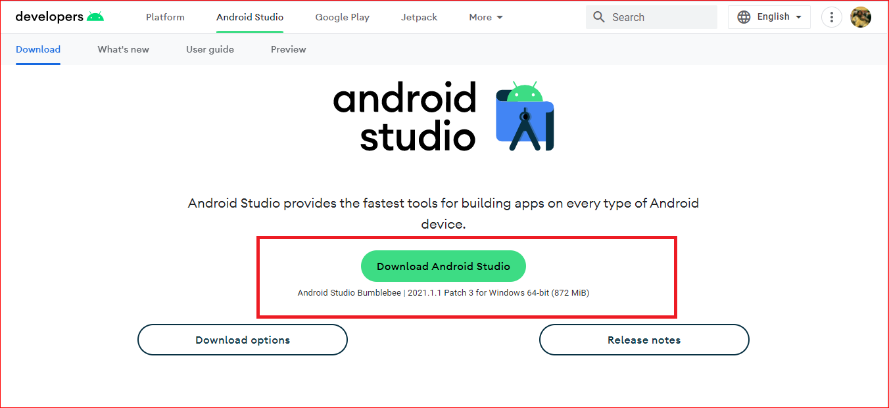

1.2. Confirm Download.

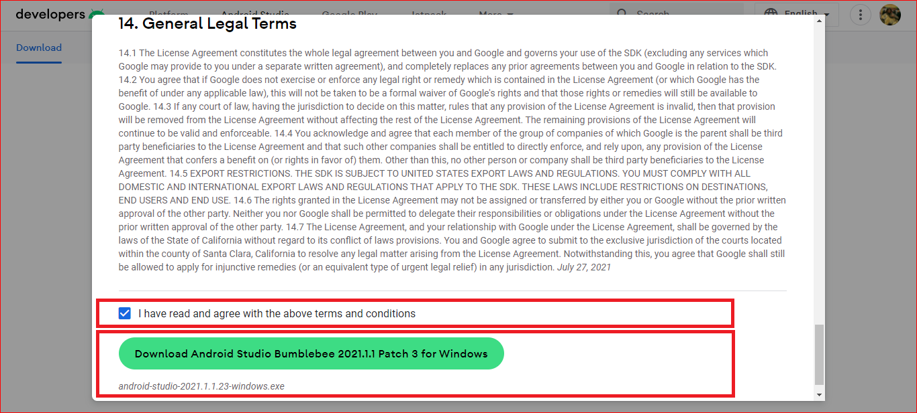

1.3. Run the installation package (in administrator mode).

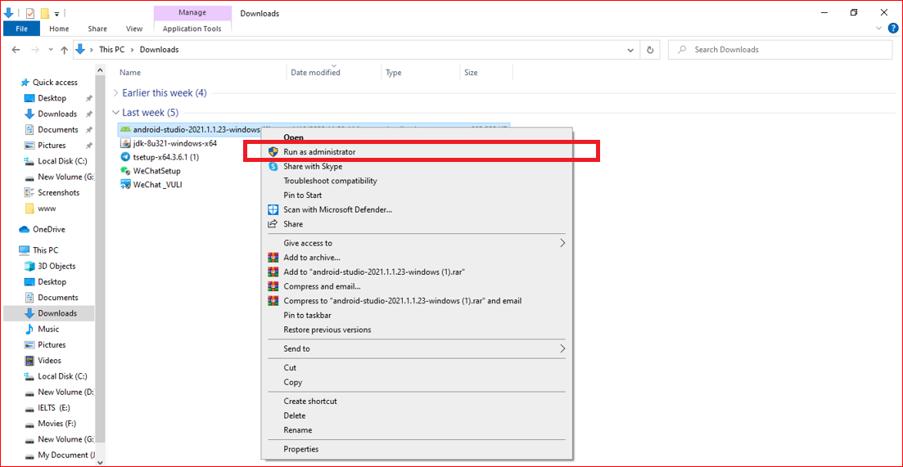

1.4. Always click‘next' to install.

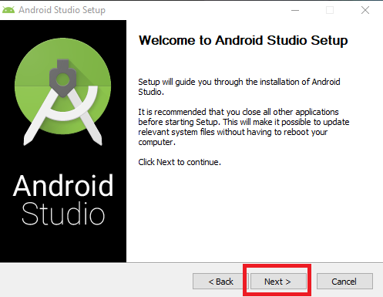

1.5. Choose Components “ Android” and “Android Virtual Device” Then Click Next.

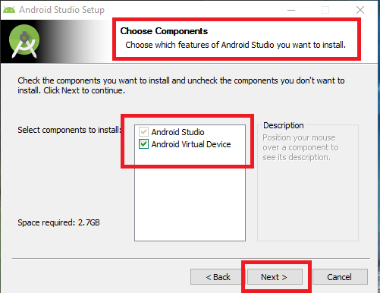

1.6. Set Configuration Settings Install Locations. Then Click Next.

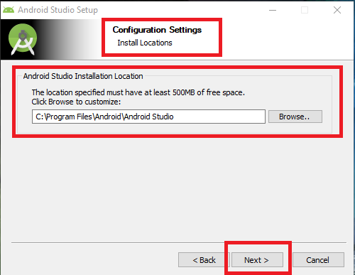

1.7. Choose Start Menu Folder of the Android Studio shortcuts. Then Click Next.

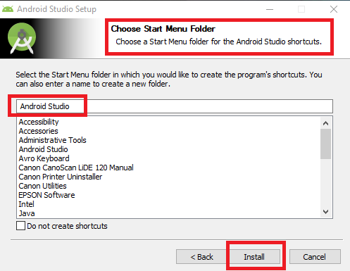

1.8. Android Studio being Installing. Then Click Next.

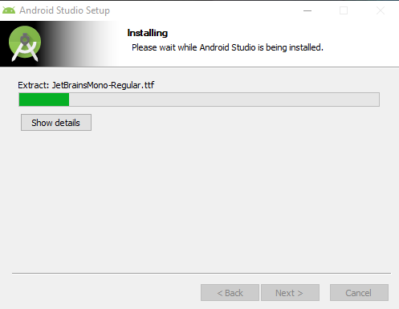

1.9. Installation Complete. Setup was Successfully completed. Then Click Next.

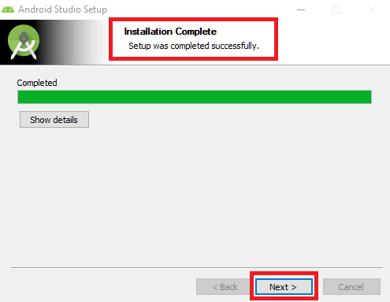

1.10. Select standard mode to install, download the components (about 10 minutes), and keep clicking next.

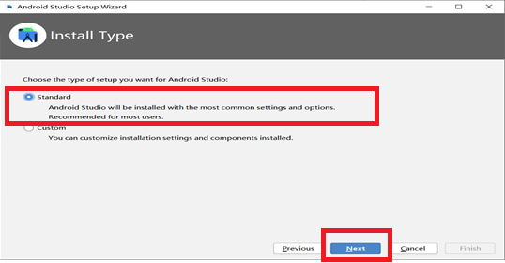

1.11. Select Start Android studio. Click finish.

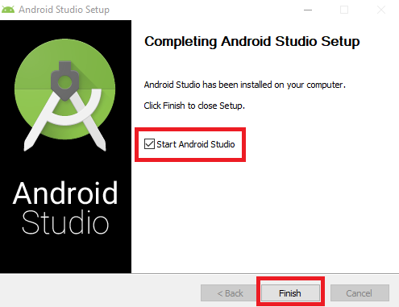

**2. Create a project**

2.1. Open Android studio and click create new project to create the project.

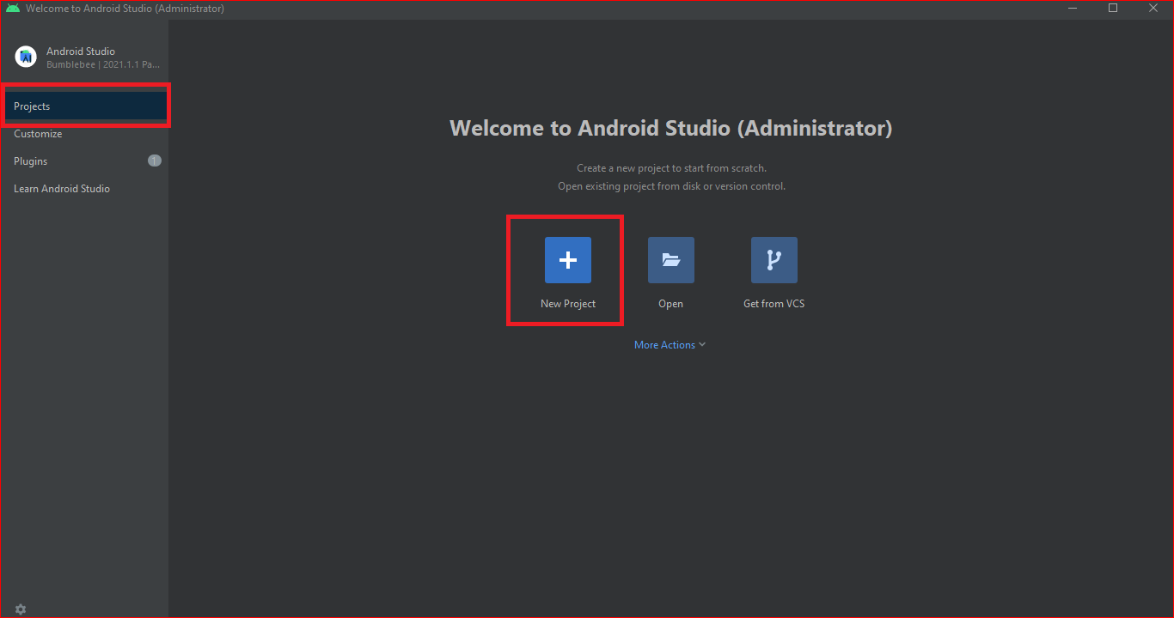

2.2. select Phone and Tablet. Then select basic activity and click next.

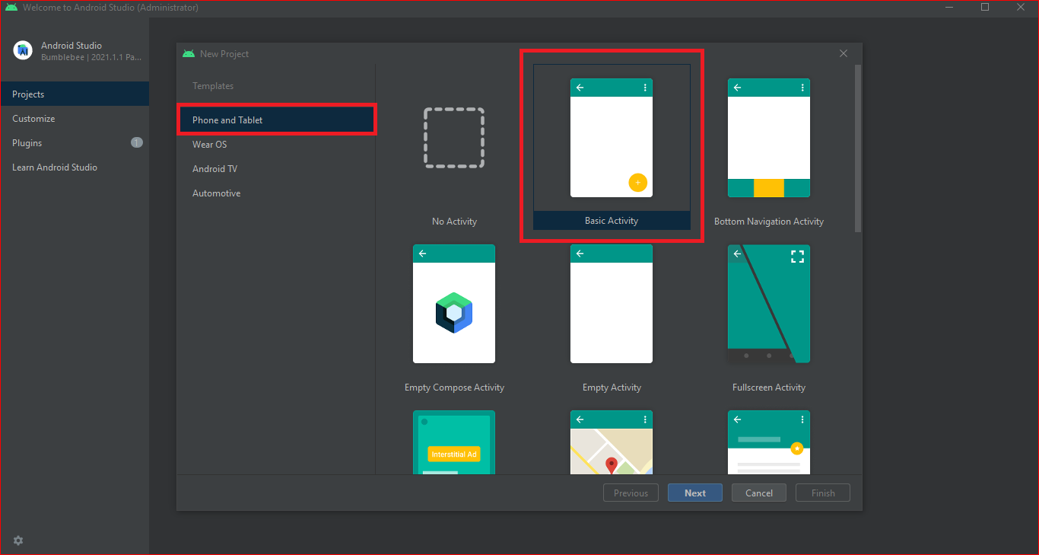

2.3. Fill in the project name, save location, select language Java, minimum SDK API 19: Android 4.4 (kitkat), and click Finish.

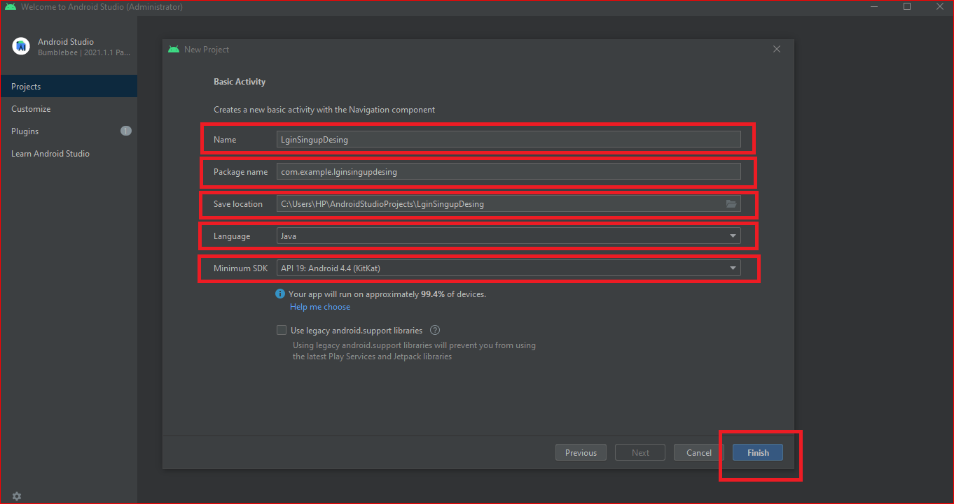

2.4. The project has been created. You need to wait for a while to install gradle (about 10 minutes). At this time, you can convert the structure type of the directory to ‘project’.

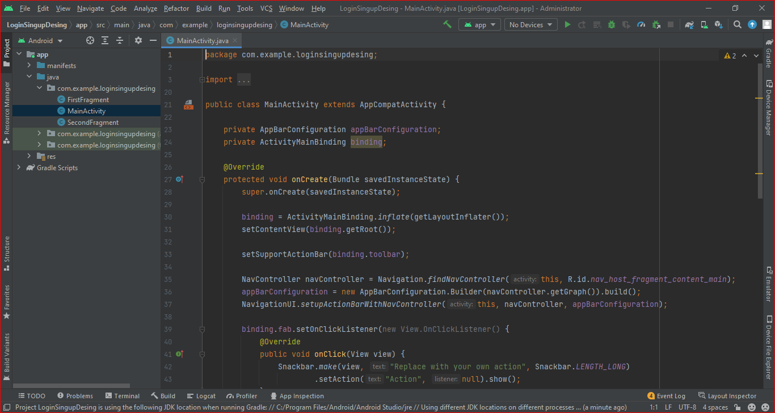

**II. Development design**

**1. Sing up interface layout**

1.1. Add background gradient and background color.

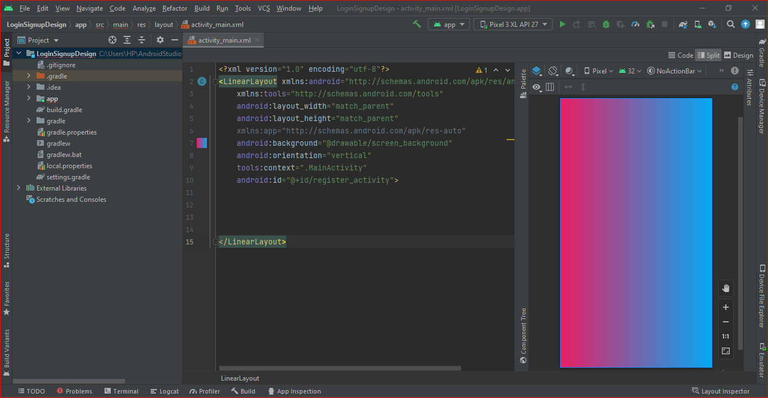

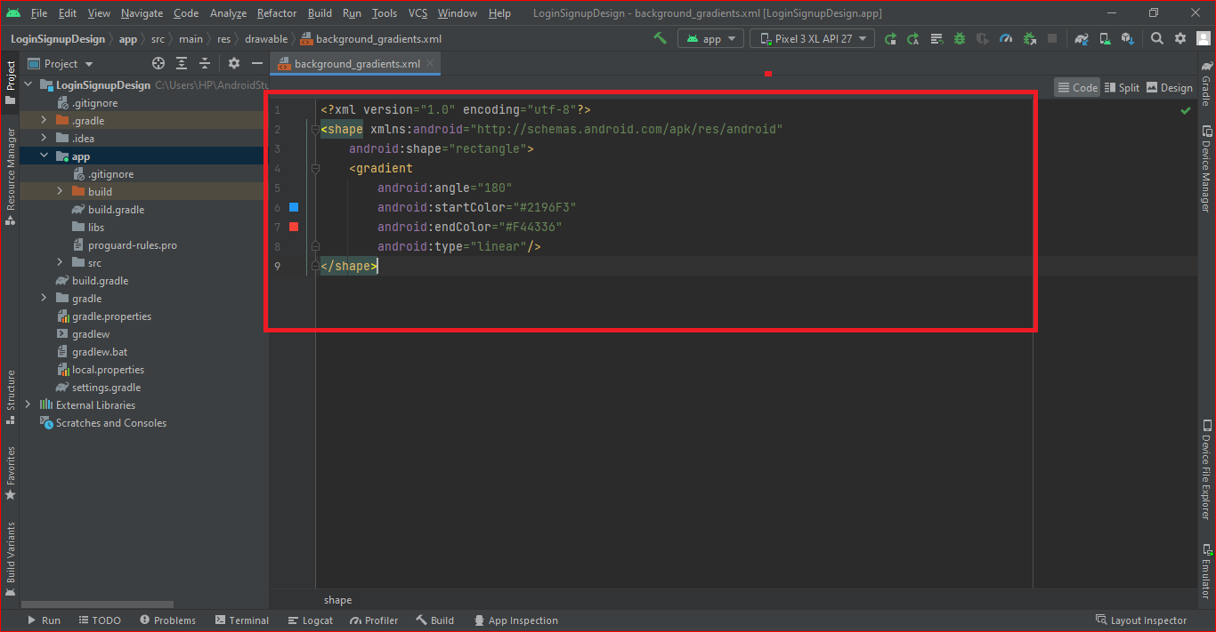

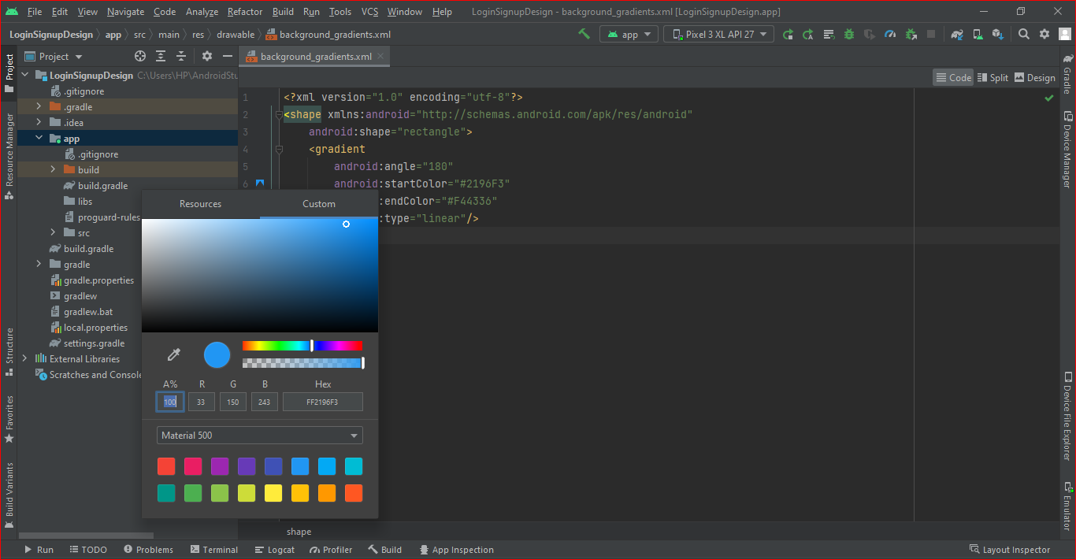

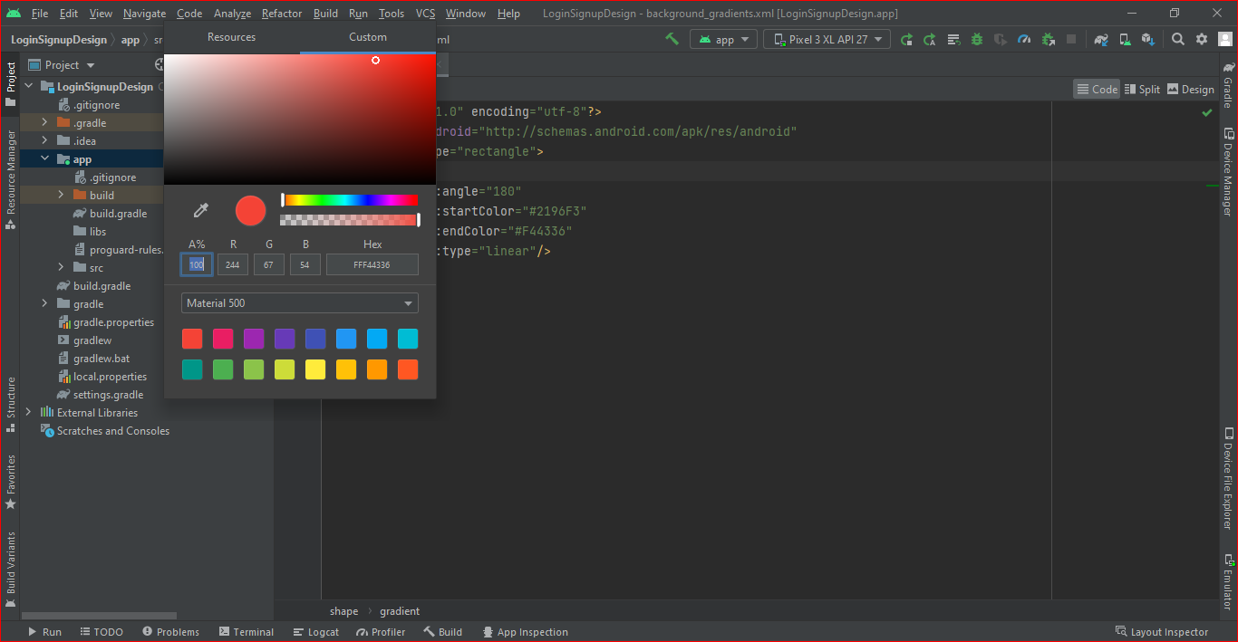

1.2. Add the top gradient in front and put into the drawable folder:

app->src->main->res->drawable->top_gradient.xml

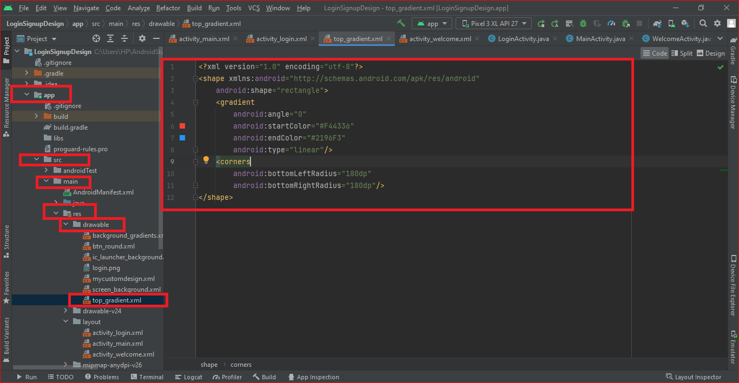

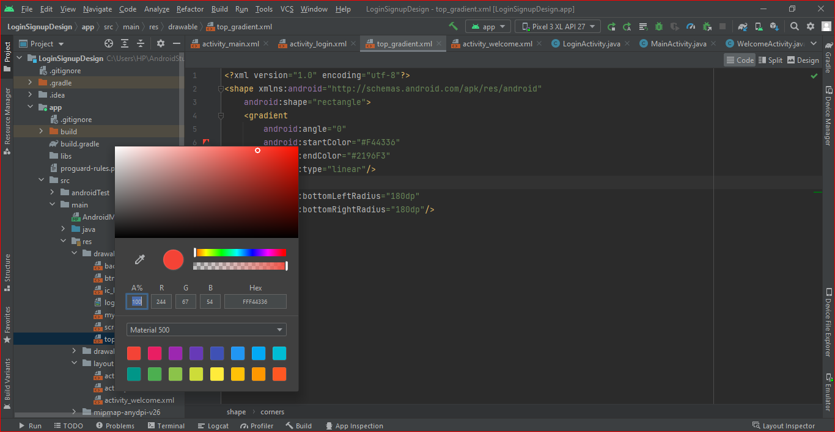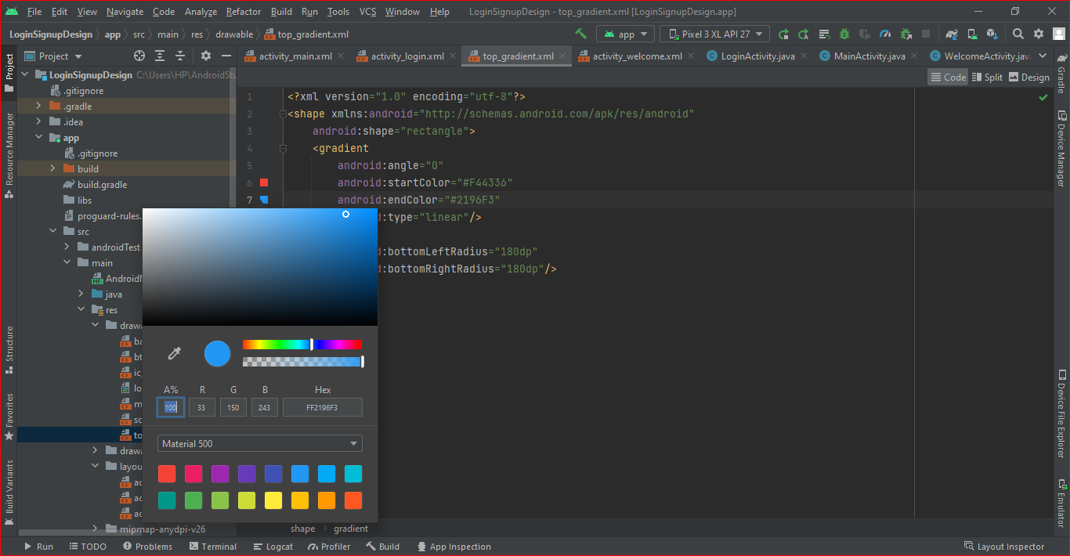

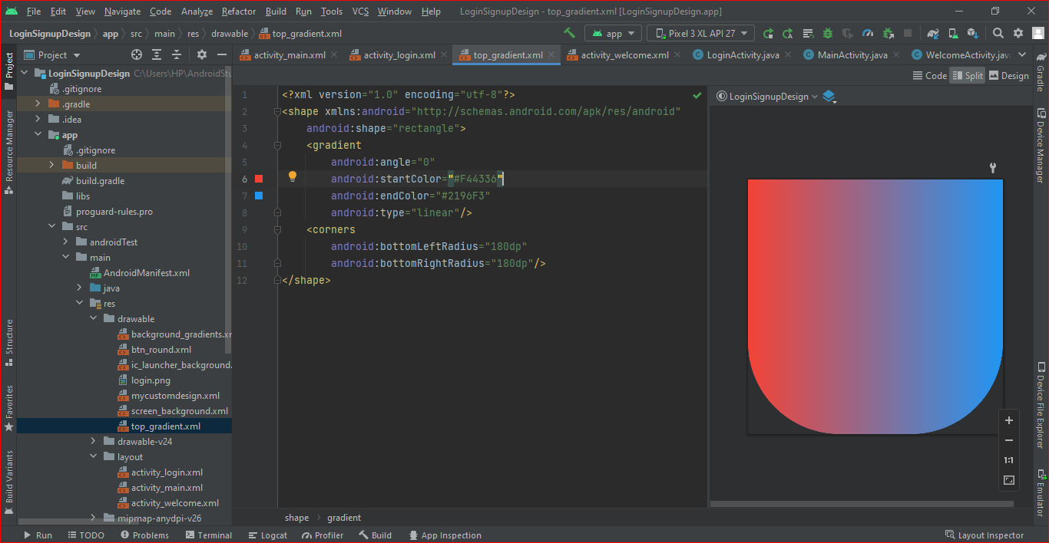

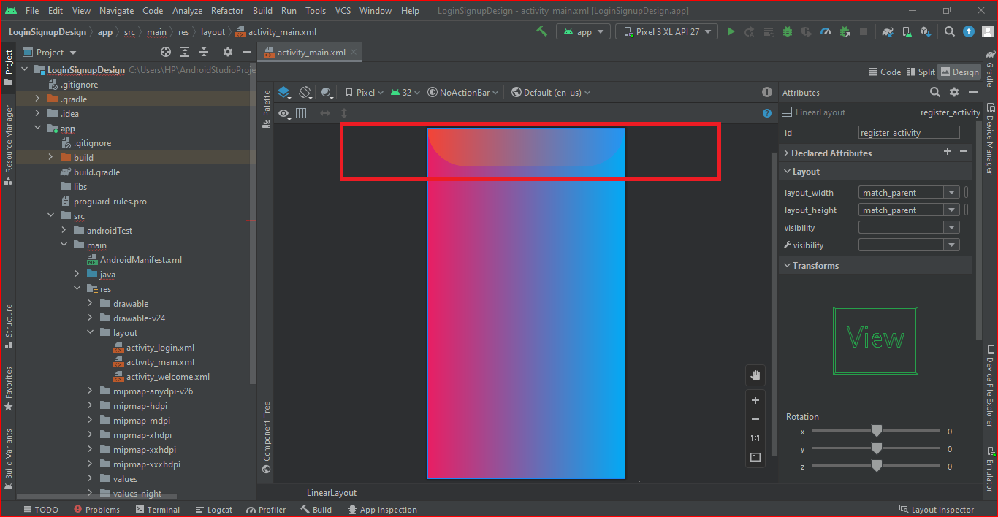1.3. Now add my own picture in the front . put the picture into the drawable folder. Add a statement to ImageView code android:src="@drawable/login" /> Open the layout file in the following:

app->src->main->res->drawable->login.png->activity_main_xml

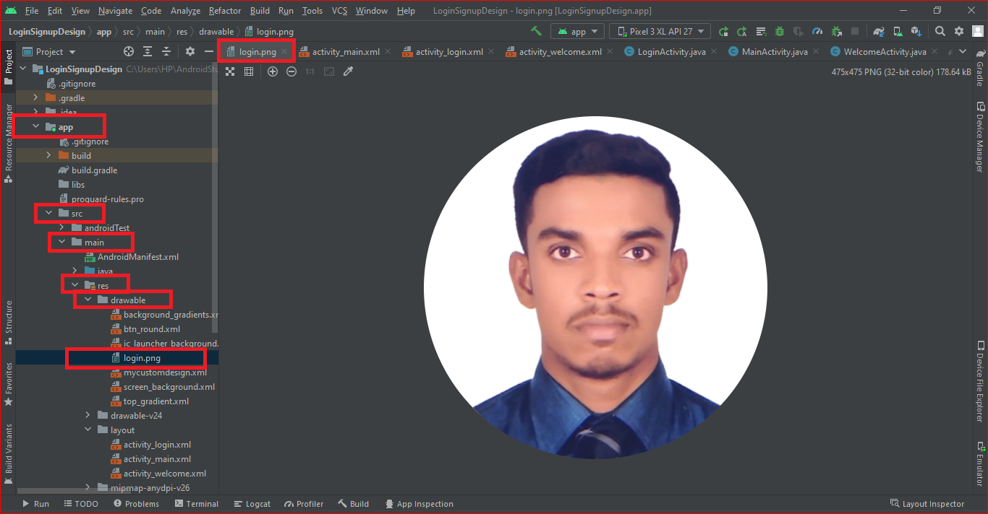

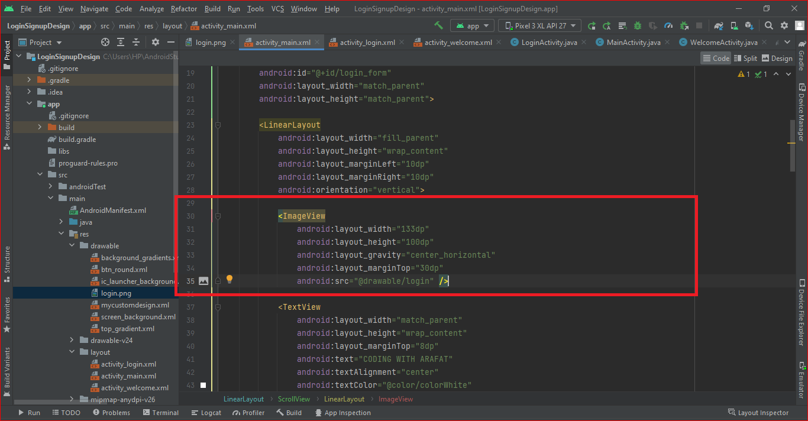

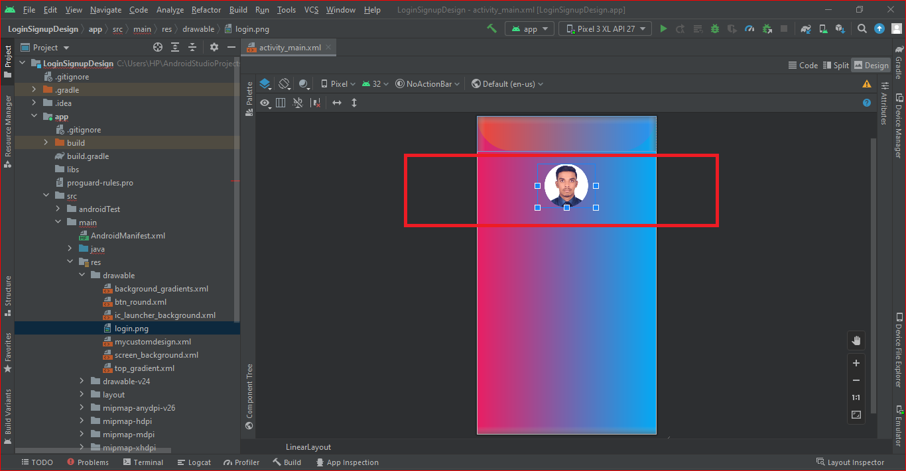

1.4. Now add to “CODING WITH ARAFAT” and “SING UP TO LEARN QUICKLY” text below in the picture. as shown in the figure below.

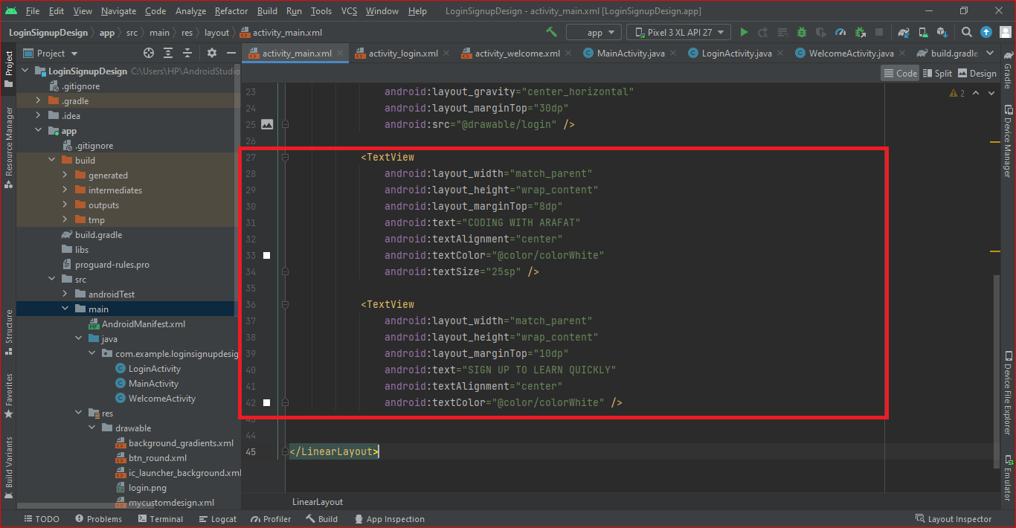

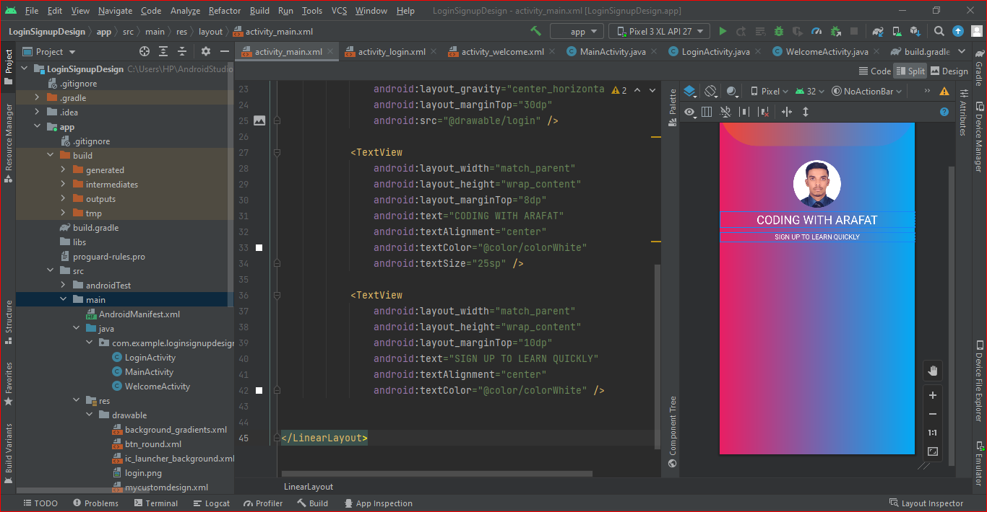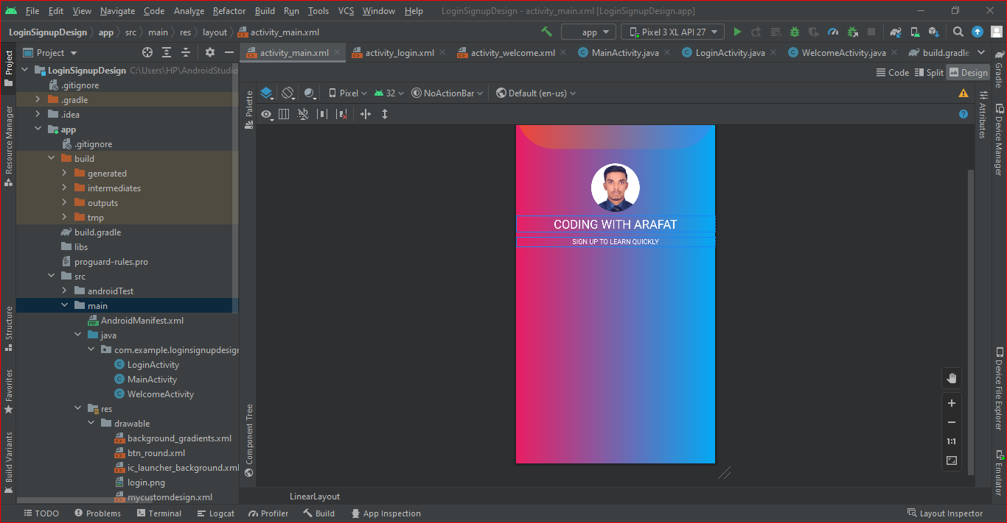

1.5. Add “User name” input box in the layout. as shown in the figure below.

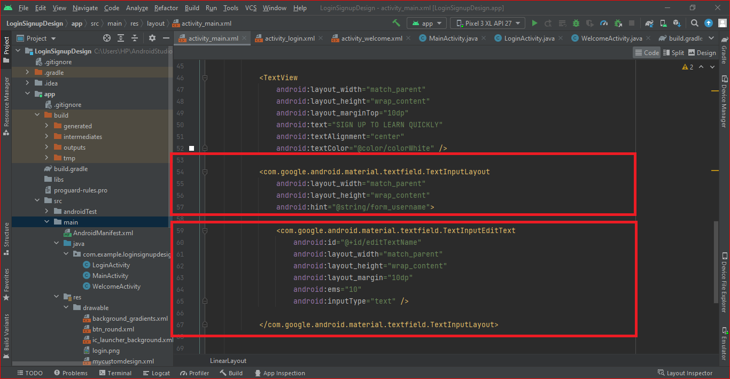

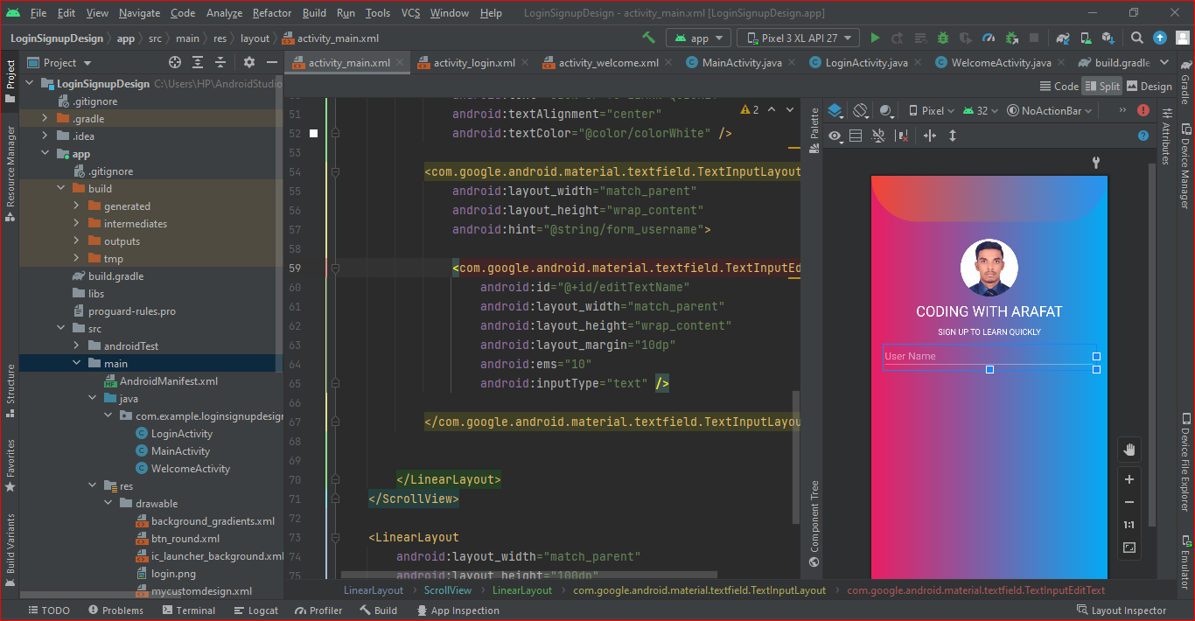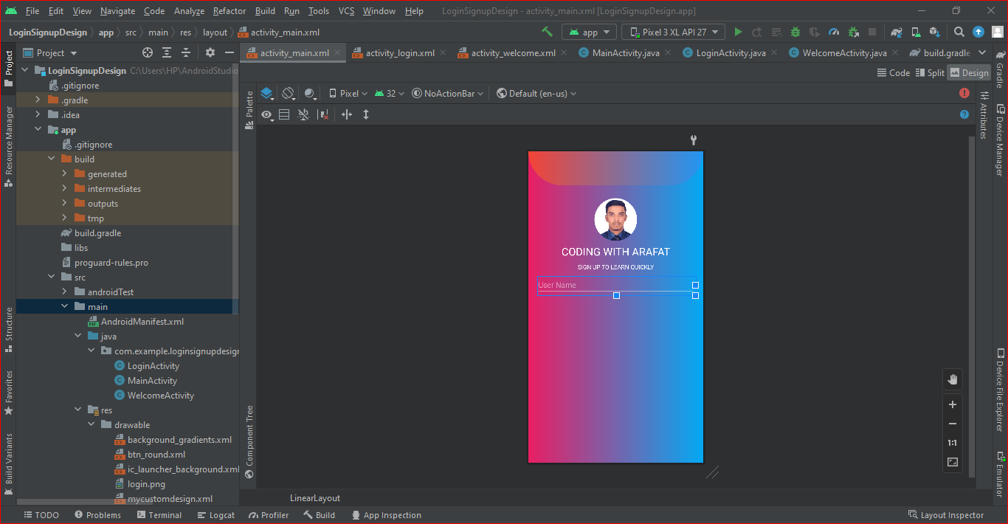

1.6. Add “Email ID” input box in the layout. as shown in the figure below.

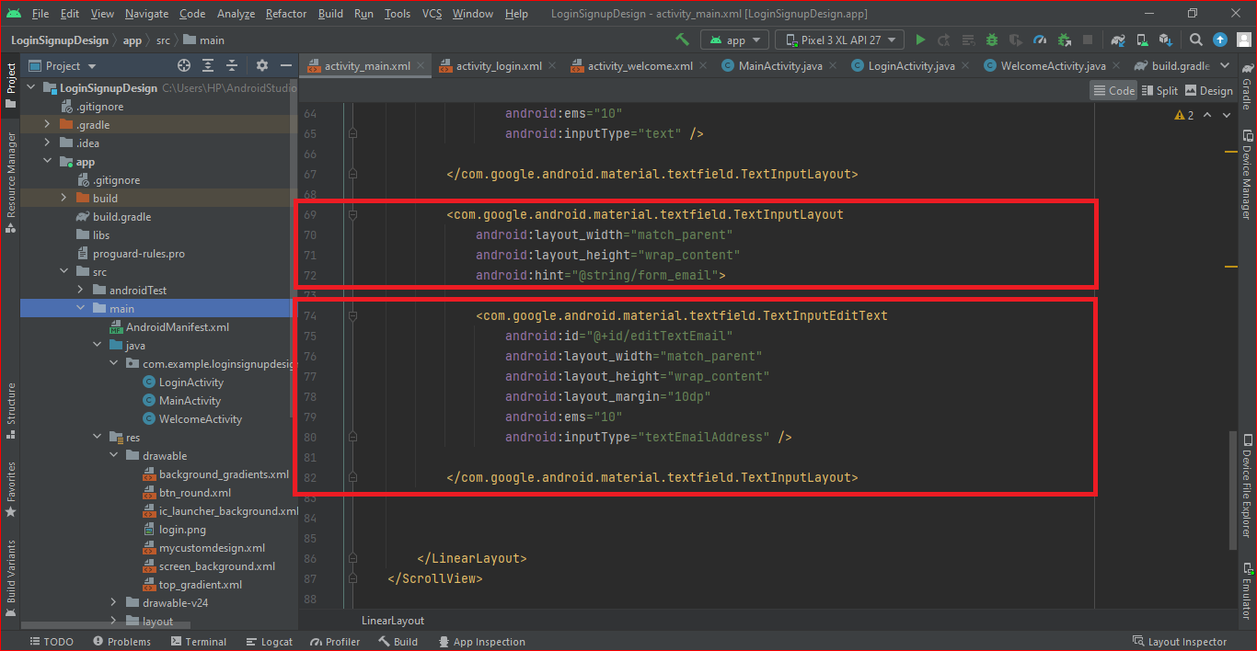

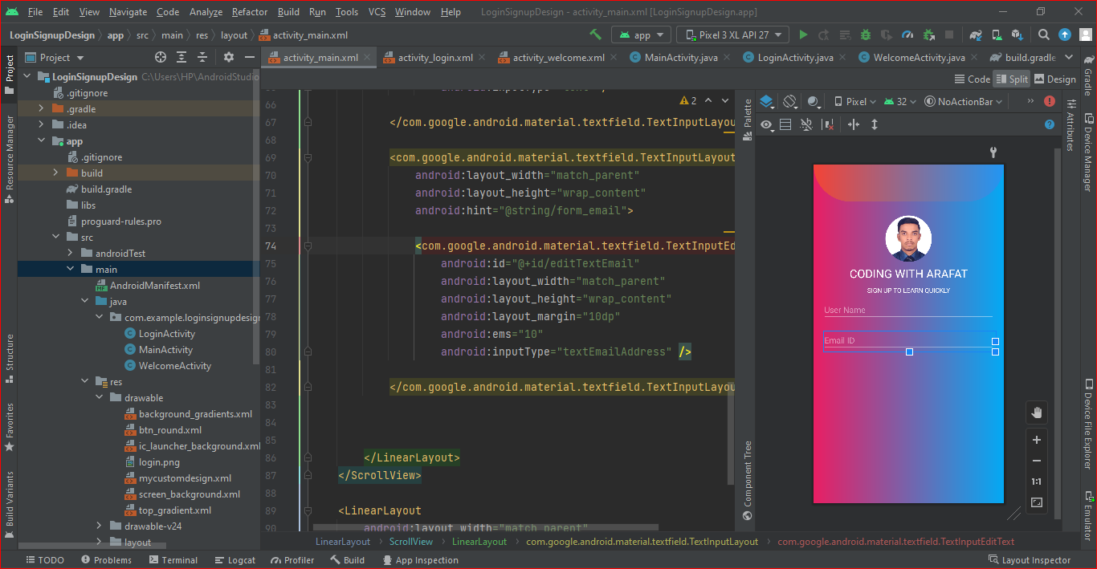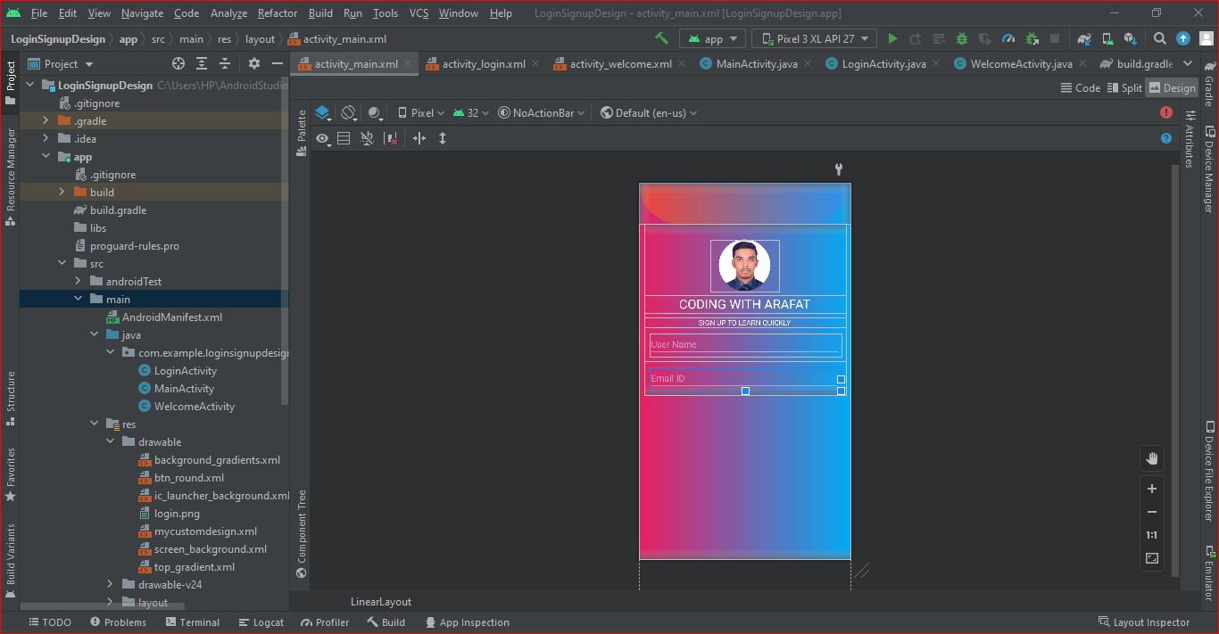

1.7. Add “Phone No” input box in the layout. as shown in the figure below.

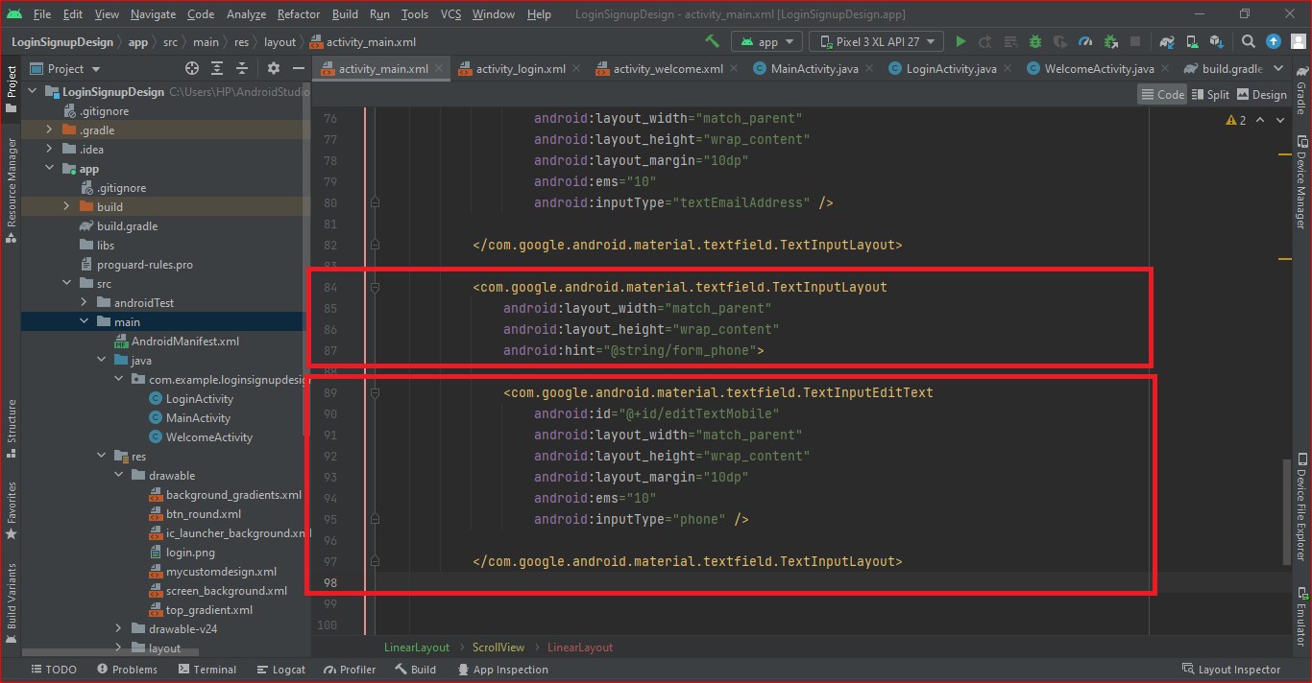

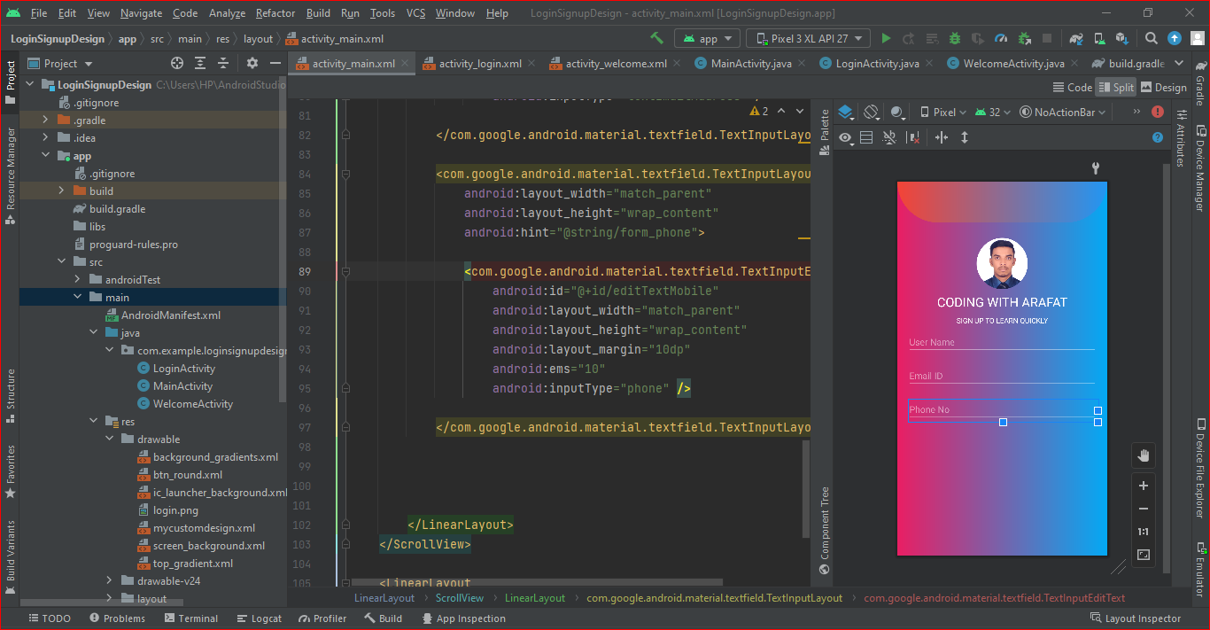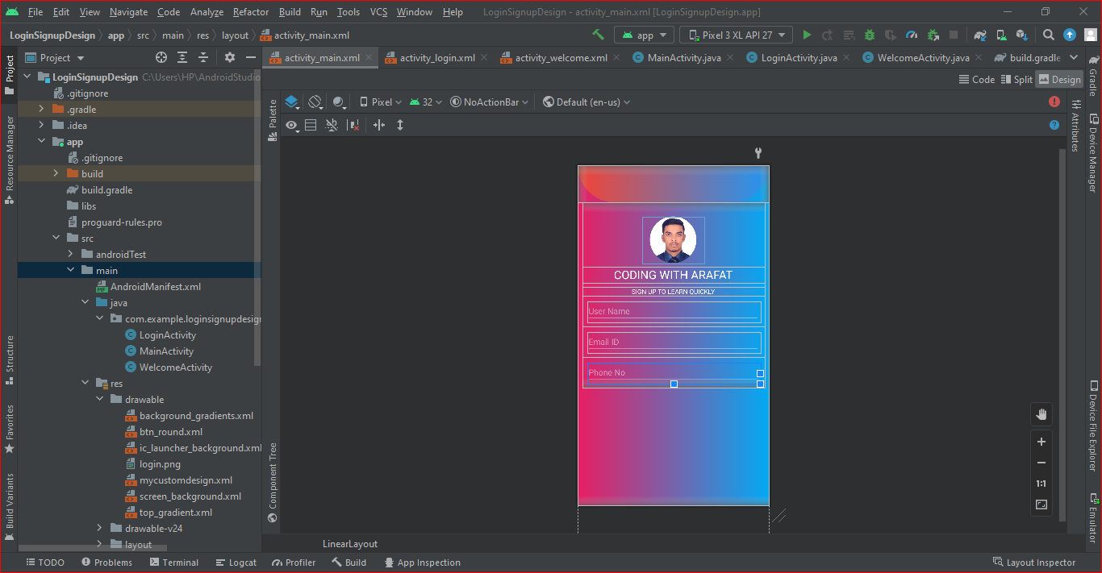

1.8. Add “Password” input box in the layout. as shown in the figure below.

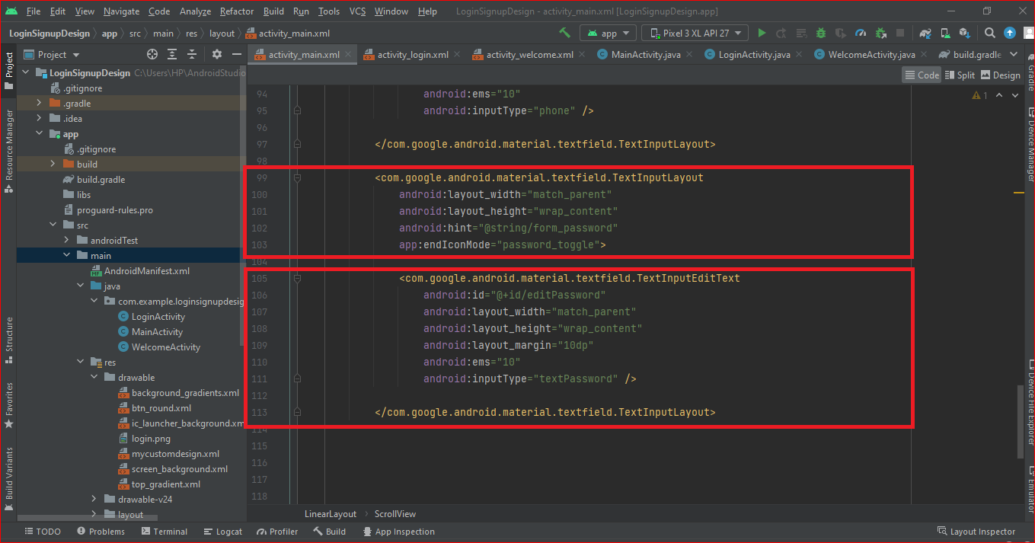

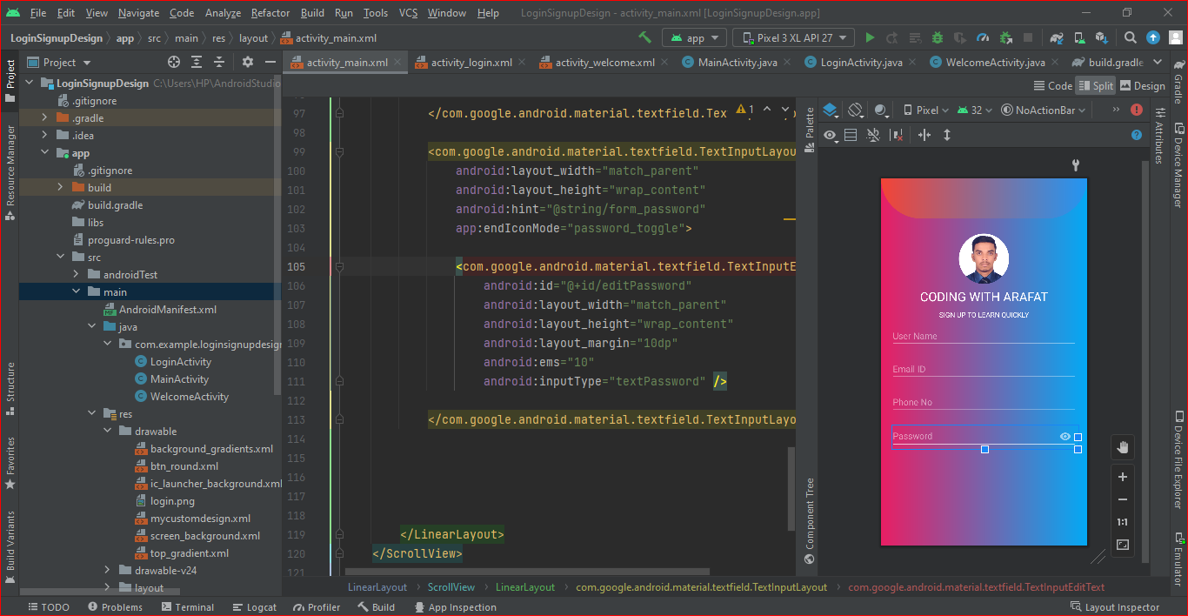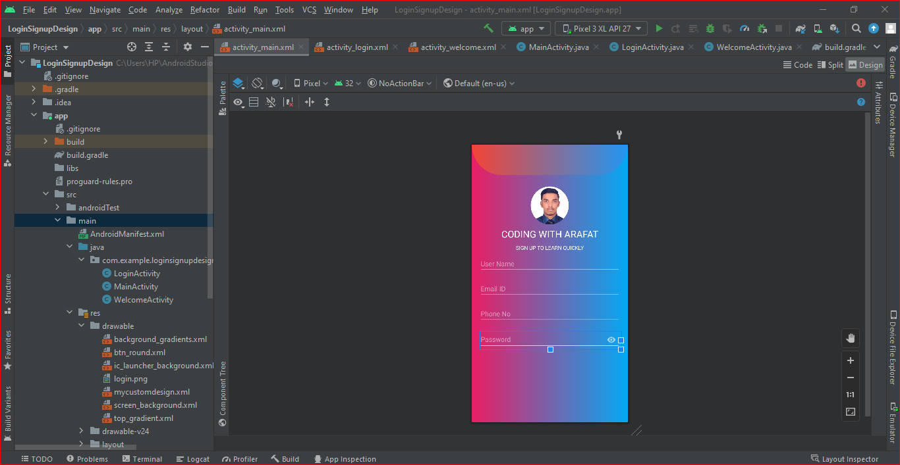

1.9. Add “Sing up” button in the layout . Sing up text, text color, and button color.

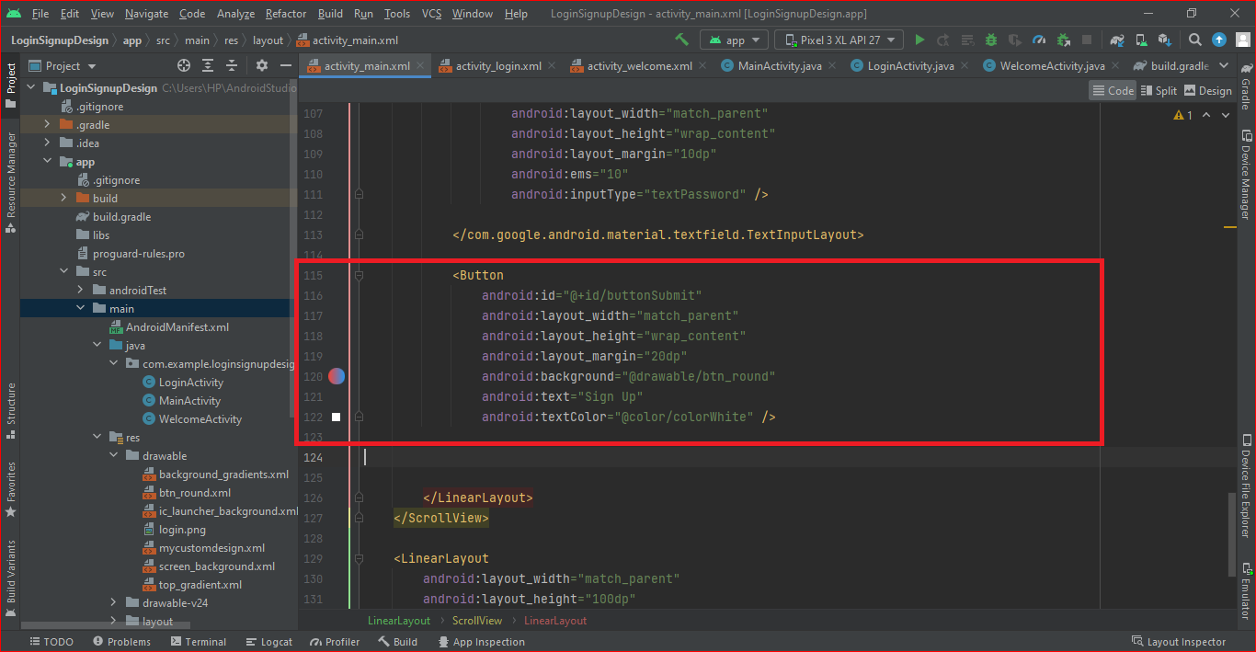

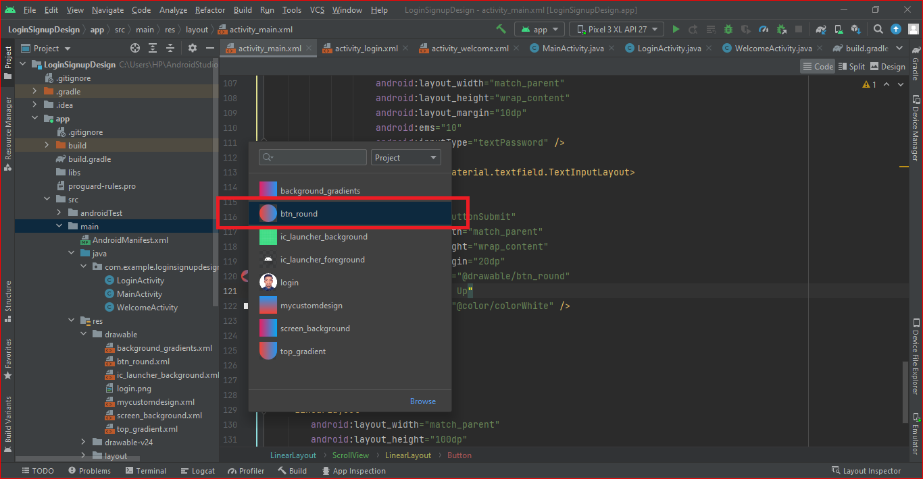

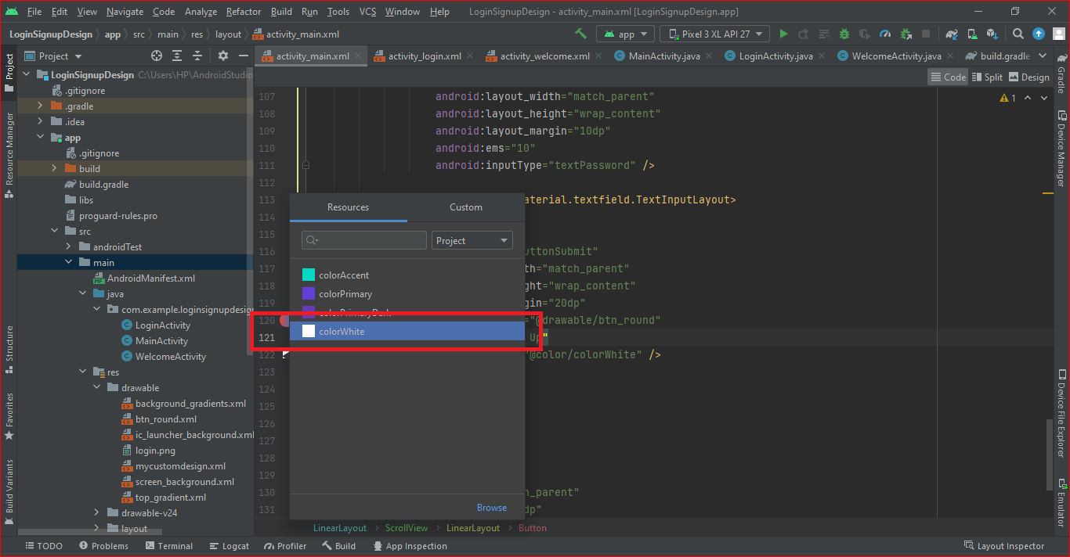

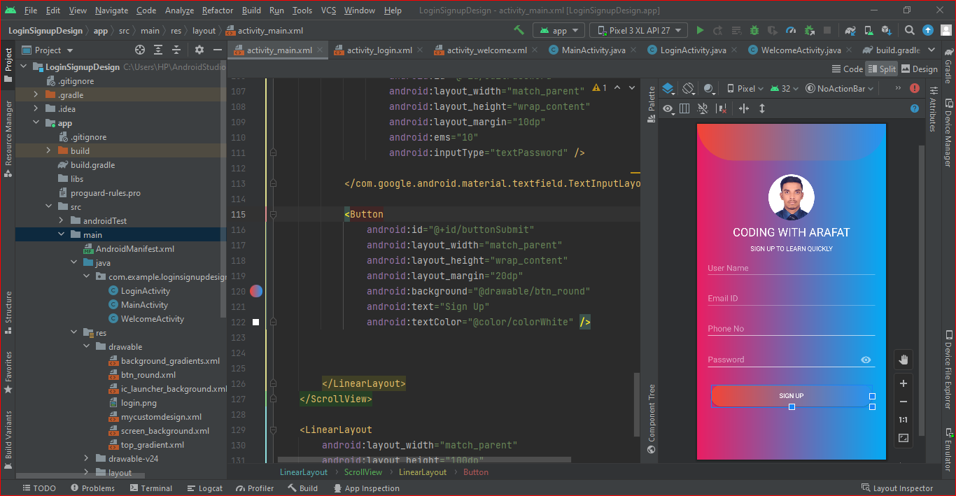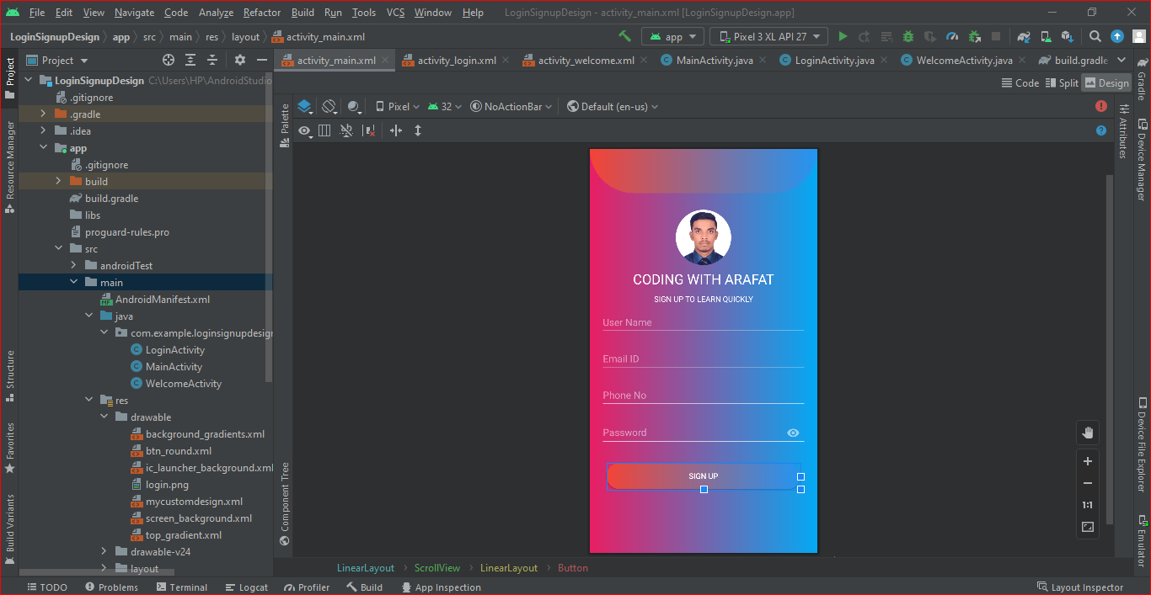

1.10. Add “I am already a member” text below in the sing up button. as shown in the figure below.

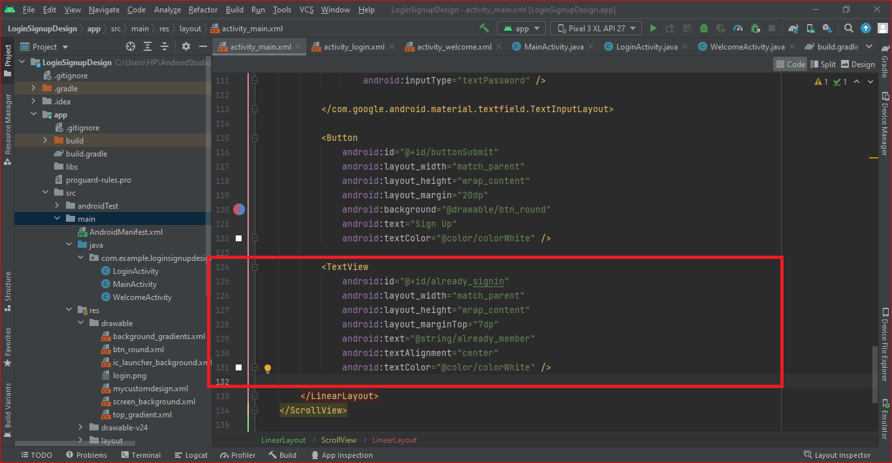

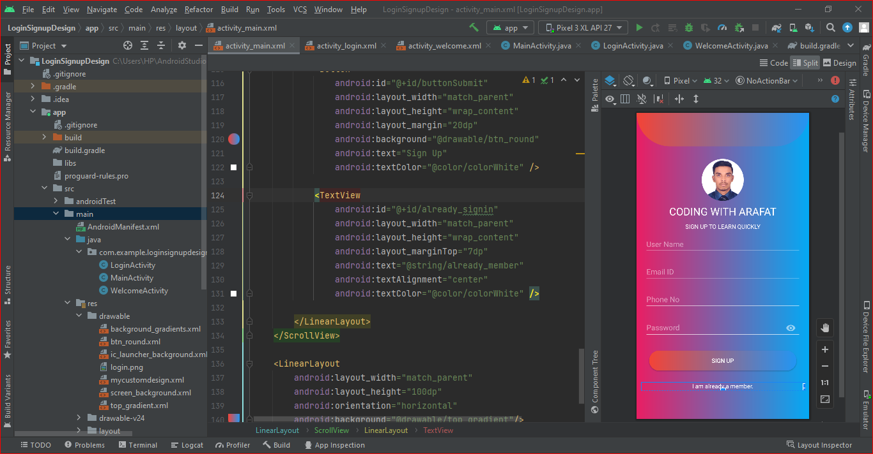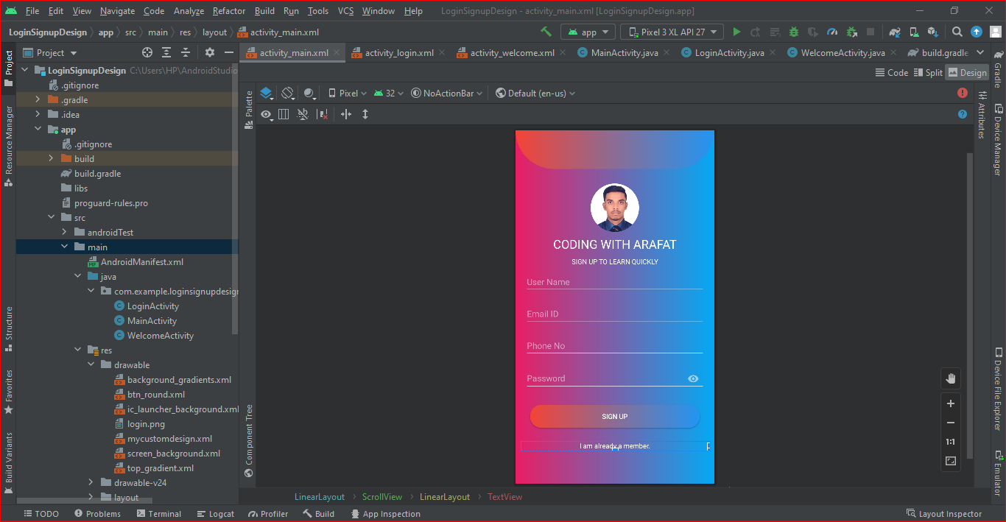

**2. Sing In interface layout**

2.1. Add background gradient and background color. as shown in the figure below.

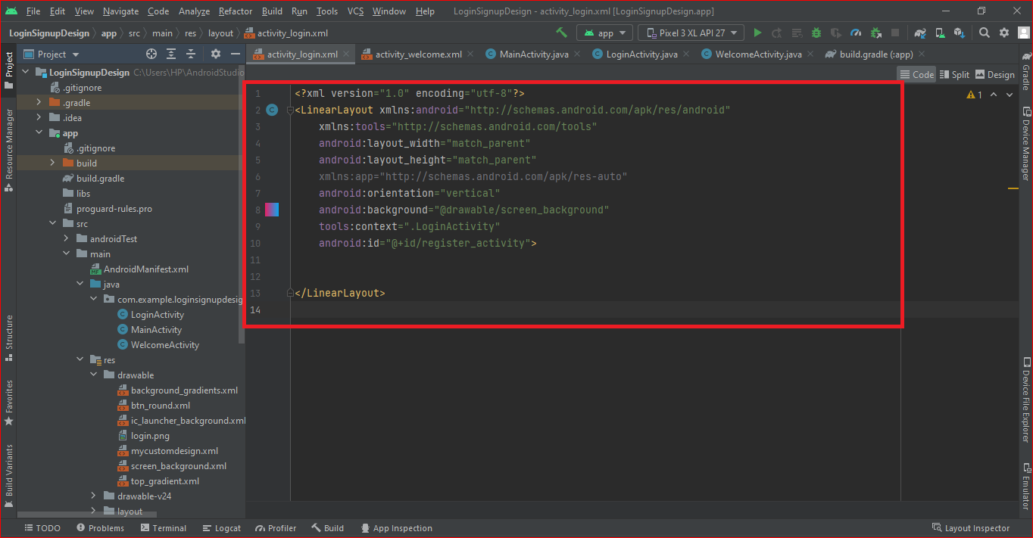

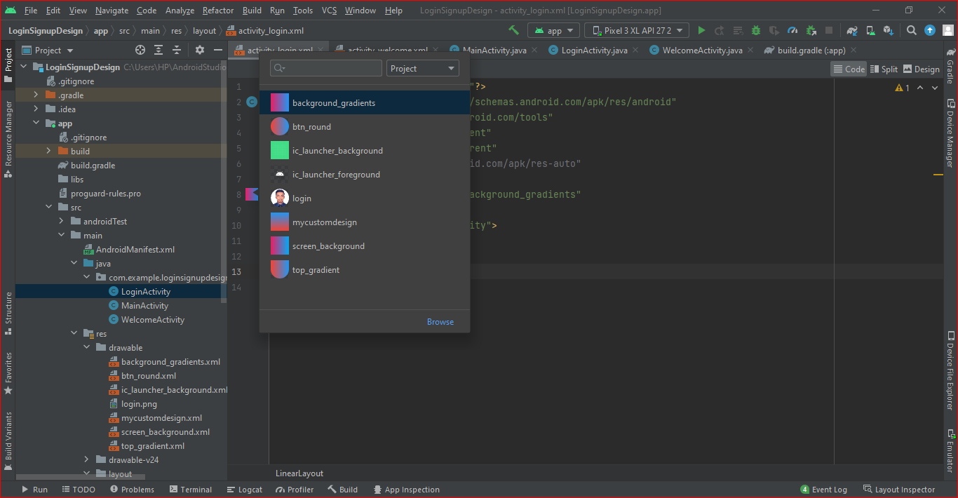

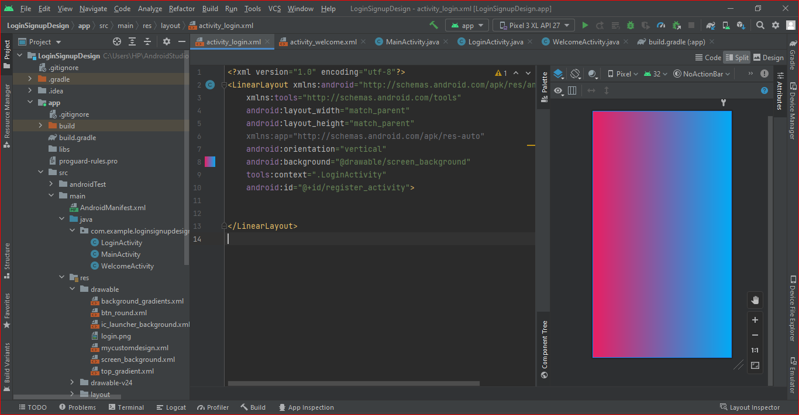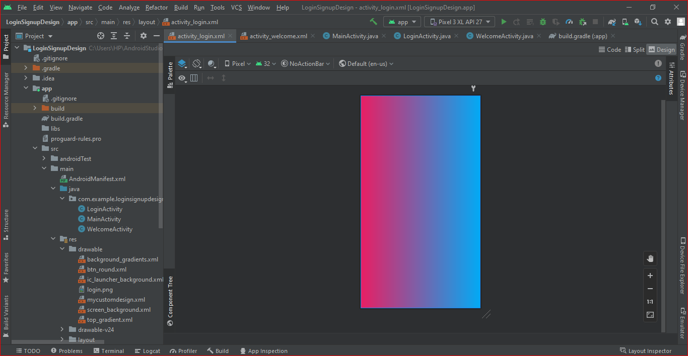

2.2. Add the top gradient in front and put into the drawable folder. as shown in the figure below.

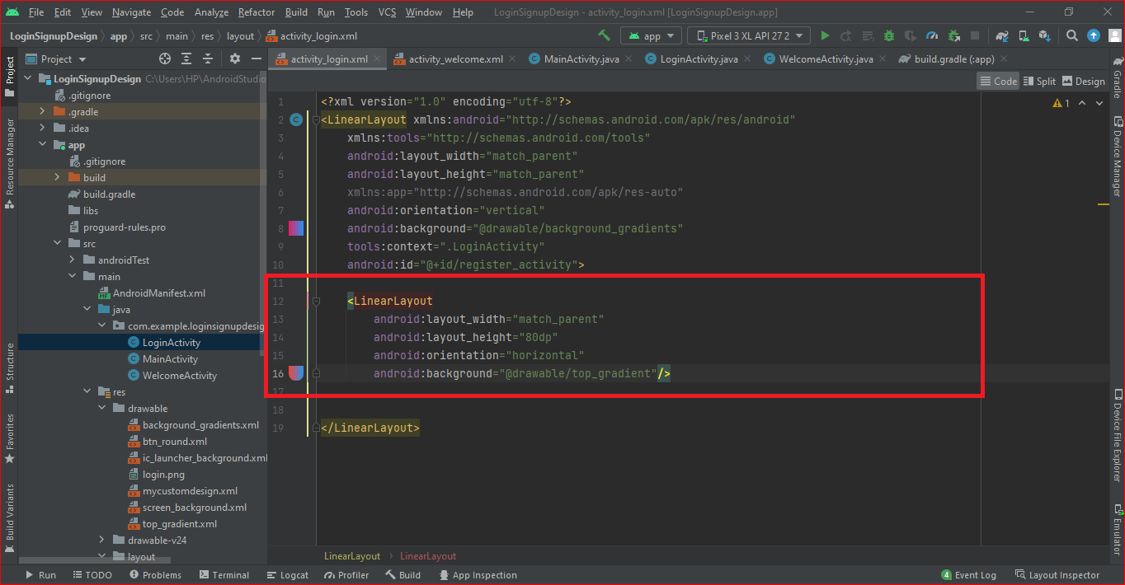

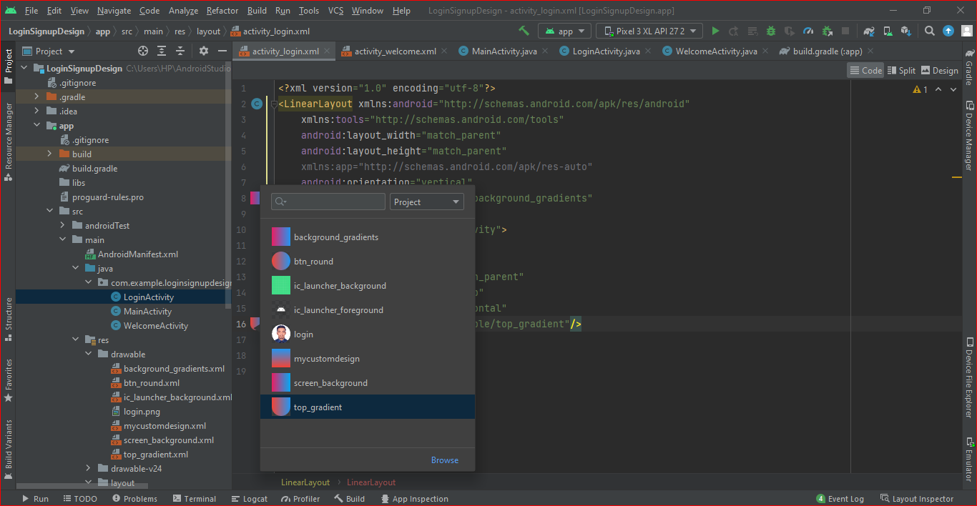

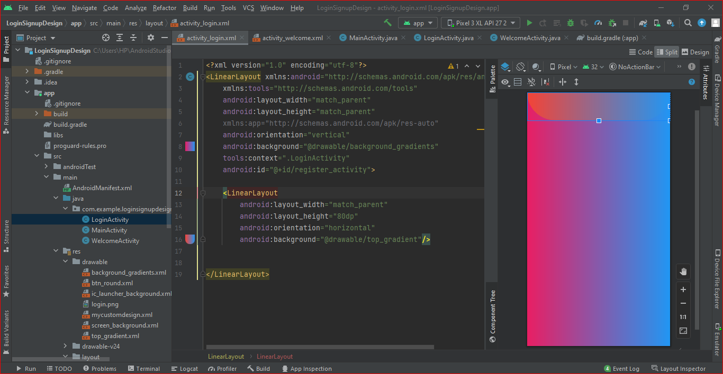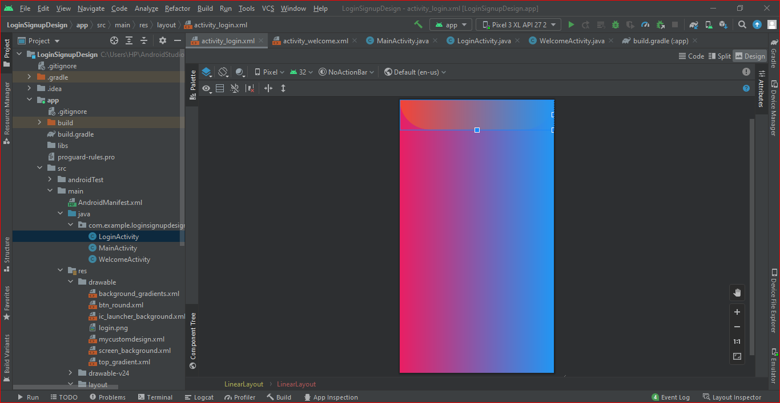

2.3. Now add my own picture in the front . put the picture into the drawable folder. Add a statement to ImageView code android:src="@drawable/login" />. as shown in the figure below.



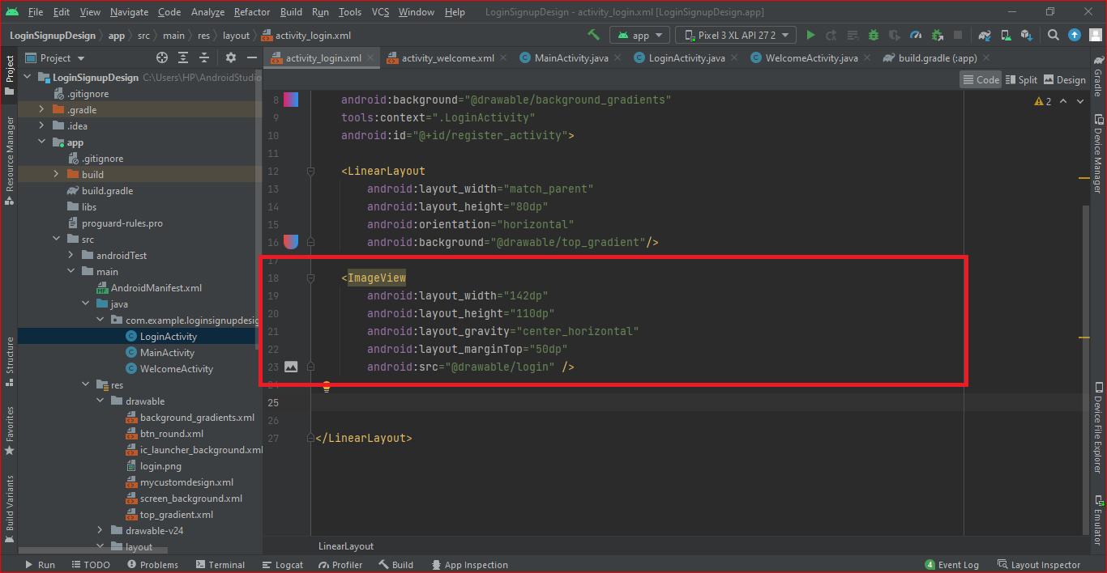

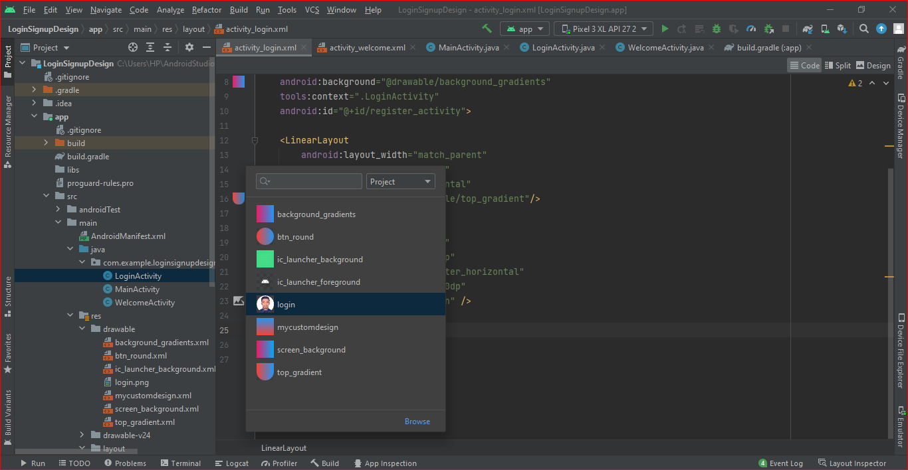

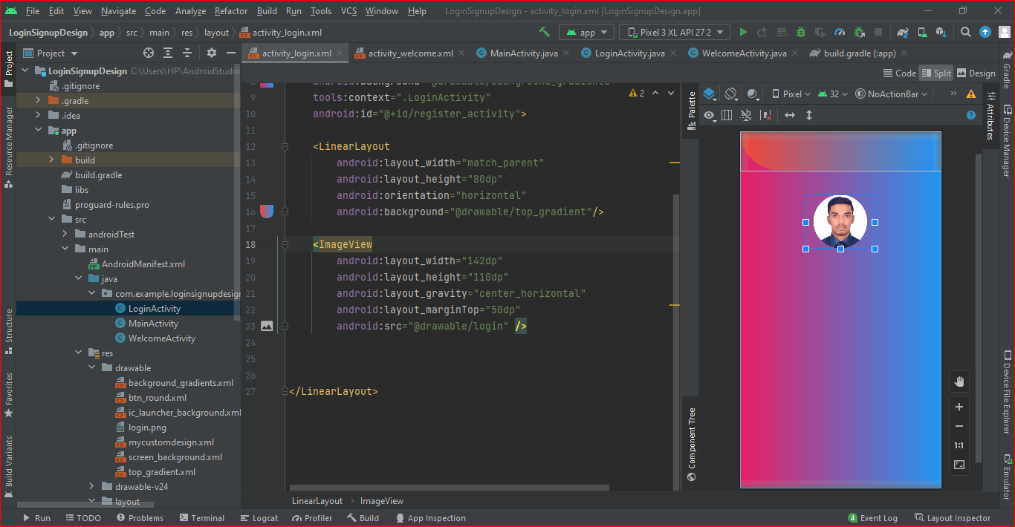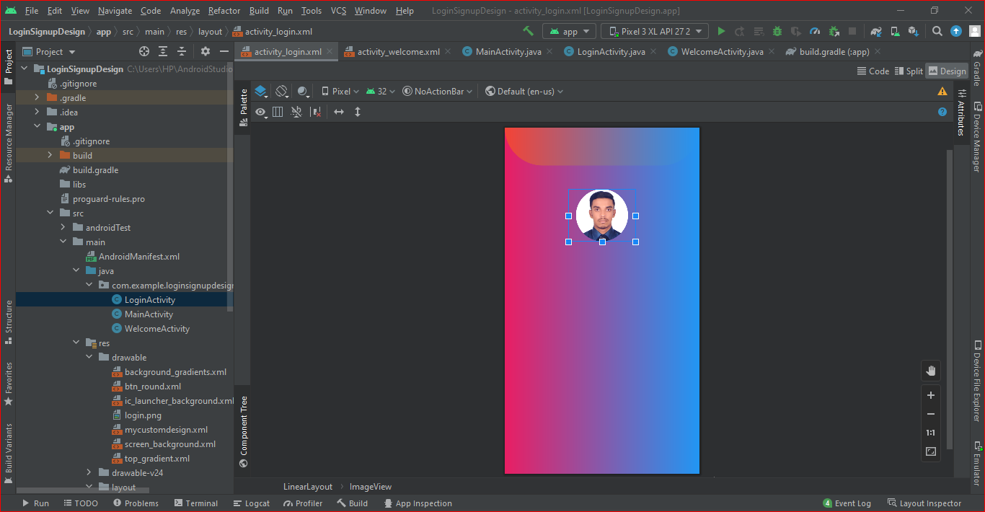

2.4. Now add to “WELCOME BACK” and “SING IN TO LEARN QUICKLY” text below in the picture. as shown in the figure below.

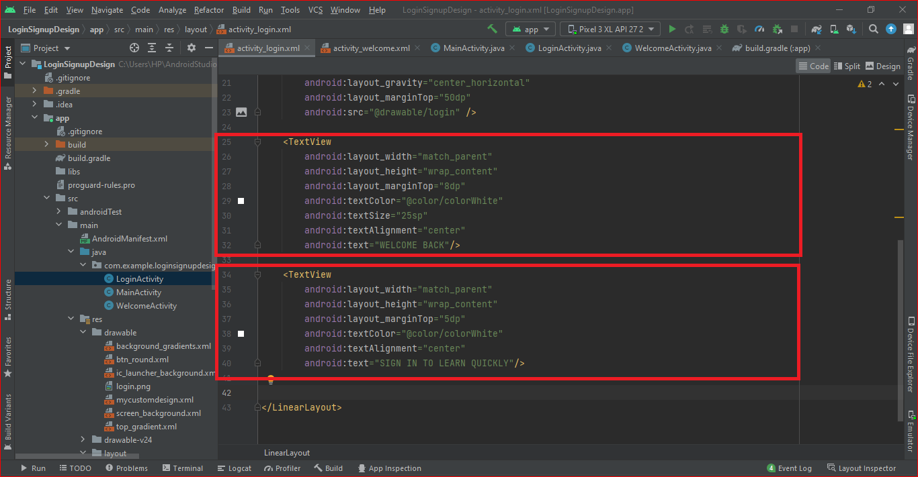

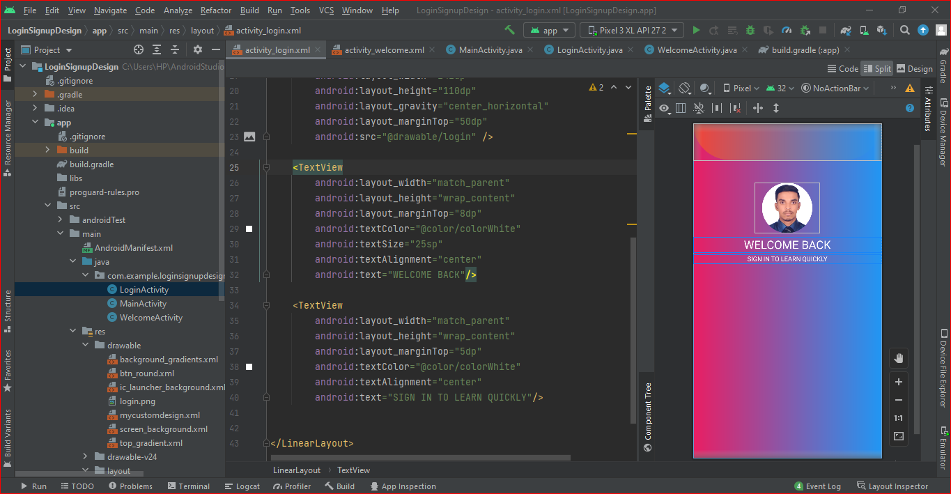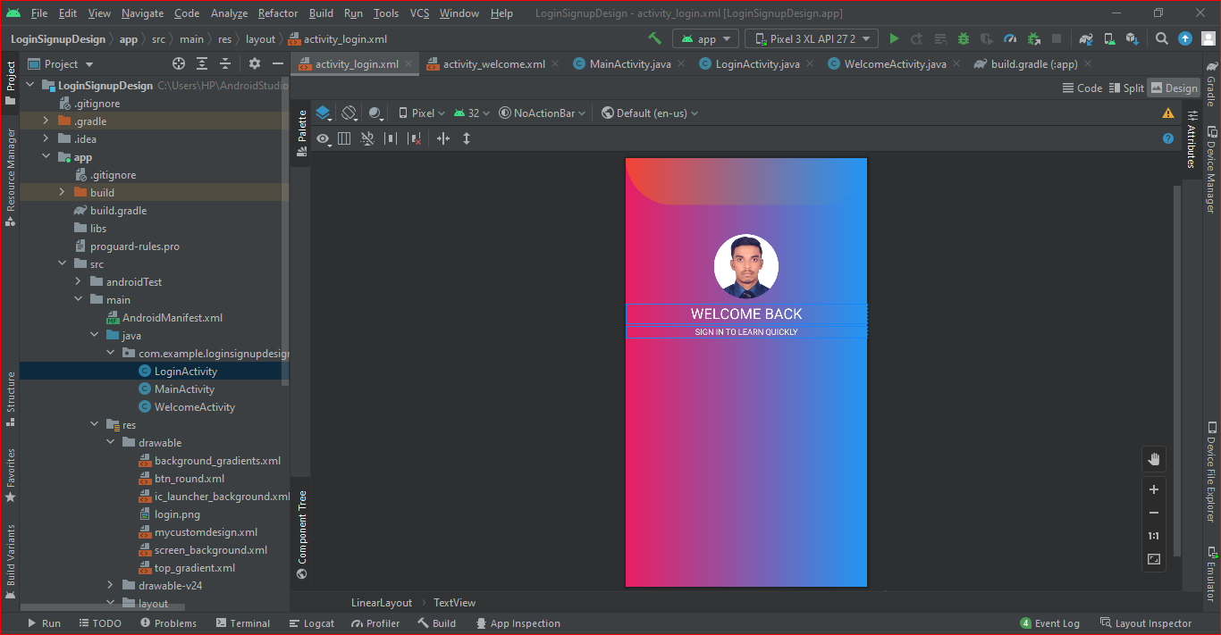

2.5. Add “Email ID” input box in the layout. as shown in the figure below.

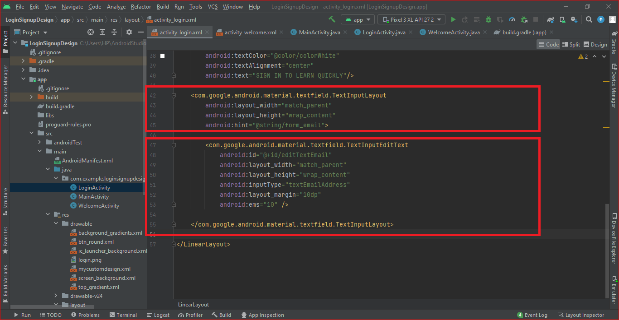

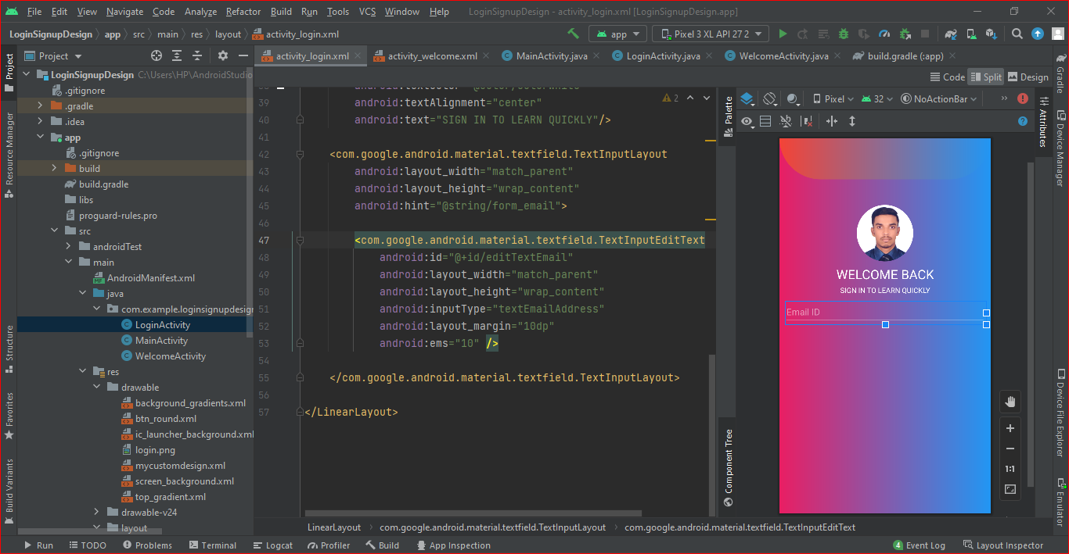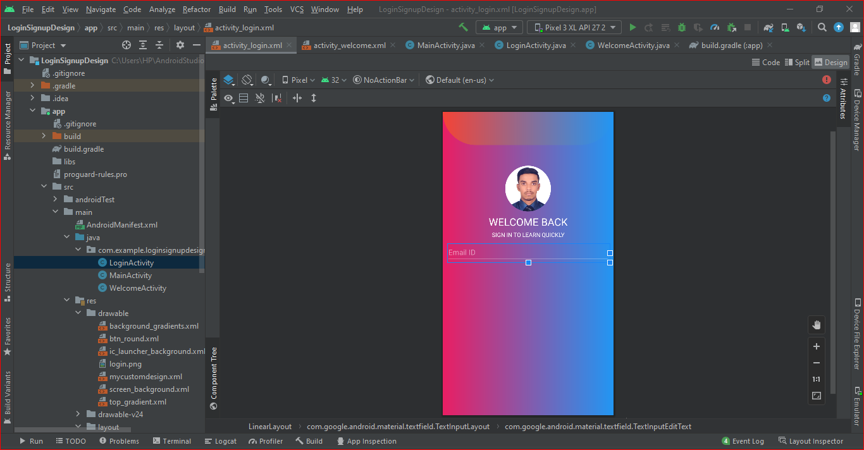

2.6. Add “Password” input box in the layout. as shown in the figure below.

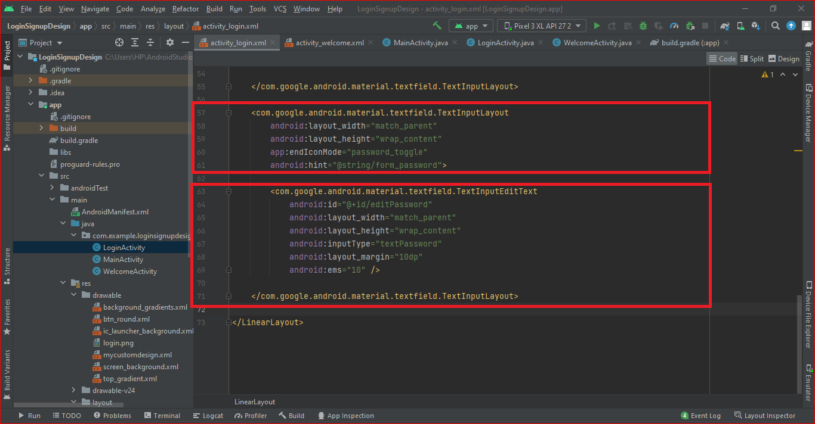

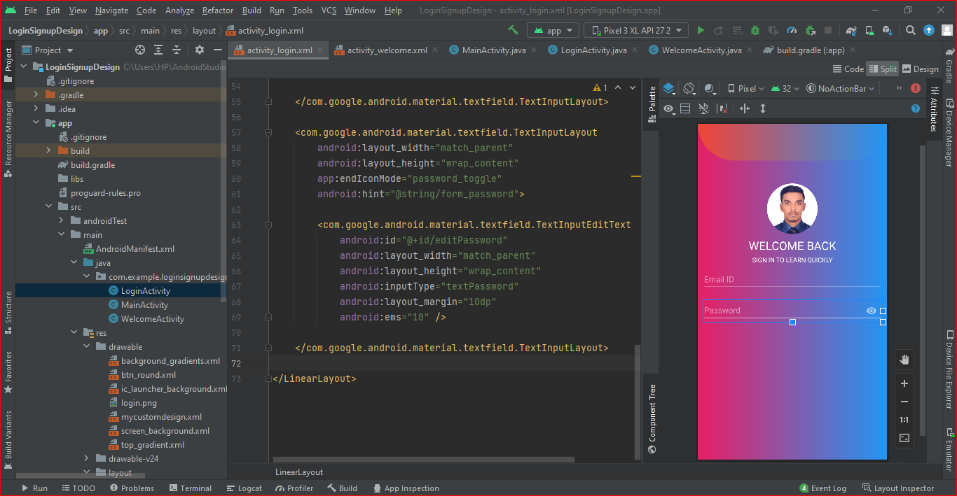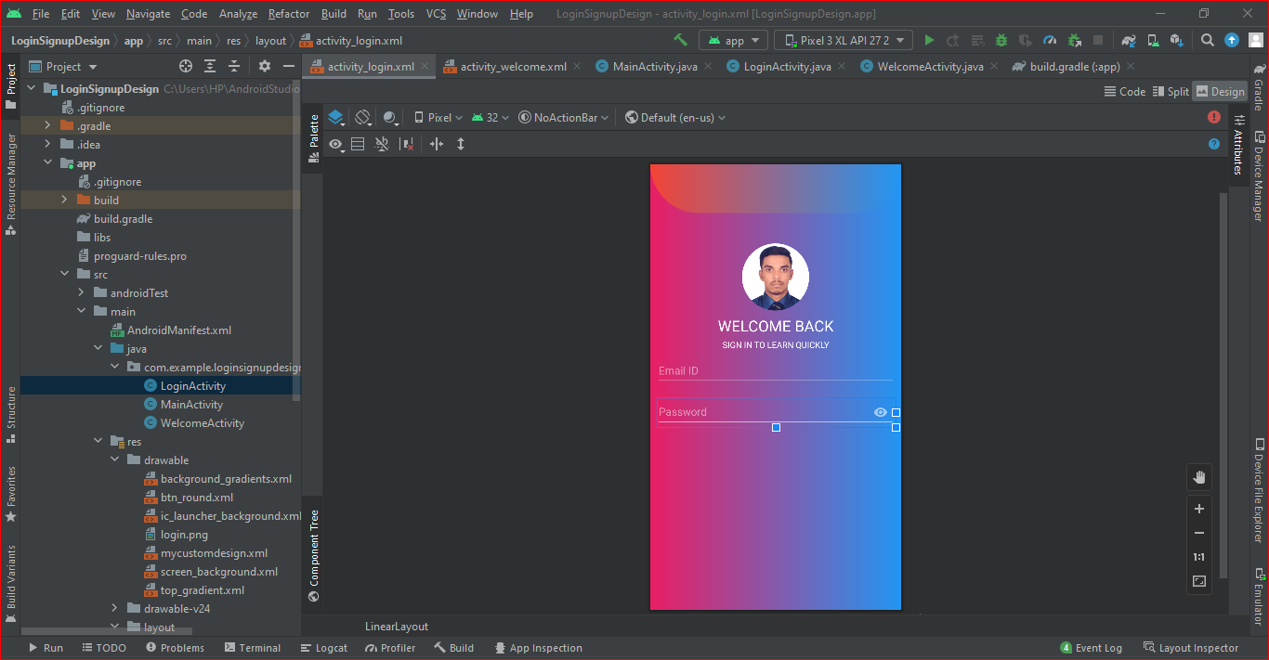

2.7. Add “Sing In” button in the layout . Sing up text, text color, and button color.

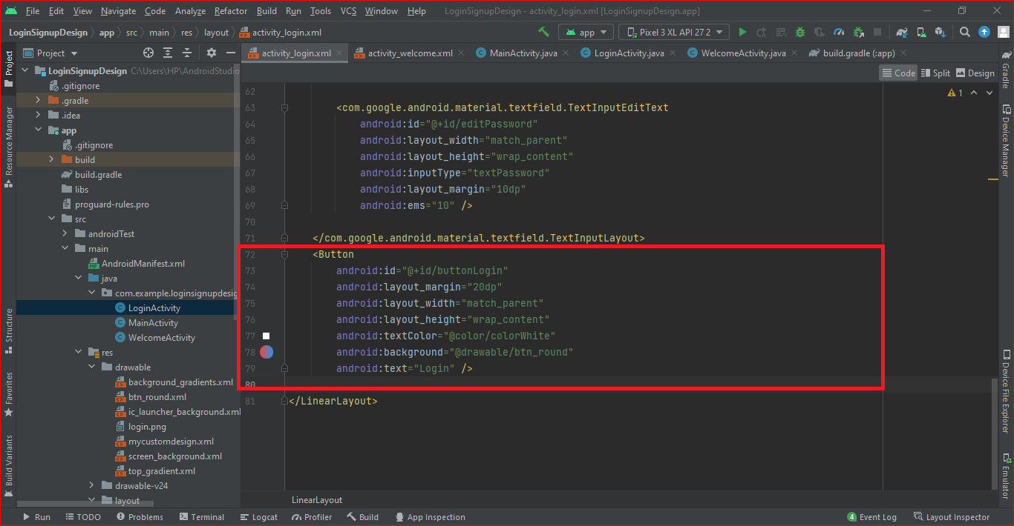

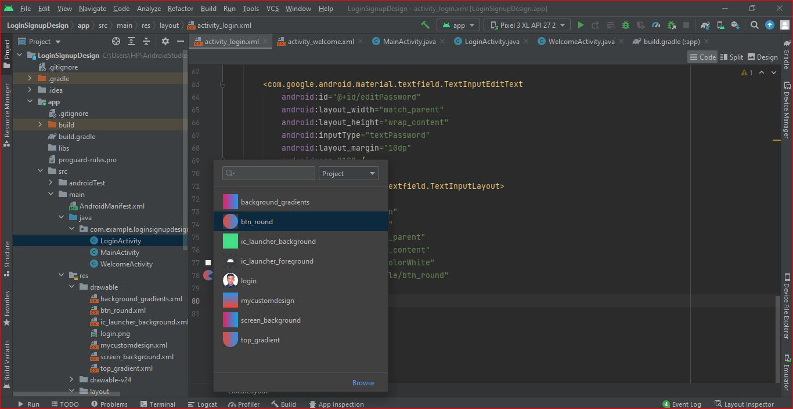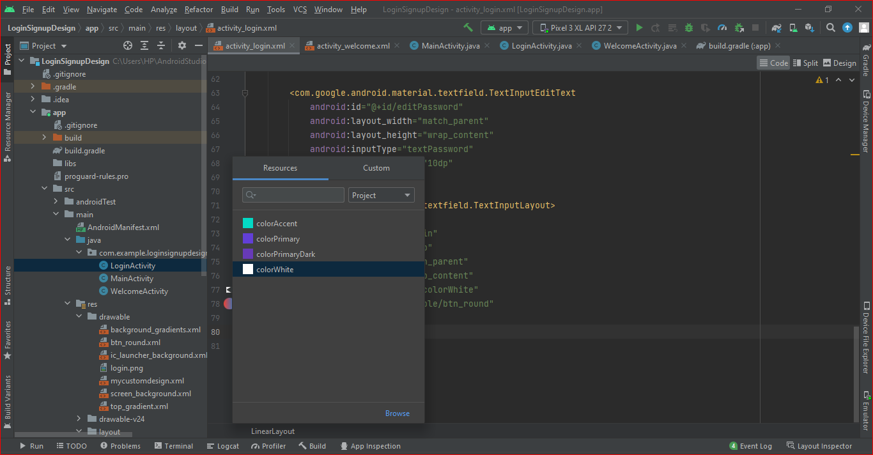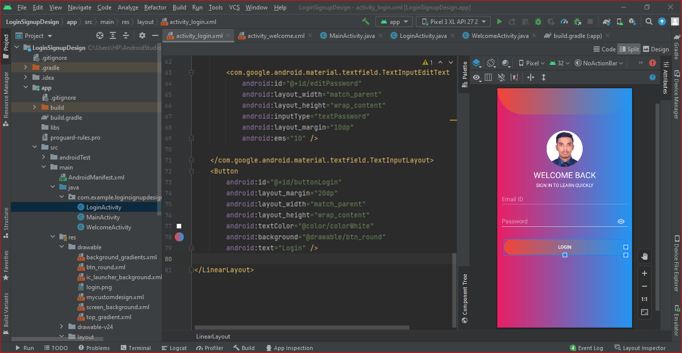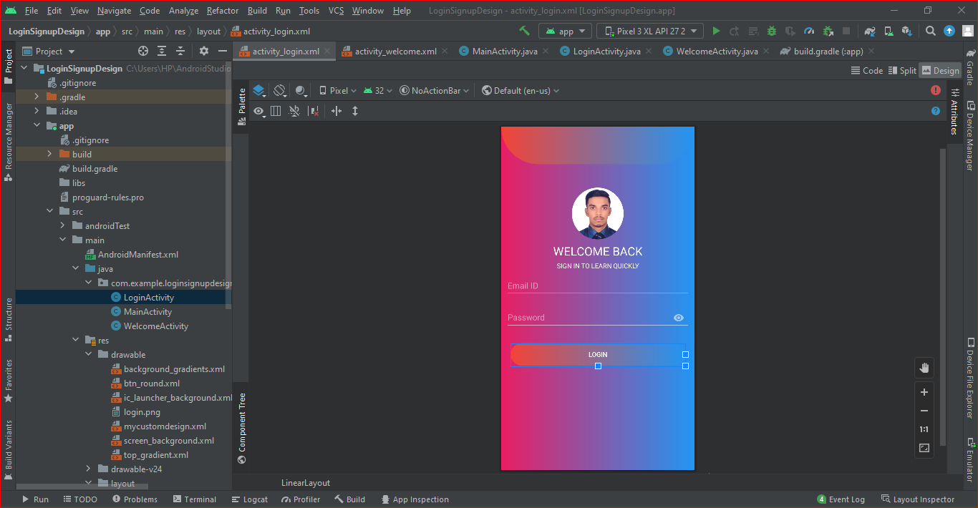

2.8. Add “New Here? Sing up instead” text below in the sing In button. as shown in the figure below.

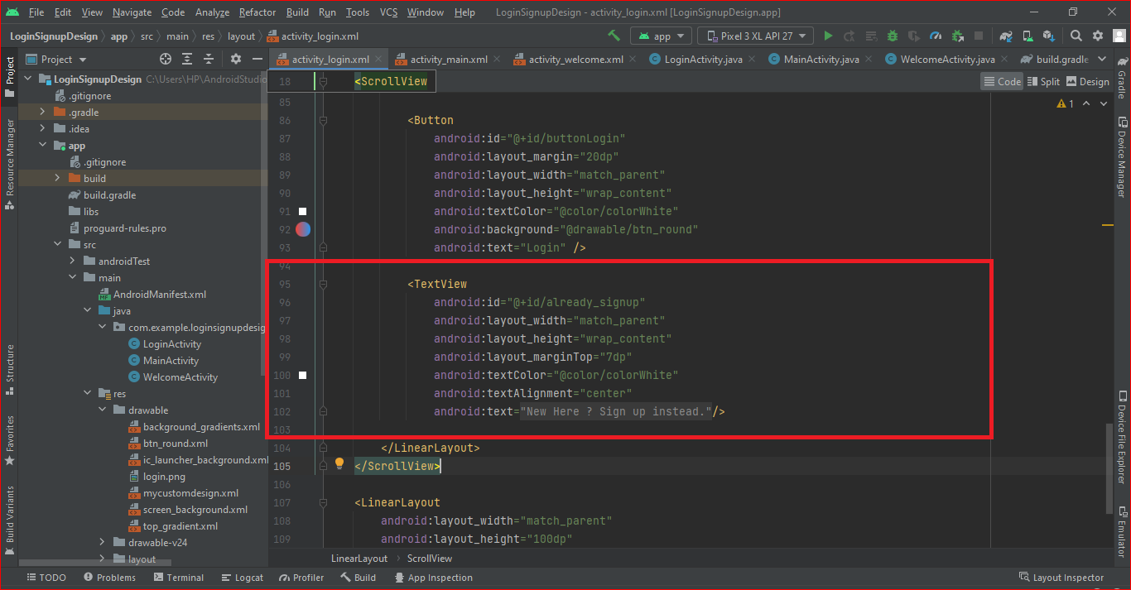

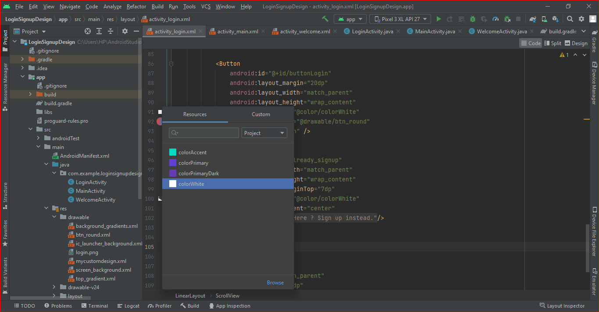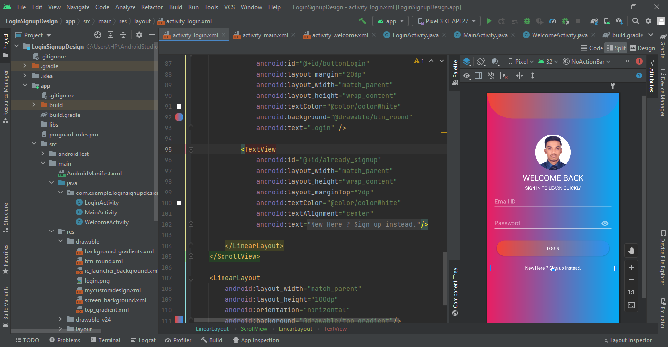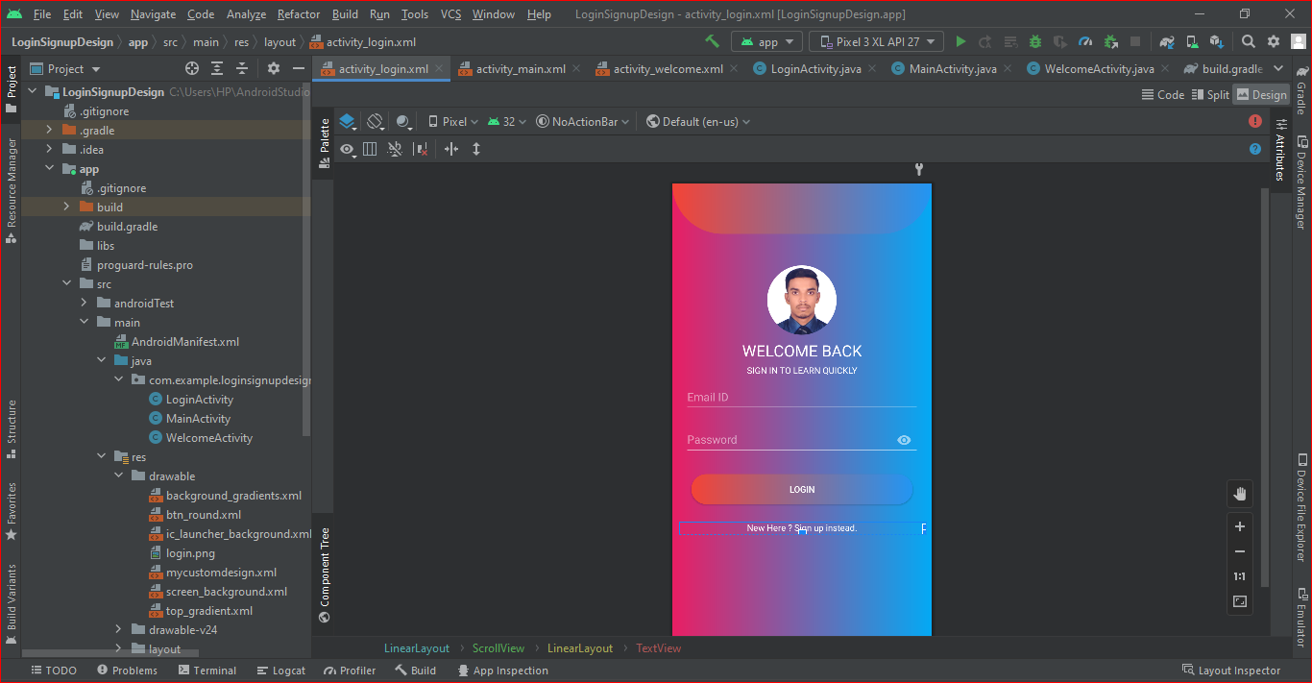

**3.Implement the login process**

3.1. Open the folder app > SRC > main > java > com > example > CODE WITH ARAFAT Singup from, delete all the files in the folder, and right-click to create MainActivity.java File, start writing login Logic. as shown in the figure below.

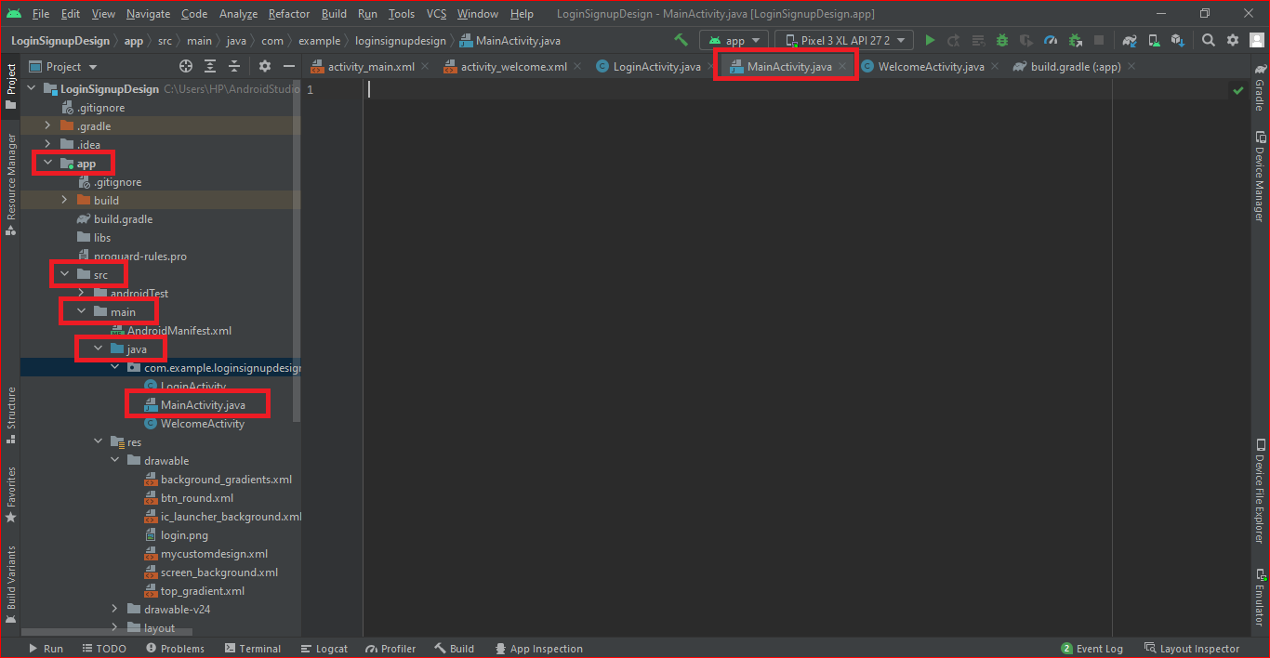

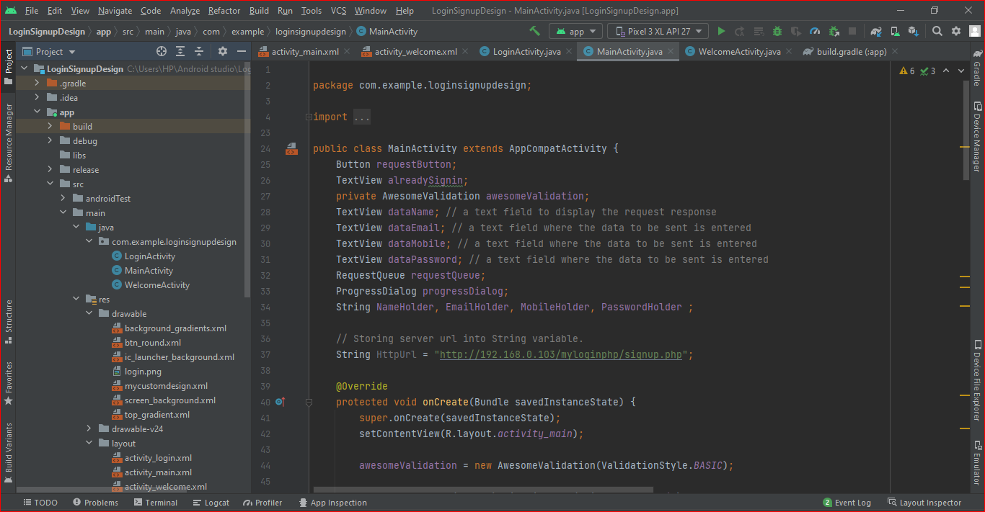

3.2. Write the framework code of the program, and fill in the layout name of the login interface in the setcontentview function (default is activity _main). as shown in the figure below.

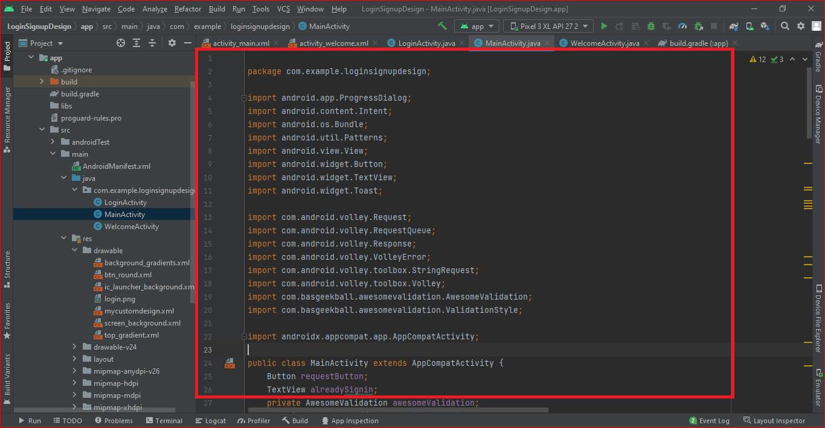

3.3. Write the response function (listening function) corresponding to the login button and the function to obtain the information in the input box. as shown in the figure below.

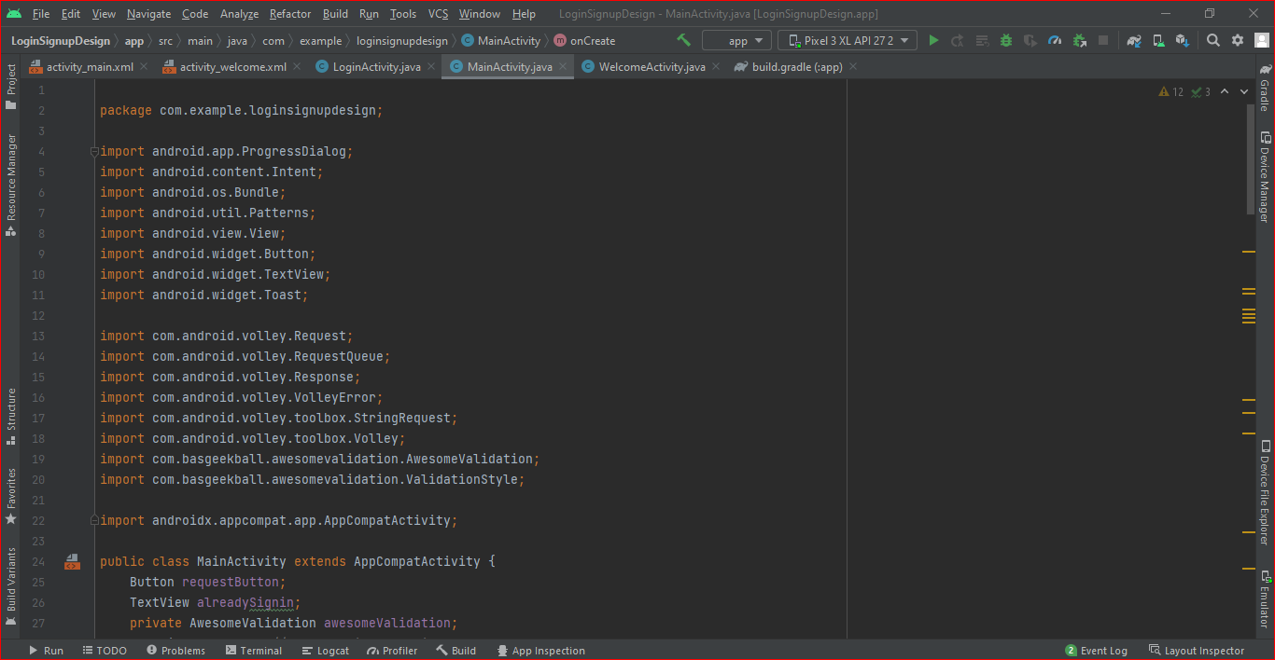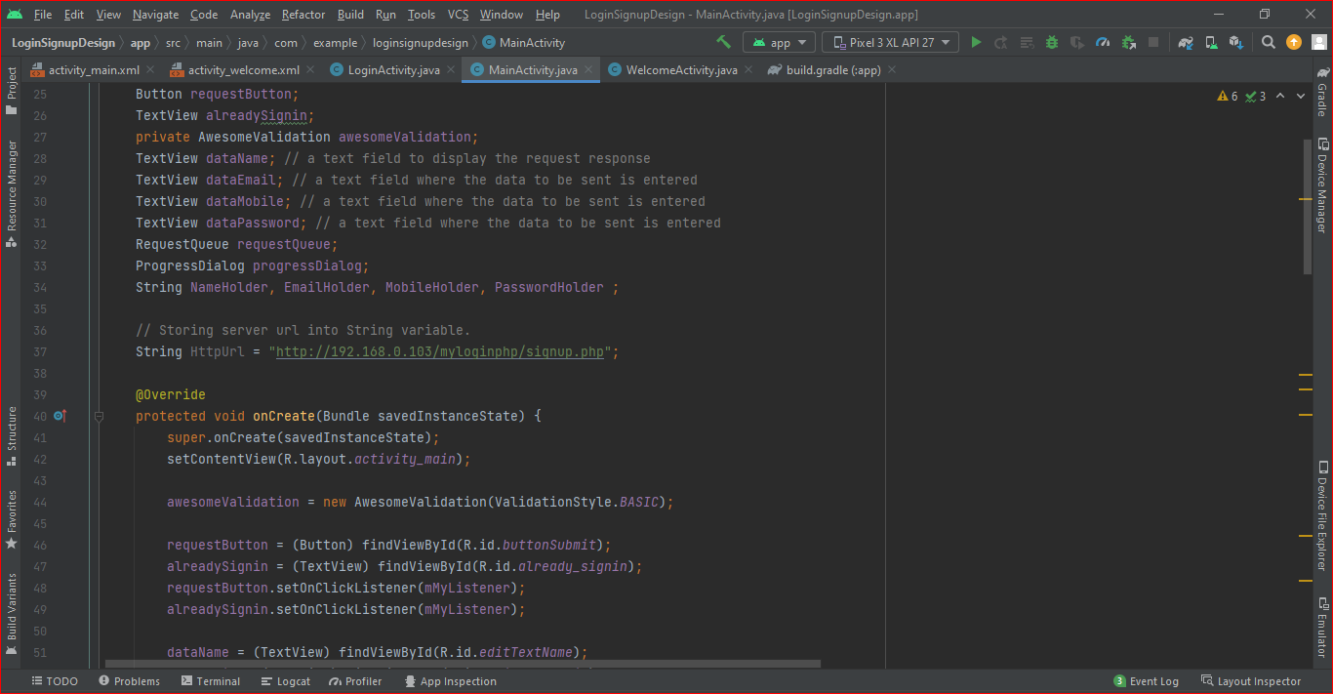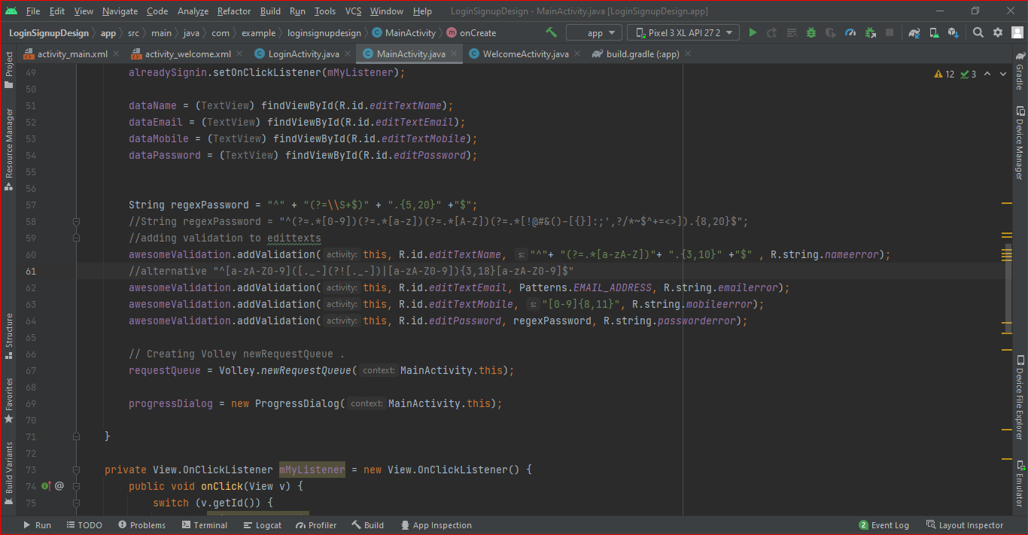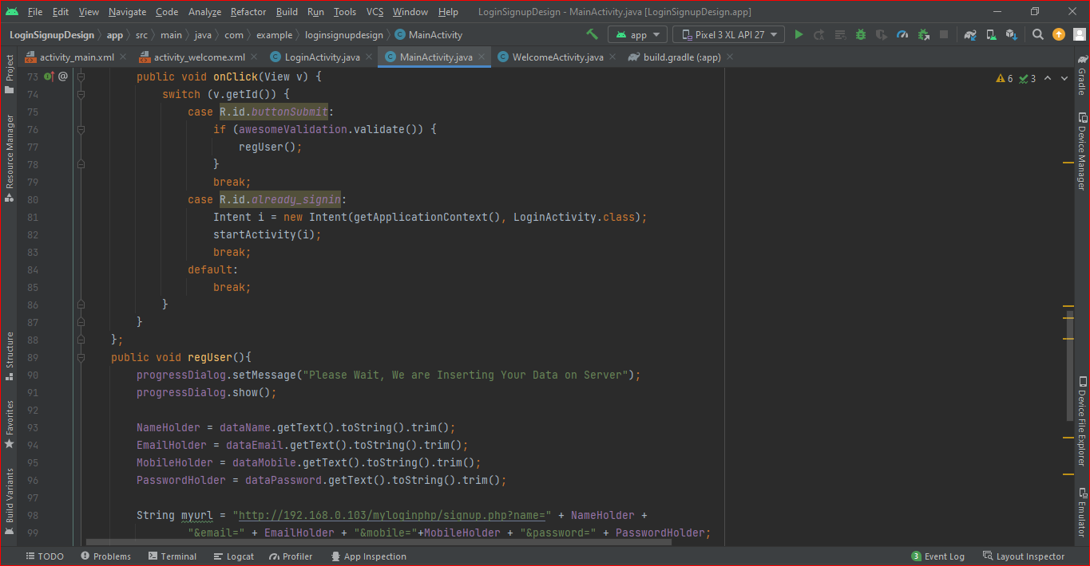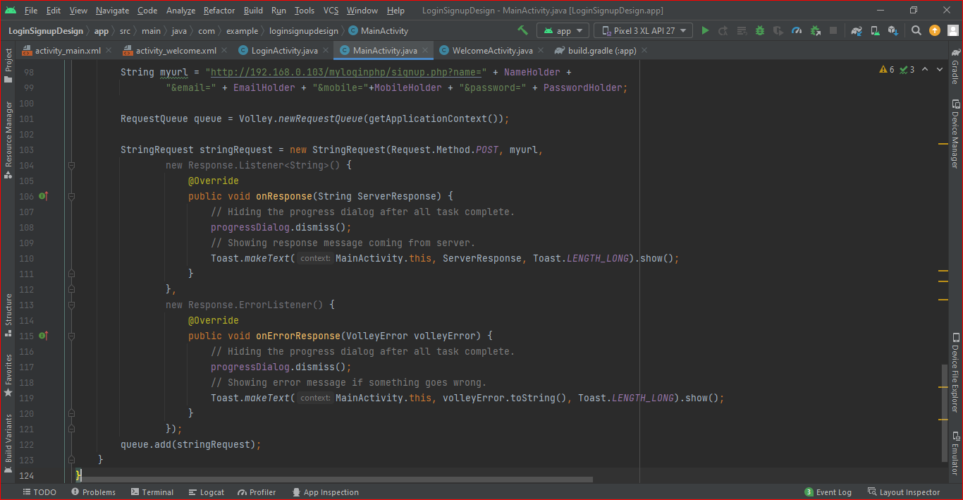

3.4. At this time, click the icon  in the upper right corner to run the program, and the virtual machine will pop up. as shown in the figure below.

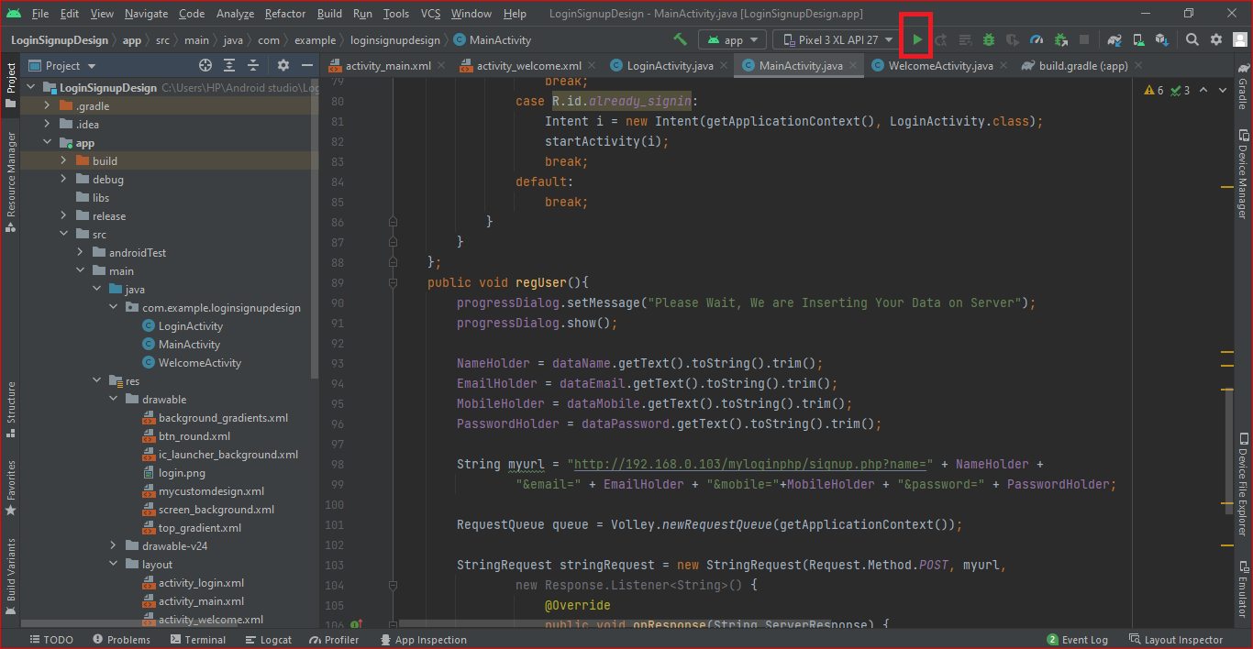

3.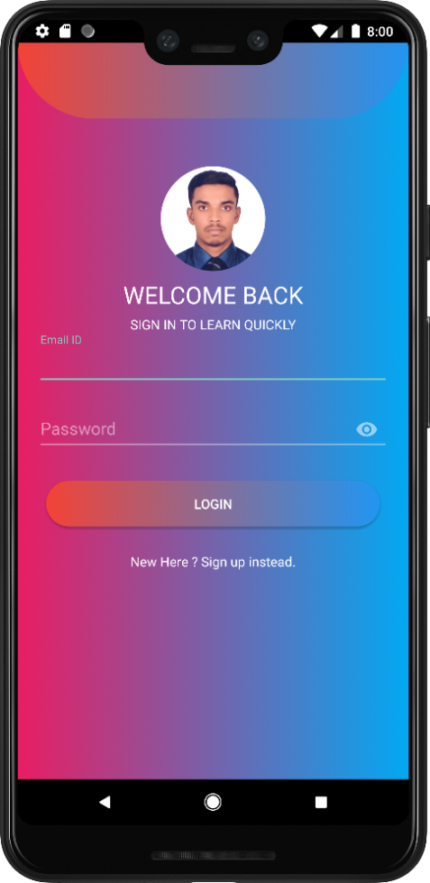5. After clicking the button on the virtual machine, the console will display the contents of the input box. as shown in the figure below.

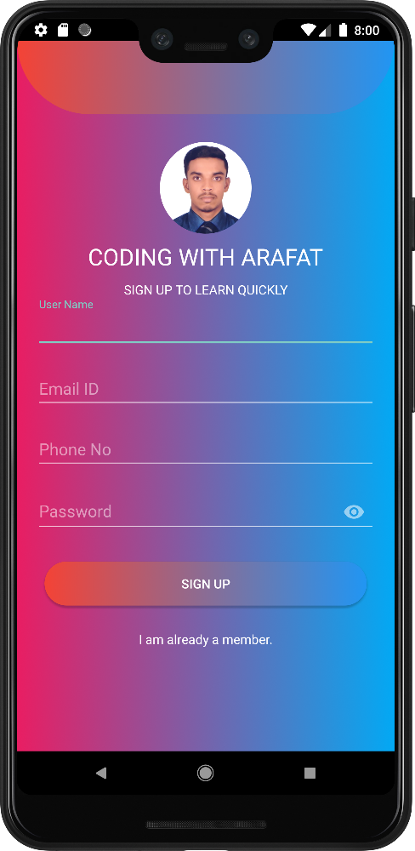

**4. Pack into.Apk file and run on your phone:**

4.1. Open the build.gradle File, which can modify the version number, name and other information of APK. as shown in the figure below.

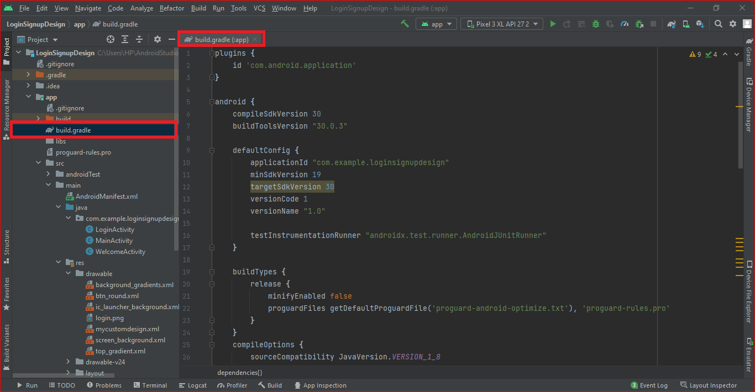

4.2. Click ‘Build->Generate Signed APK’

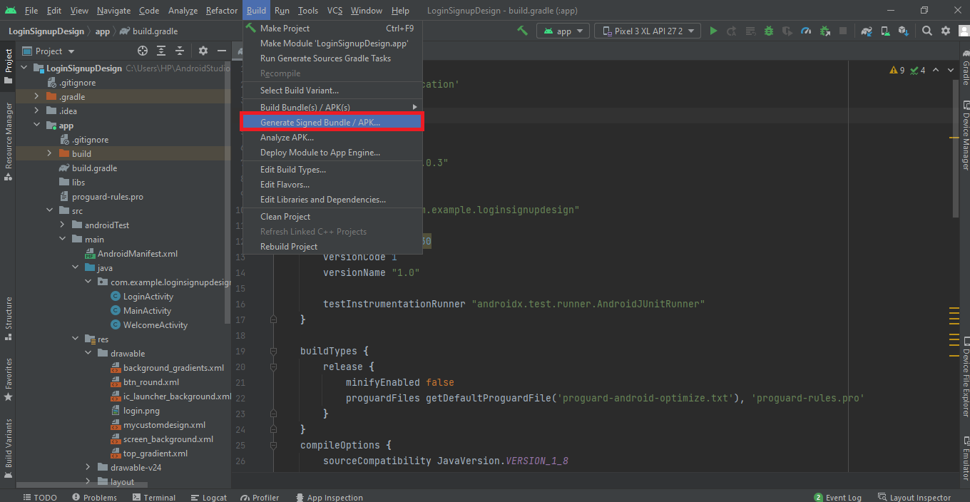

4.3. Select APK after opening

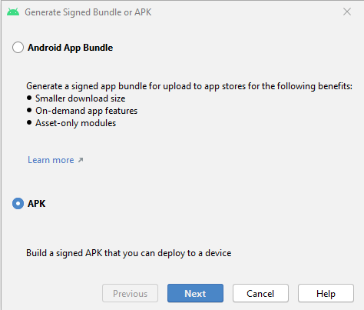

4.4. Click the Button‘ create new...’

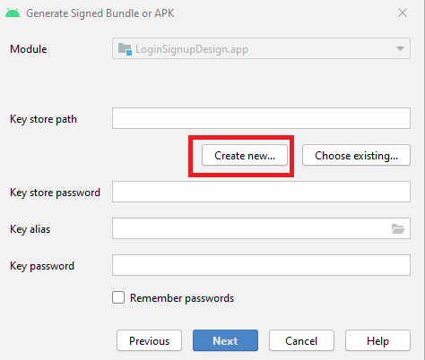

4.5. Create a key file with suffix.JKS

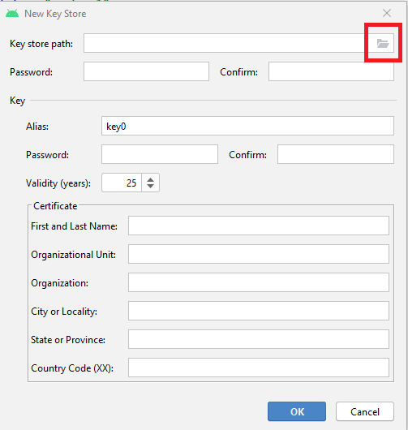

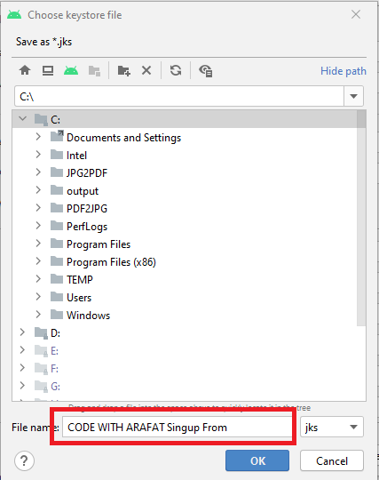

4.6. Fill in other information

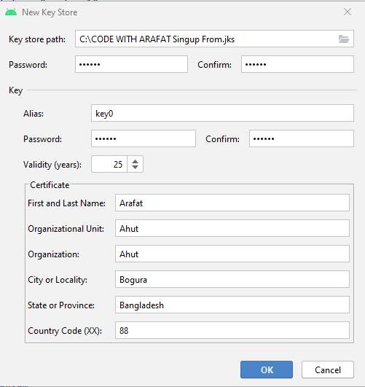

4.7. Click next, select Build Variants,Signature Version and then click finish

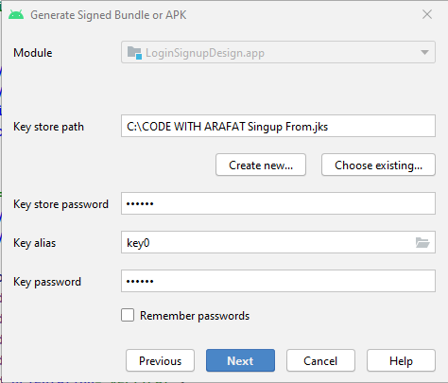

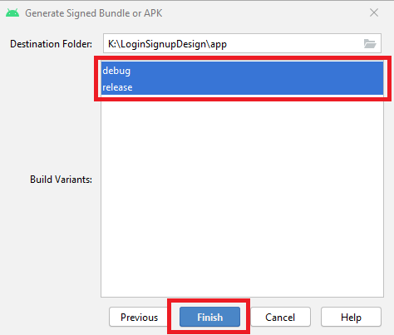

4.8. Click app > debug to find the. APK file and copy it to the phone.

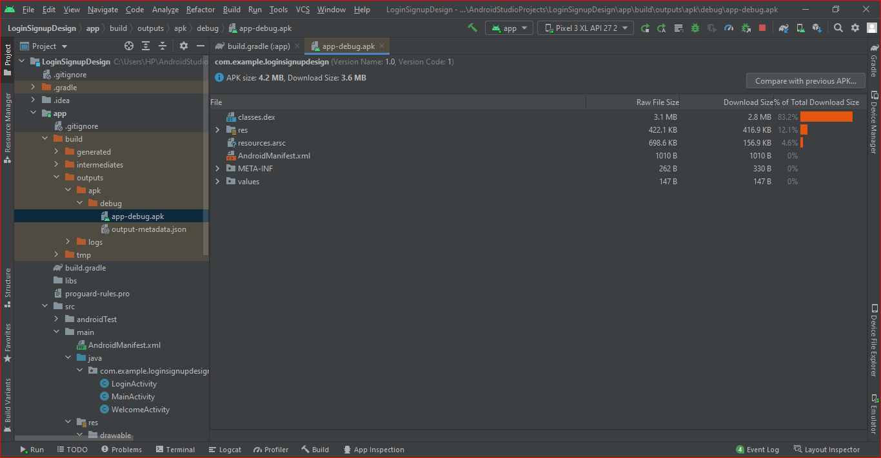

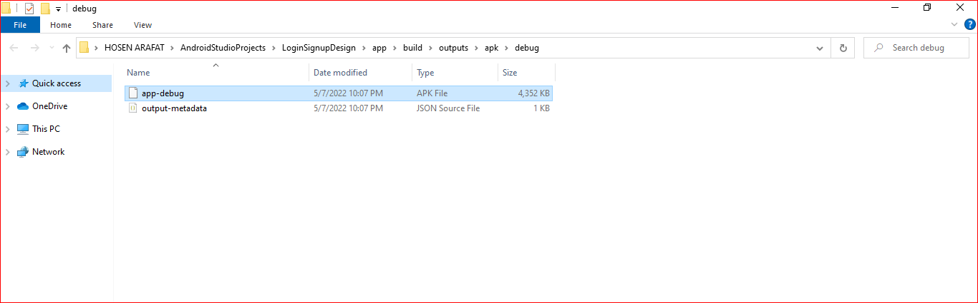

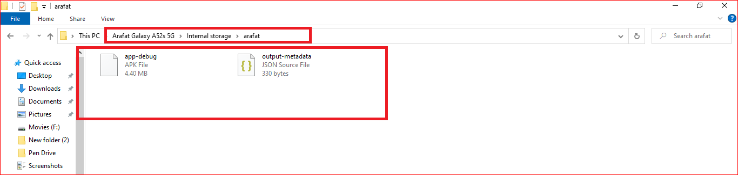

4.9. Download and install the program on my mobile.

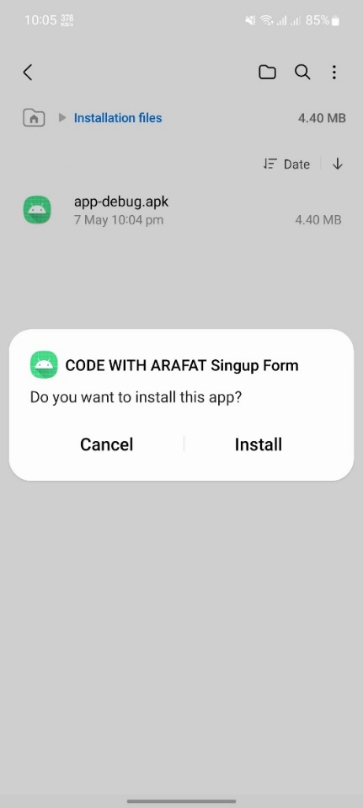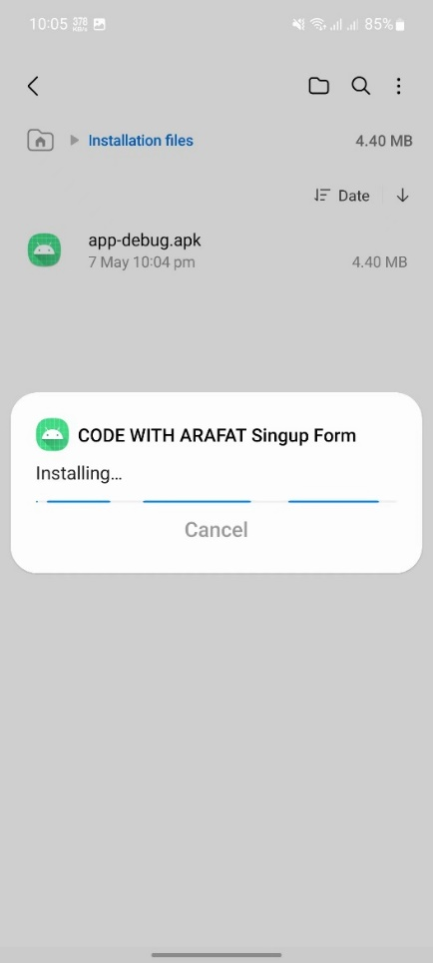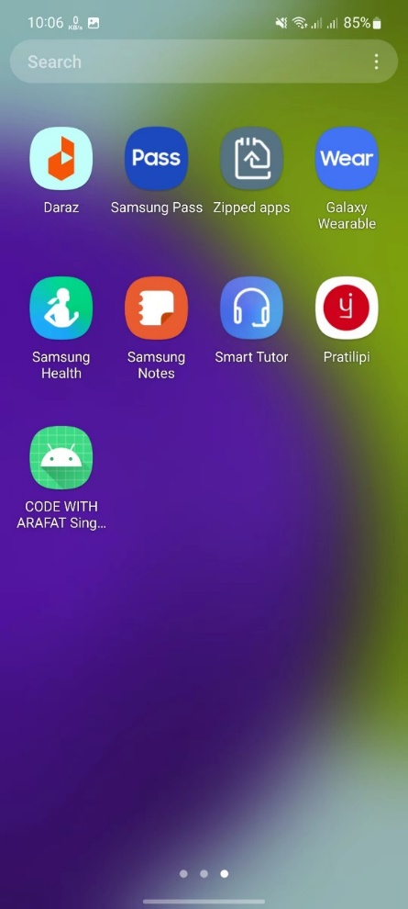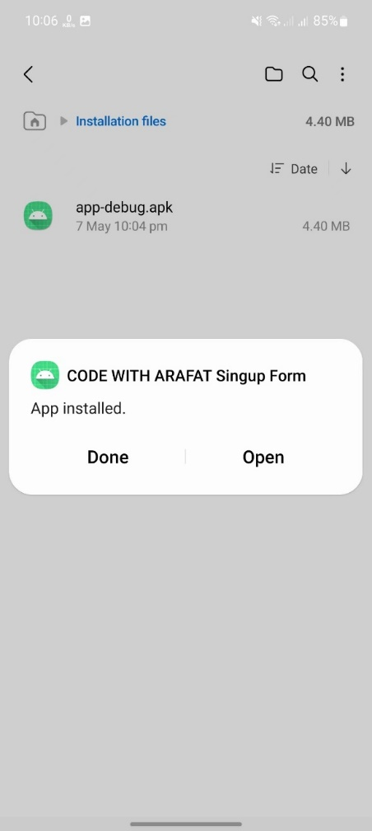

4.10. My first app is finished!

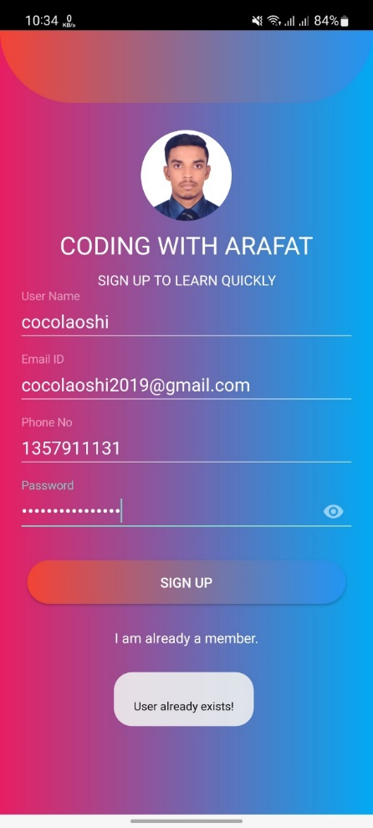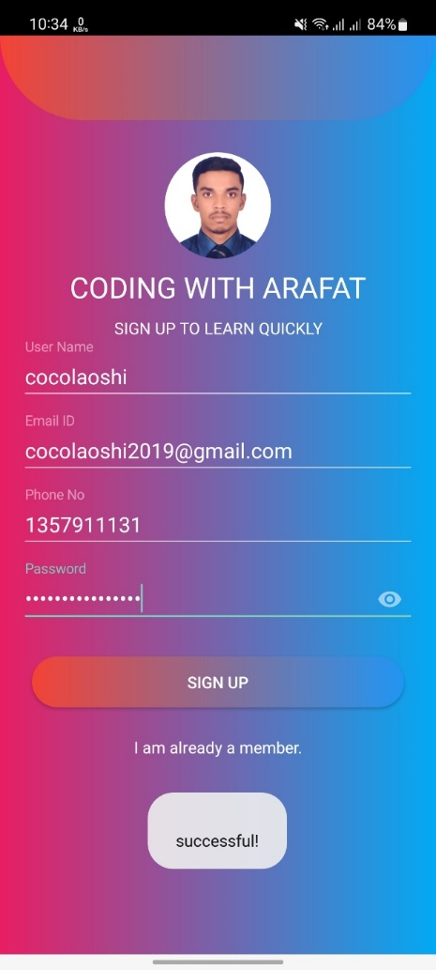

**III. building MYSQL database environment**

**1.Complete the basic user authentication and jump**

1.1. New login success page.

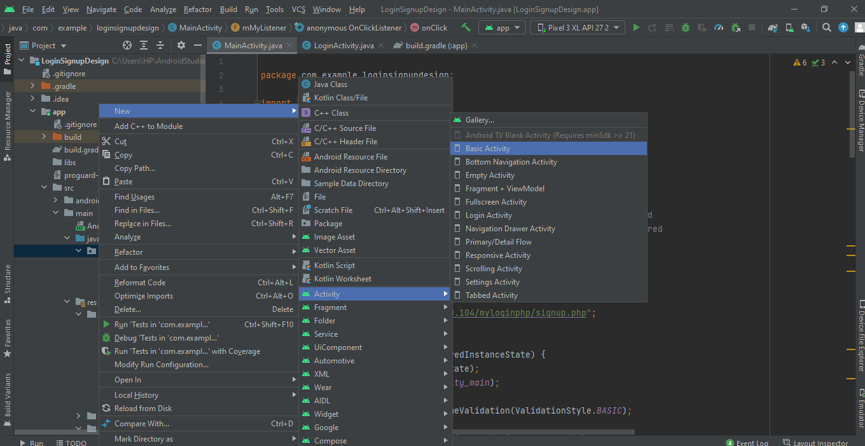

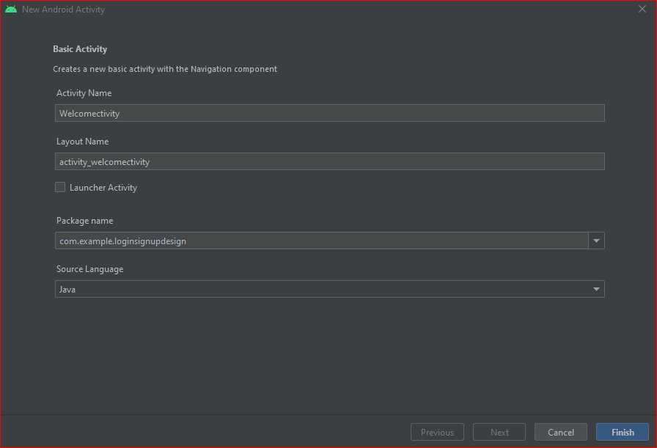

1.2. Modify the login Activity_welcome.xml page, and modify the code to display "Welcome by ARAFAT (199076003)". as shown in the figure below.

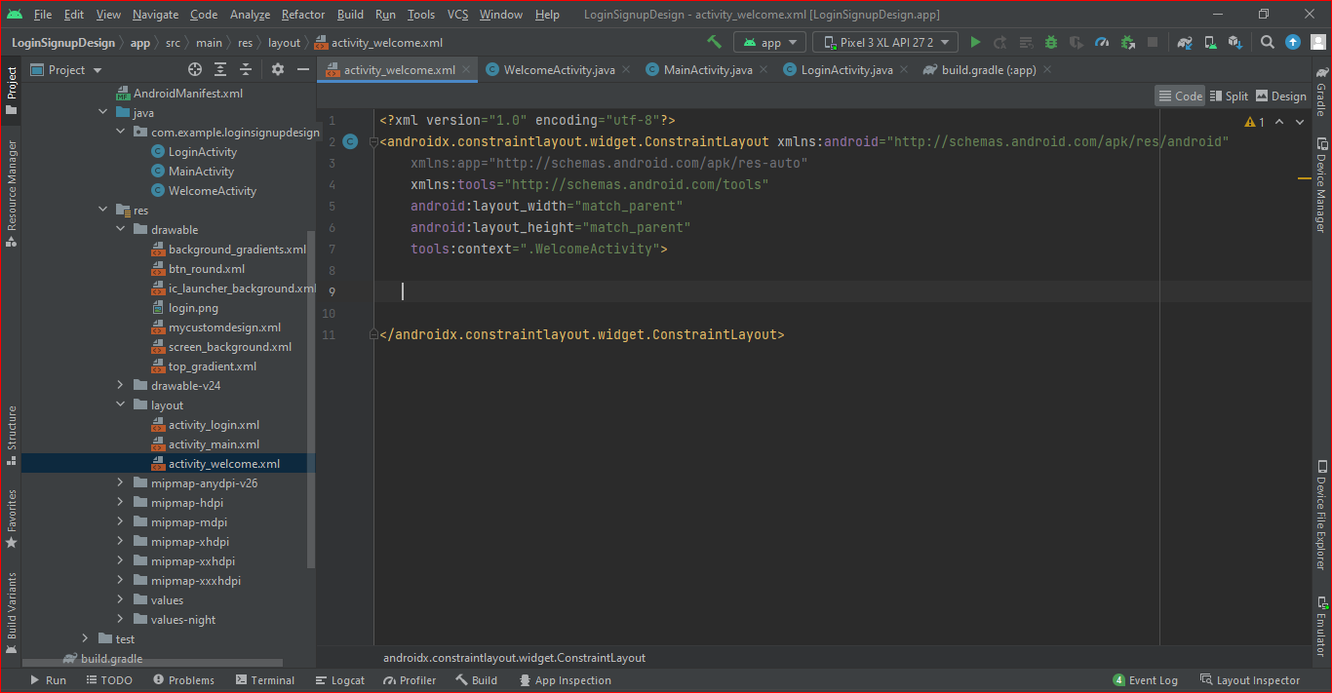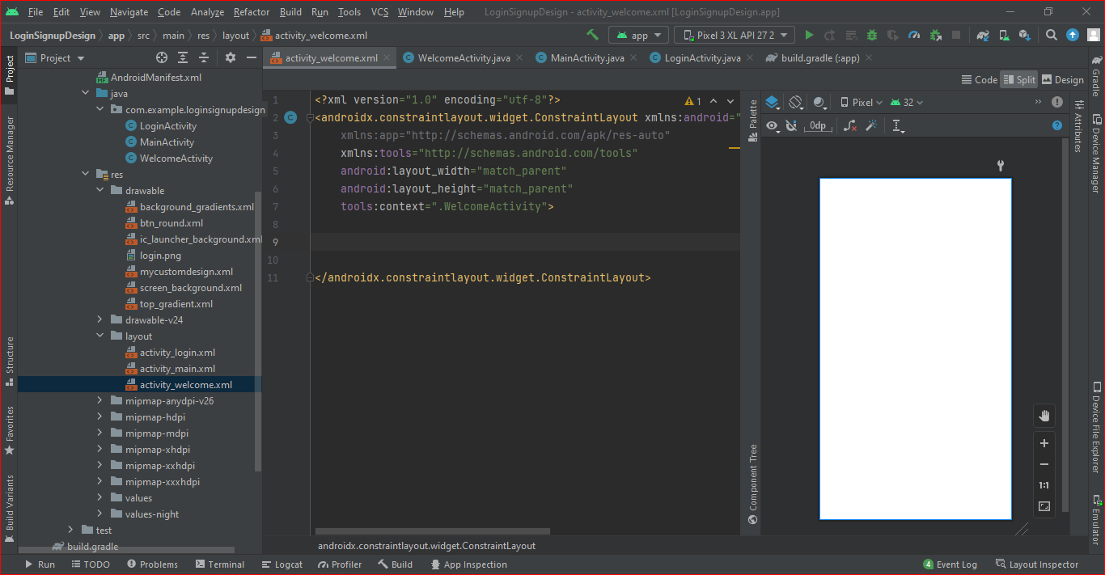

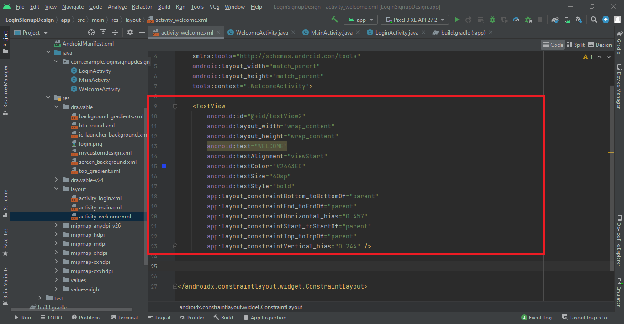

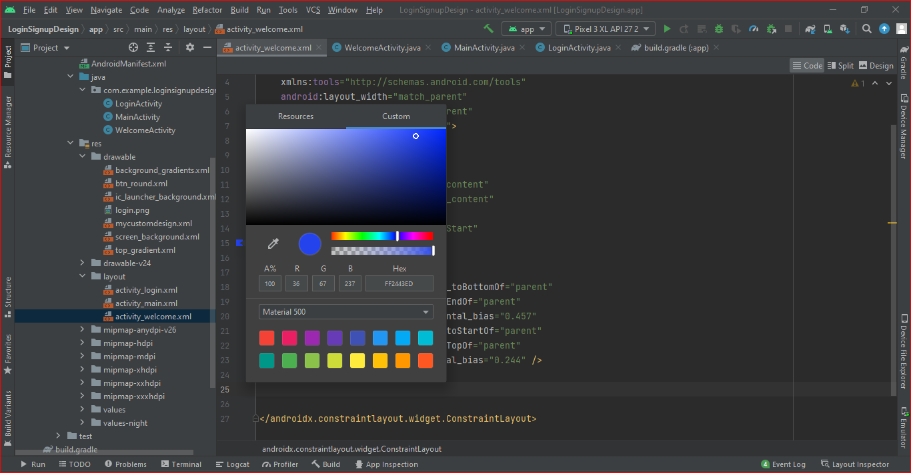

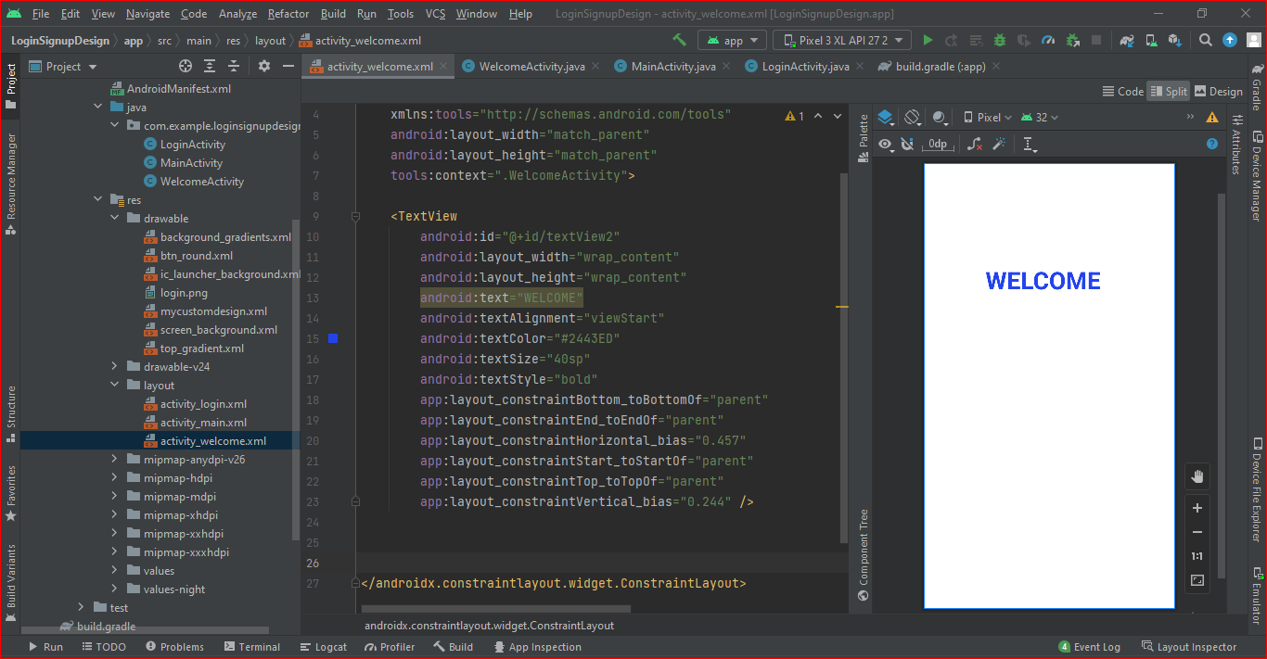

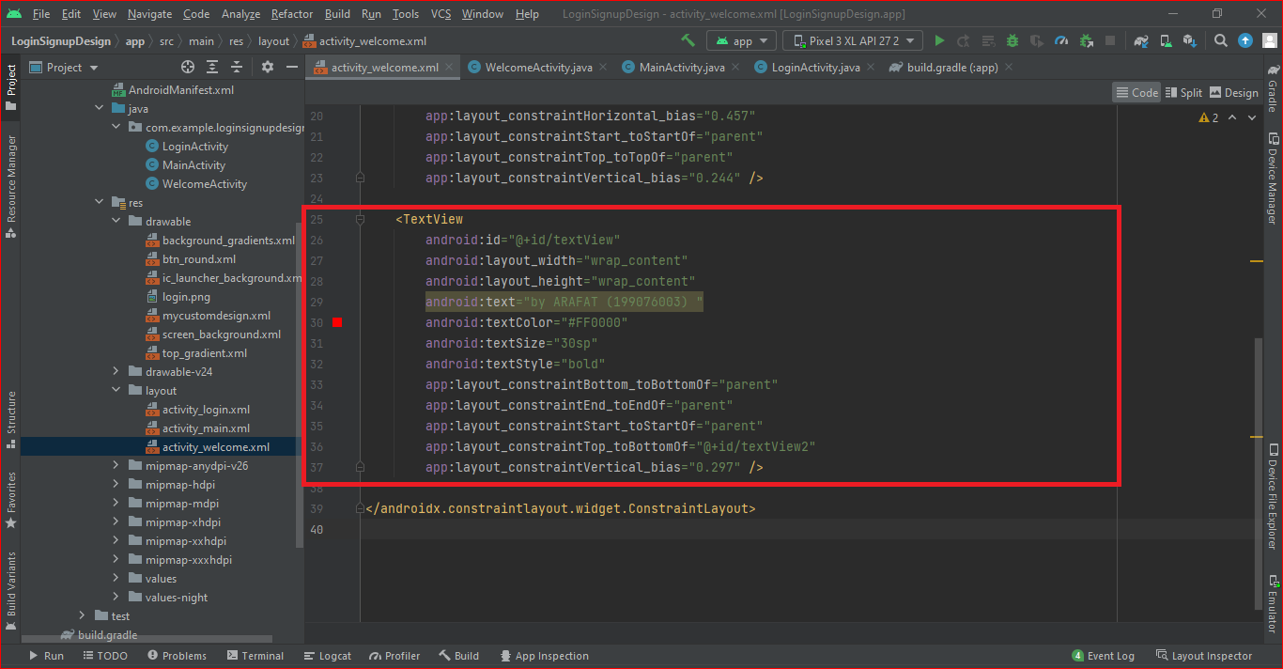

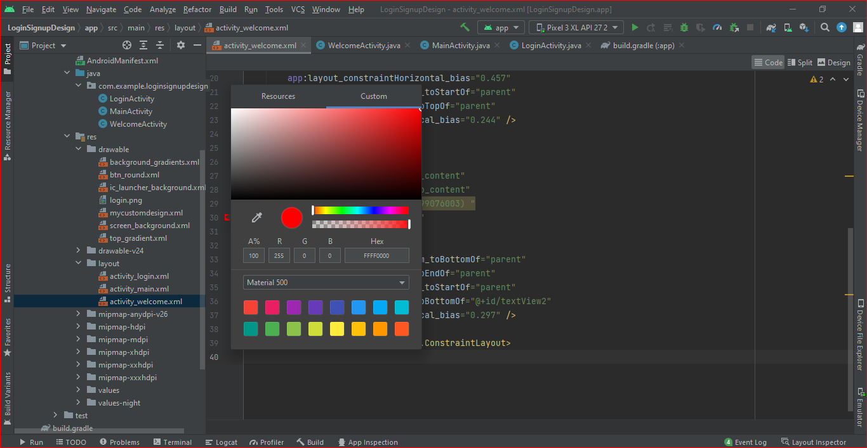

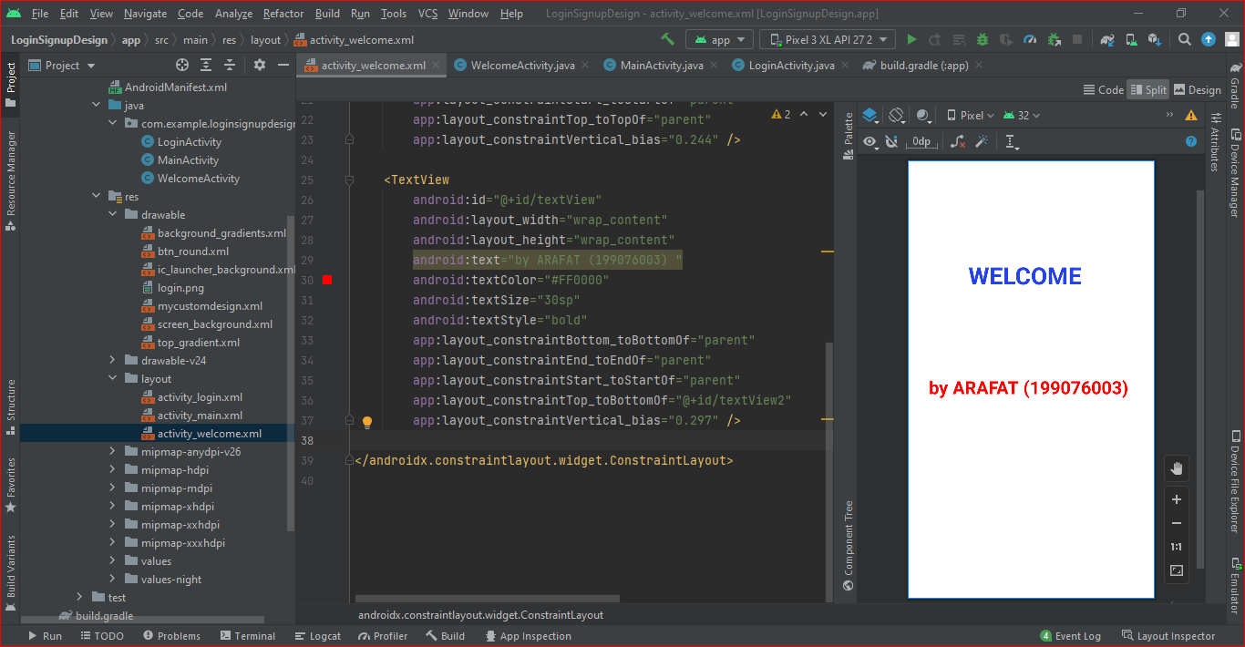

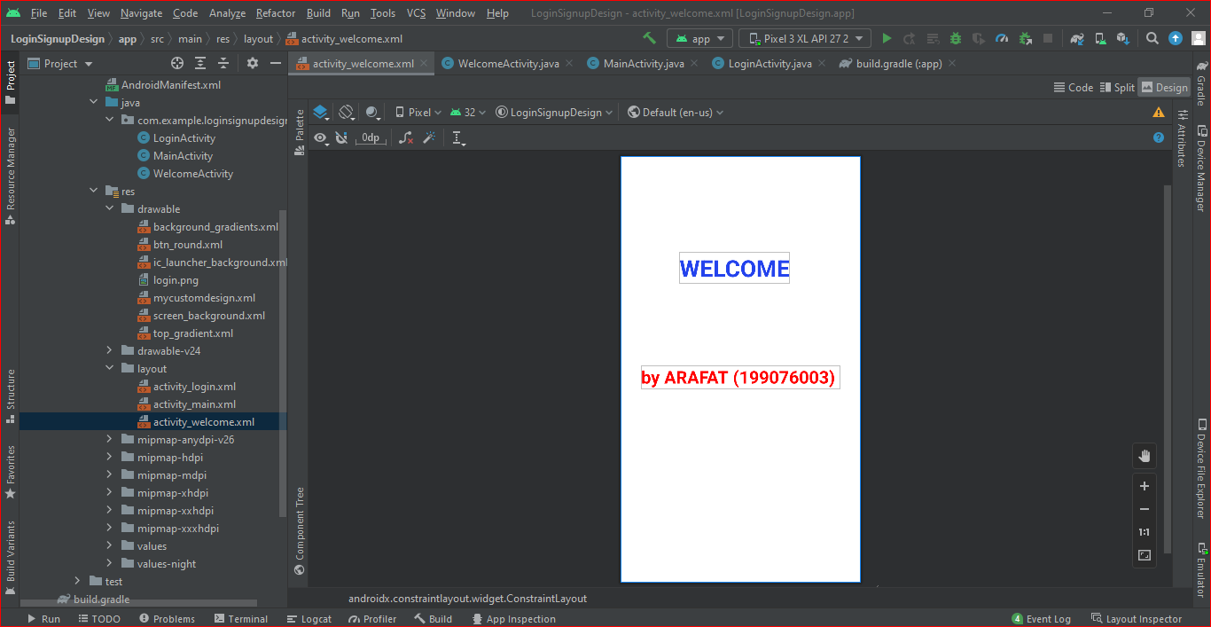



1.3.In and MainActivity.java Create in the same folder welcomeactivity.java File, and write code, guide the activity_welcome.xml Page written. as shown in the figure below.

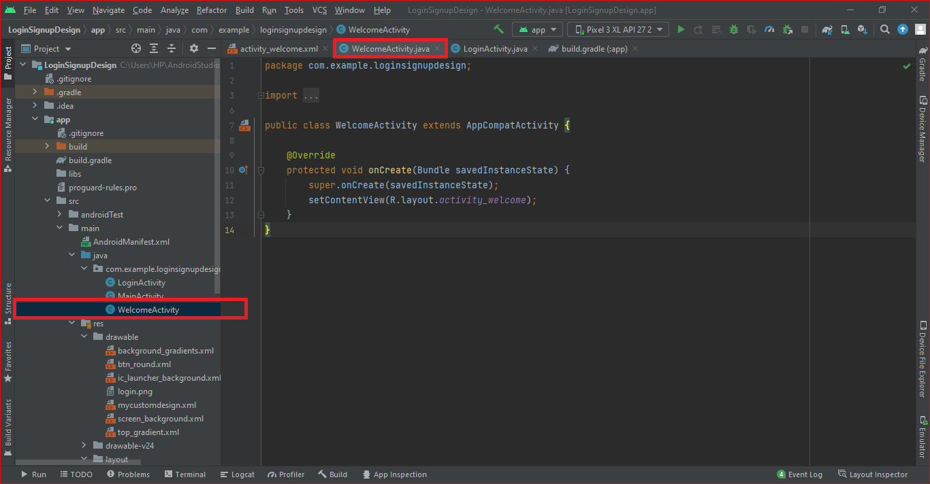

1.4.stay MainActivity.java When I write user name, valid email id, valid phone no, and password must contain at least 5 to 20 characters. Then click sing up button. Show the “successful!” in the below. When i click Sing up button again show the “user already exists”. judge whether the user name= Yafei, email id=yafei2023@gmail.com, phone no= 24487654567, and password= Yafei23Ahut . as shown in the figure below.

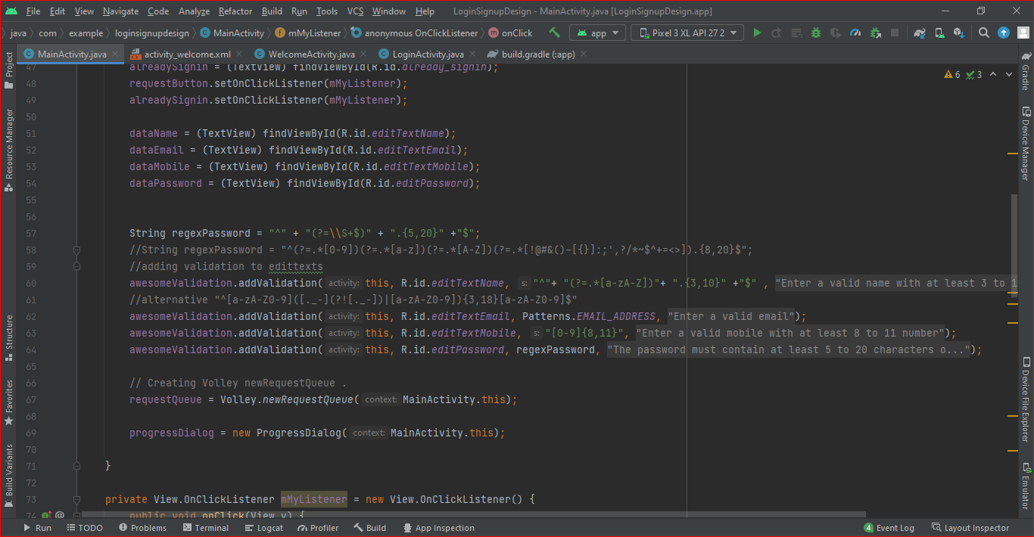

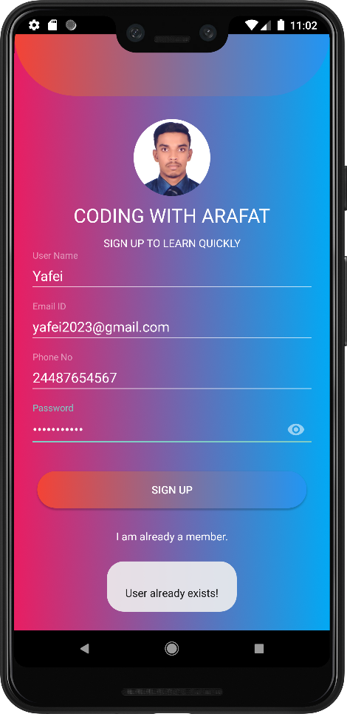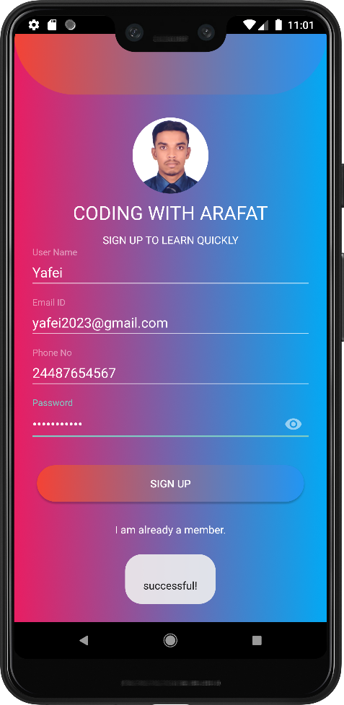

1.5. Test with virtual machine, when the Email id and password are **Email id= yafei2023@gmail.com** and **password= Yafei23Ahut**. Then click the login button, then immediately jump to the activity welcome page .

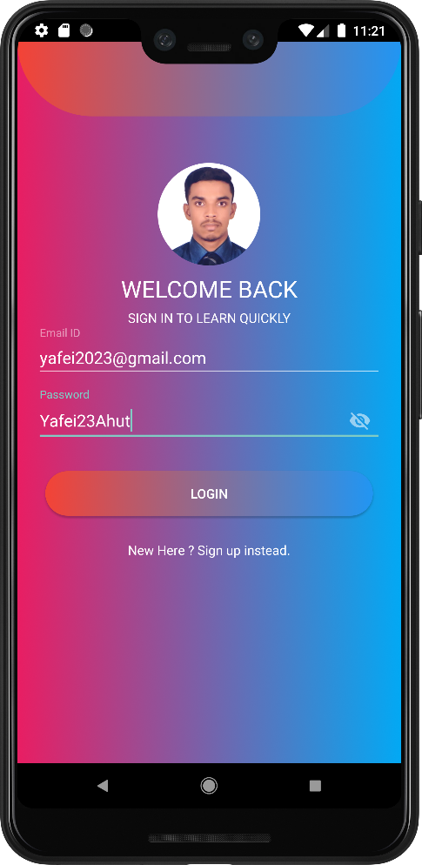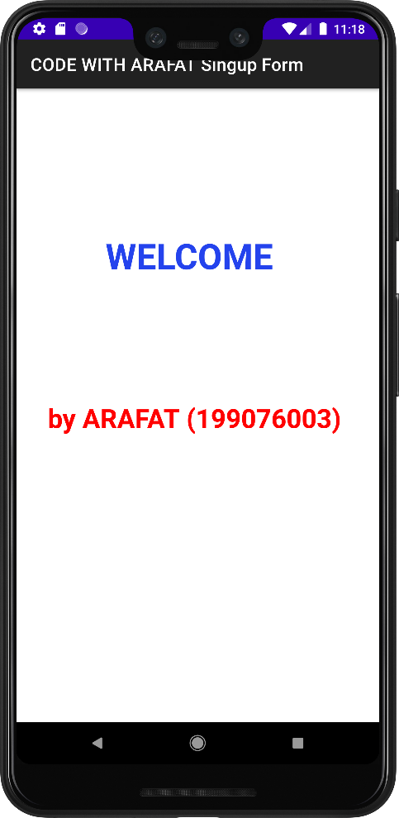

**IV. Configure Login and registration to database using PHP and MySQL:**

**1. Create database**

**1.1 Download and install XAMPP (The whole process**

**needs network)**

1.1.1. Open the website of XAMPP , Click DOWNLOAD

XAMPP to download.

(<https://www.apachefriends.org/download.html>)

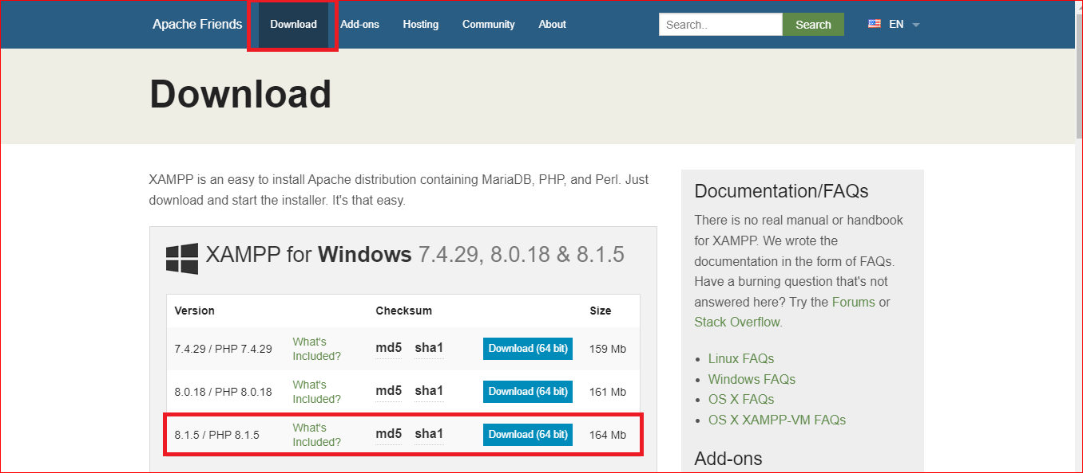

1.1.2. Run the installation package (in administrator mode).

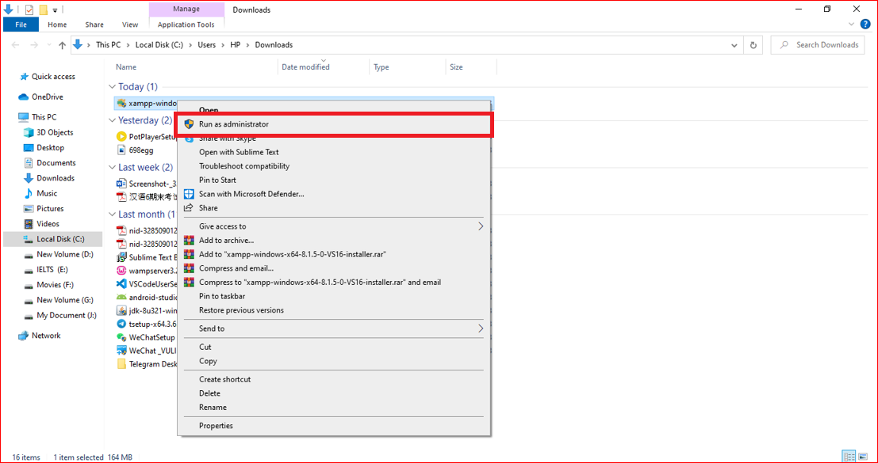

1.1.3. Always click ‘next' to install.

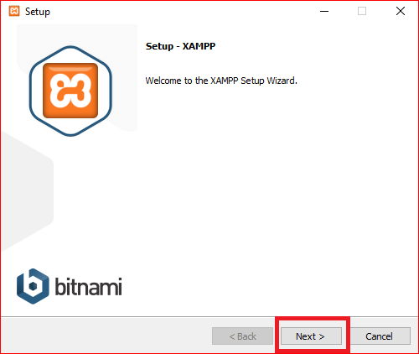

1.1.4. Select all Components “ XAMPP ” Then Click Next.

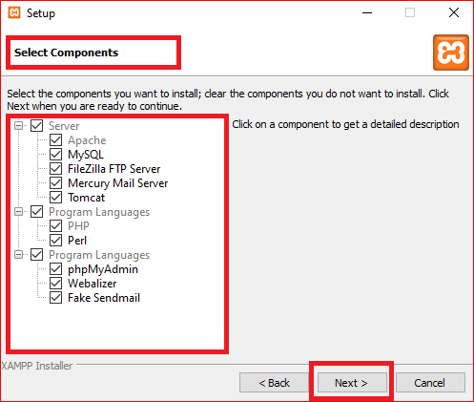

1.1.5. Choose Installation folder of the XAMPP . Then Click Next.

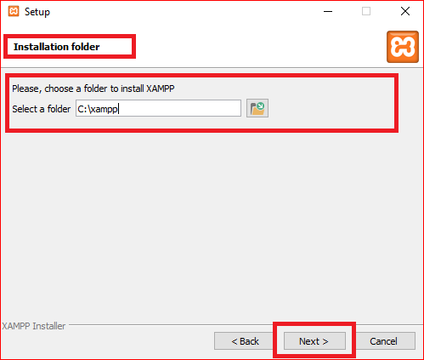

1.1.6. Set Language of the XAMPP . Then Click Next.

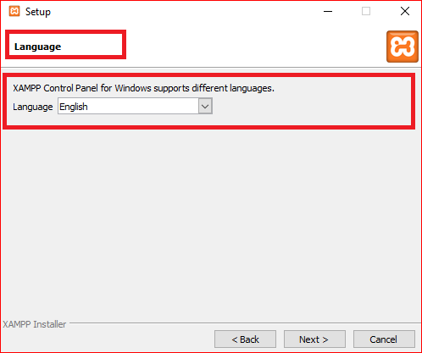

1.1.7. Setup is now Ready to being installing XAMPP of my computer. Then Click Next.

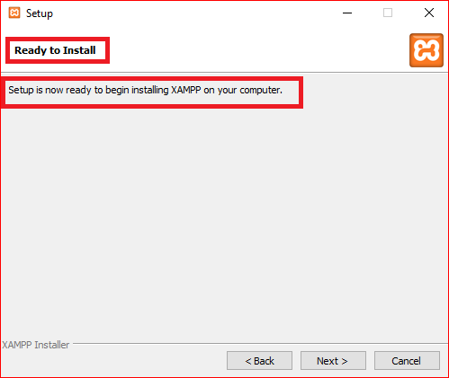

1.1.8. Installing XAMPP , Unpacking files.

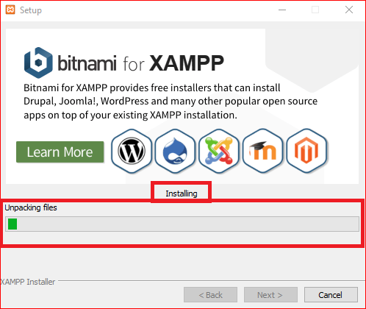

1.1.9. Now finish the XAMPP installing. Click finish.

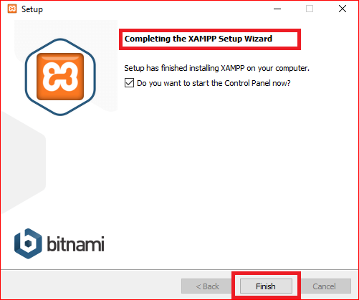

1.1.10. Now open XAMPP control panel.

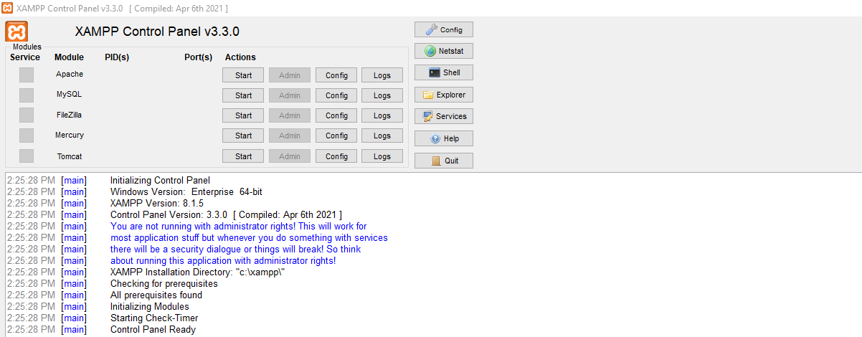

1.1.11. Start Apache.

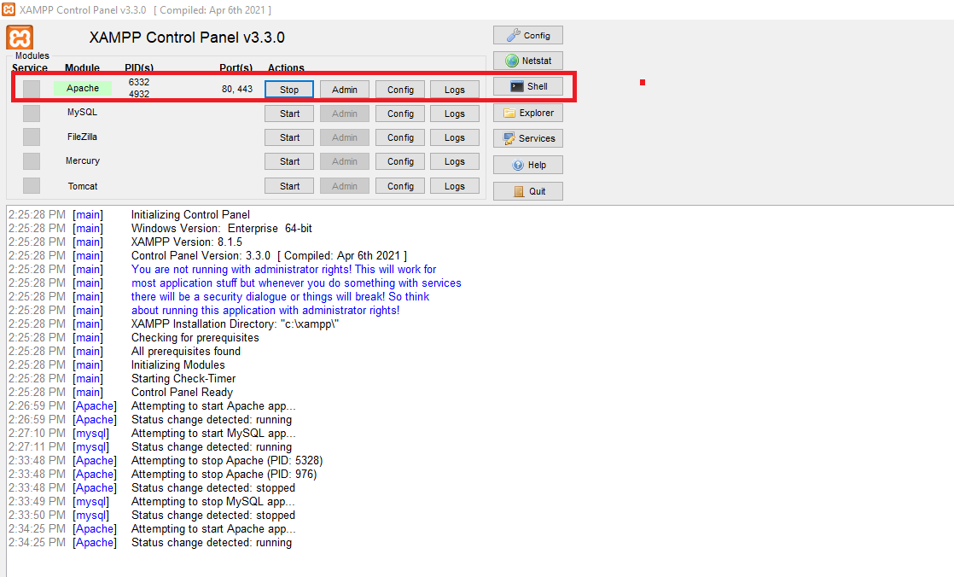

1.1.12. Start MySQL

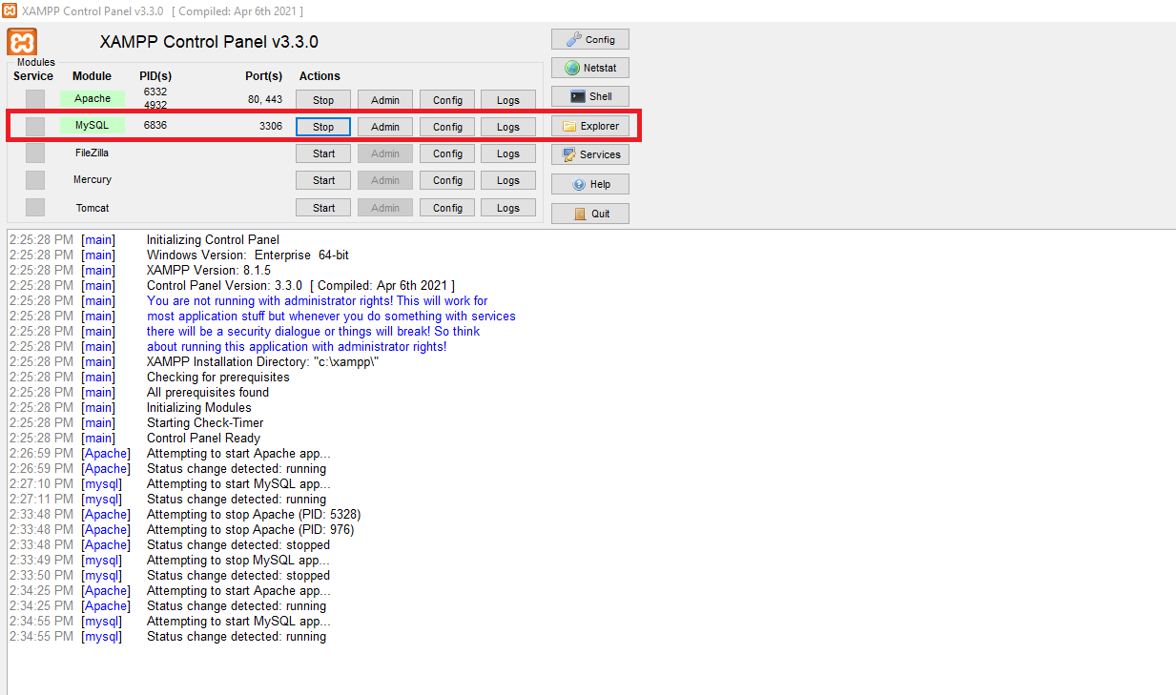

1.1.13. Click Admin then go to “phpMyAdmin” .

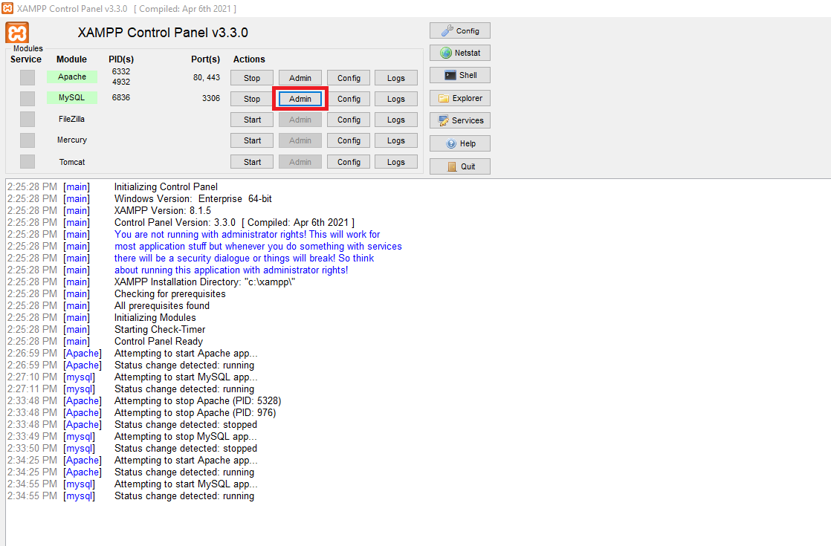

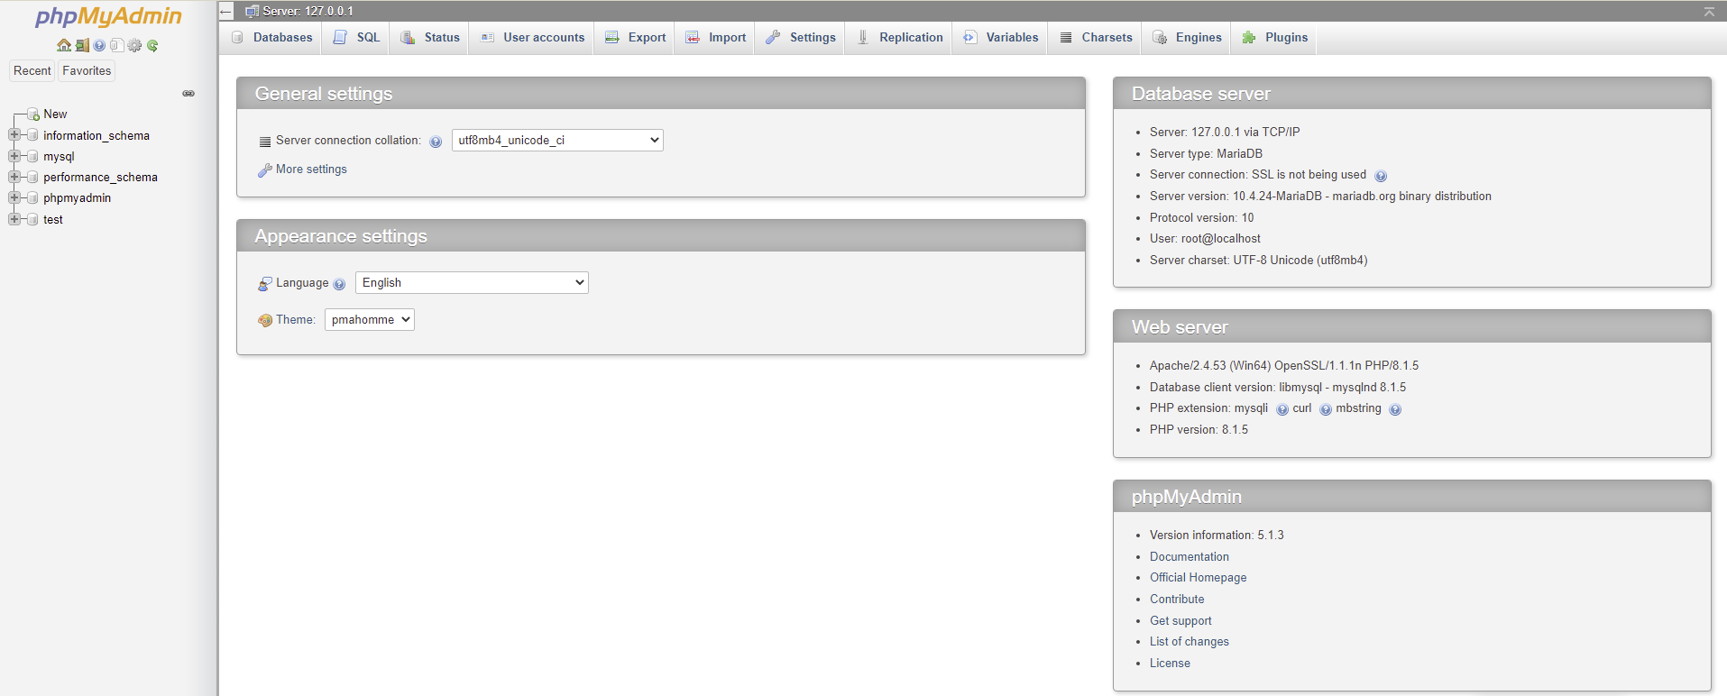

1.1.14. Now Create a Database Folder “singupdb" show query box. and create table users ( name, email, mobile, password ). as shown in the figure below.

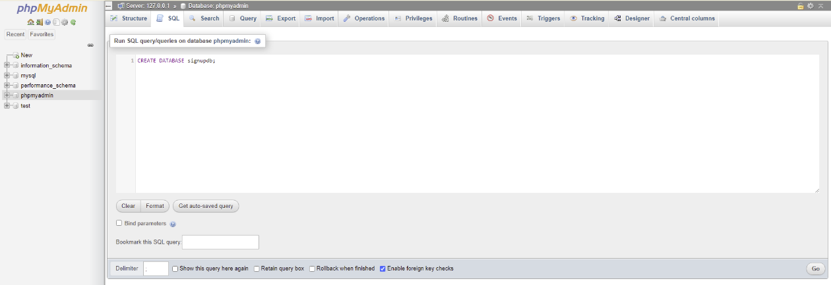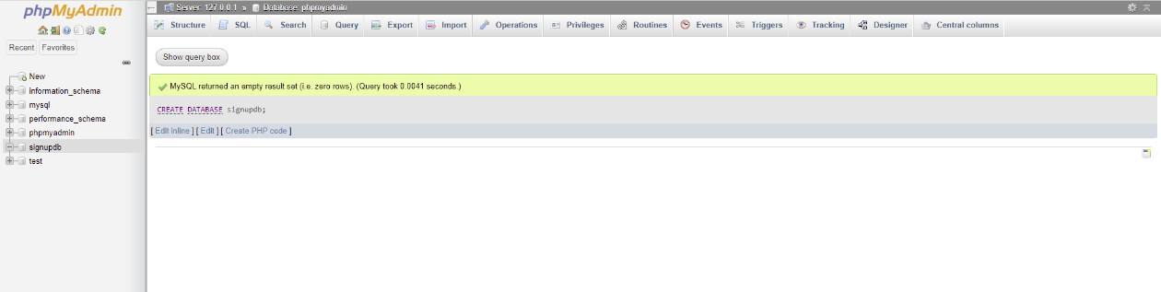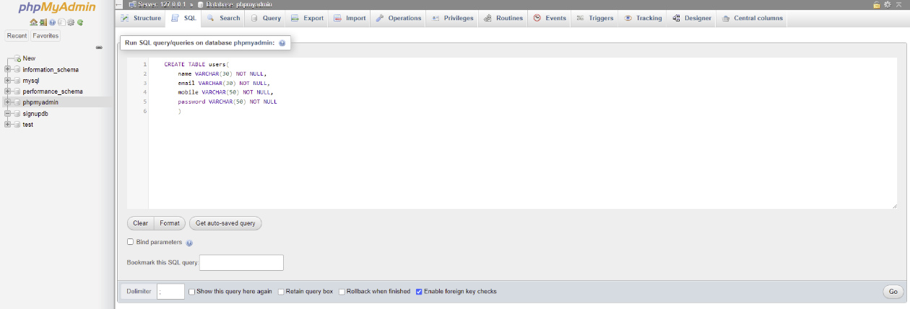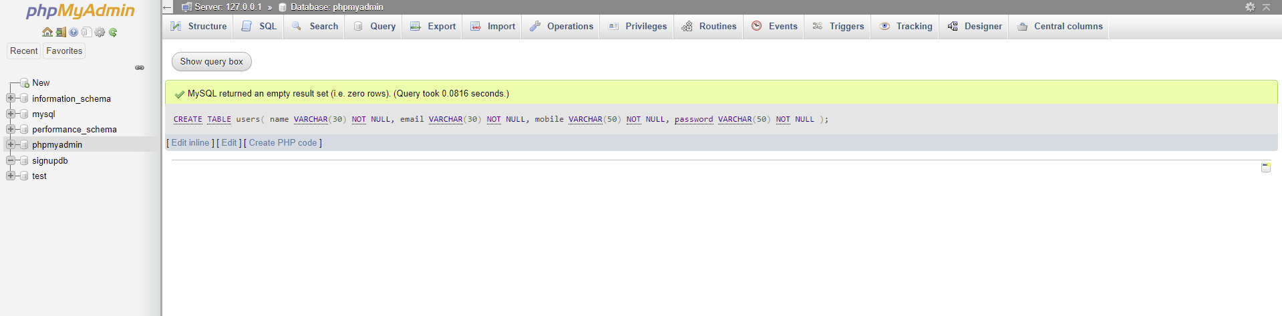

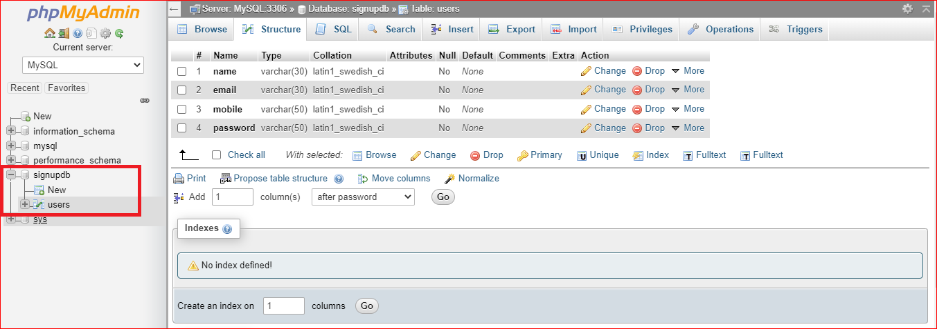

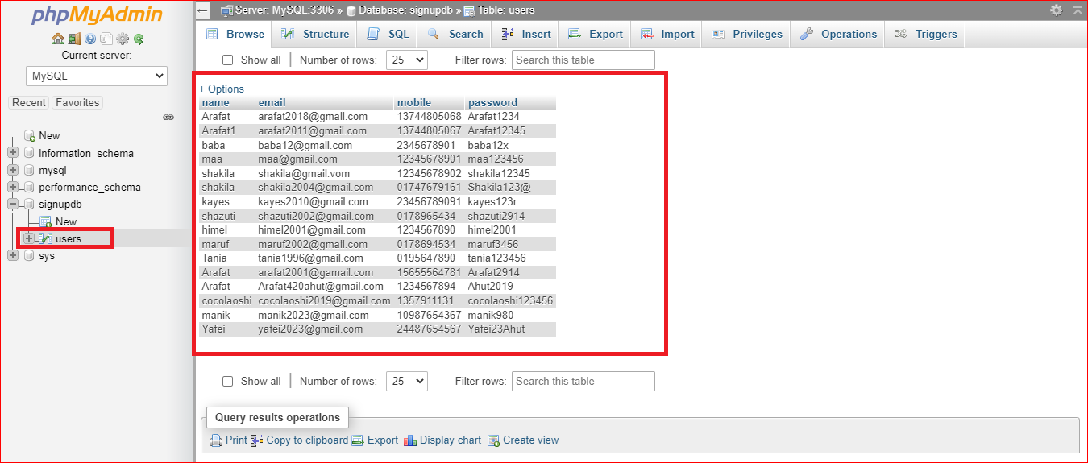

**2. Add insert function**

2.1.Create a loginphp folder inside of the htdocs folder. And create loginin.php and signup.php inside of this folder. And write code for loginin.php and signup.php.

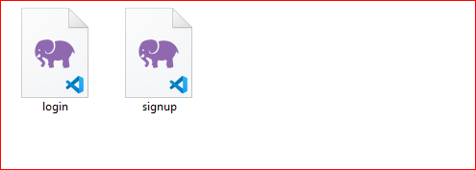

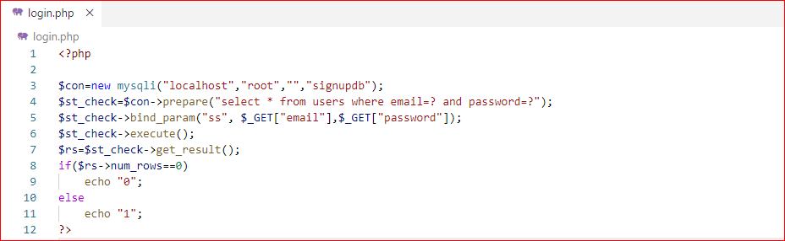

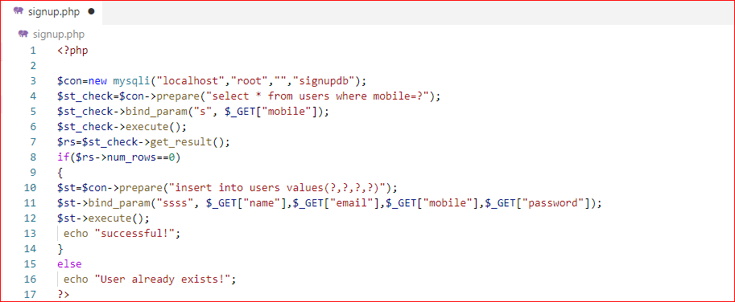

**3.connect to database using IP address**

3.1. Now connect the Android app with database using my local server, I mean by using our ip address we can connect out android app with Signin.php and signup.php to database.

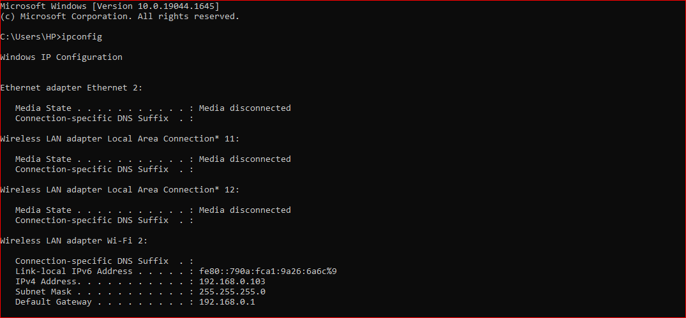

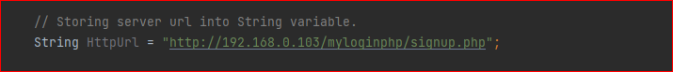

**4. Testing**

4.1. Login interface



4.2. Registration interface.



**V. curriculum requirements**

Project Name: login registration system

1. I user Using Java, php and Mysql database for storing users information

2. I create a user interface, Where user must have to input at least 3 characters or digits to maximun 10 characters or digit. If user input 2 or 3 characters /digits then they wom’t be able to register and login.

Regular expression for this username:

**"^"+ "(?=.*[a-zA-Z])"+ ".{3,10}" +"$"**

4.Regualr expression for password. Minimum 5 character/ digits to maximum 20 character/digits . Regular expression for this: **"^" + "(?=\\S+$)" + ".{5,20}" +"$"**

5. I use Beautiful and practical software interface and amazing UI design in my app.

**Experimental report submission:**

I have submited project folder, database folder myloginphp, database information and APK file.

ALL CODES：

## login.php:

<?php

$con=new mysqli("localhost","root","","signupdb");

$st_check=$con->prepare("select * from users where email=? and password=?");

$st_check->bind_param("ss", $_GET["email"],$_GET["password"]);

$st_check->execute();

$rs=$st_check->get_result();

if($rs->num_rows==0)

echo "0";

else

echo "1";

?>

## signup.php:

<?php

$con=new mysqli("localhost","root","","signupdb");

$st_check=$con->prepare("select * from users where mobile=?");

$st_check->bind_param("s", $_GET["mobile"]);

$st_check->execute();

$rs=$st_check->get_result();

if($rs->num_rows==0)

{

$st=$con->prepare("insert into users values(?,?,?,?)");

$st->bind_param("ssss", $_GET["name"],$_GET["email"],$_GET["mobile"],$_GET["password"]);

$st->execute();

echo "successful!";

}

else

echo "User already exists!";

?>

**MainActivity.java:**

package com.example.loginsignupdesign;  
  
import android.app.ProgressDialog;  
import android.content.Intent;  
import android.os.Bundle;  
import android.util.Patterns;  
import android.view.View;  
import android.widget.Button;  
import android.widget.TextView;  
import android.widget.Toast;  
  
import com.android.volley.Request;  
import com.android.volley.RequestQueue;  
import com.android.volley.Response;  
import com.android.volley.VolleyError;  
import com.android.volley.toolbox.StringRequest;  
import com.android.volley.toolbox.Volley;  
import com.basgeekball.awesomevalidation.AwesomeValidation;  
import com.basgeekball.awesomevalidation.ValidationStyle;  
  
import androidx.appcompat.app.AppCompatActivity;  
  
public class MainActivity extends AppCompatActivity {  
 Button requestButton;  
 TextView alreadySignin;  
 private AwesomeValidation awesomeValidation;  
 TextView dataName; // a text field to display the request response  
 TextView dataEmail; // a text field where the data to be sent is entered  
 TextView dataMobile; // a text field where the data to be sent is entered  
 TextView dataPassword; // a text field where the data to be sent is entered  
 RequestQueue requestQueue;  
 ProgressDialog progressDialog;  
 String NameHolder, EmailHolder, MobileHolder, PasswordHolder ;  
  
 // Storing server url into String variable.  
 String HttpUrl = "http://192.168.0.103/myloginphp/signup.php";  
  
 @Override  
 protected void onCreate(Bundle savedInstanceState) {  
 super.onCreate(savedInstanceState);  
 setContentView(R.layout.*activity_main*);  
  
 awesomeValidation = new AwesomeValidation(ValidationStyle.*BASIC*);  
  
 requestButton = (Button) findViewById(R.id.*buttonSubmit*);  
 alreadySignin = (TextView) findViewById(R.id.*already_signin*);  
 requestButton.setOnClickListener(mMyListener);  
 alreadySignin.setOnClickListener(mMyListener);  
  
 dataName = (TextView) findViewById(R.id.*editTextName*);  
 dataEmail = (TextView) findViewById(R.id.*editTextEmail*);  
 dataMobile = (TextView) findViewById(R.id.*editTextMobile*);  
 dataPassword = (TextView) findViewById(R.id.*editPassword*);  
  
  
 String regexPassword = "^" + "(?=\\S+$)" + ".{5,20}" +"$";  
 //String regexPassword = "^(?=.*[0-9])(?=.*[a-z])(?=.*[A-Z])(?=.*[!@#&()–[{}]:;',?/*~$^+=<>]).{8,20}$";  
 //adding validation to edittexts  
 awesomeValidation.addValidation(this, R.id.*editTextName*, "^"+ "(?=.*[a-zA-Z])"+ ".{3,10}" +"$" , R.string.*nameerror*); //alternative "^[a-zA-Z0-9]([._-](?![._-])|[a-zA-Z0-9]){3,18}[a-zA-Z0-9]$"  
 awesomeValidation.addValidation(this, R.id.*editTextEmail*, Patterns.*EMAIL_ADDRESS*, R.string.*emailerror*);  
 awesomeValidation.addValidation(this, R.id.*editTextMobile*, "[0-9]{8,11}", R.string.*mobileerror*);  
 awesomeValidation.addValidation(this, R.id.*editPassword*, regexPassword, R.string.*passworderror*);  
  
 // Creating Volley newRequestQueue .  
 requestQueue = Volley.*newRequestQueue*(MainActivity.this);  
  
 progressDialog = new ProgressDialog(MainActivity.this);  
  
 }  
  
 private View.OnClickListener mMyListener = new View.OnClickListener() {  
 public void onClick(View v) {  
 switch (v.getId()) {  
 case R.id.*buttonSubmit*:  
 if (awesomeValidation.validate()) {  
 regUser();  
 }  
 break;  
 case R.id.*already_signin*:  
 Intent i = new Intent(getApplicationContext(), LoginActivity.class);  
 startActivity(i);  
 break;  
 default:  
 break;  
 }  
 }  
 };  
 public void regUser(){  
 progressDialog.setMessage("Please Wait, We are Inserting Your Data on Server");  
 progressDialog.show();  
  
 NameHolder = dataName.getText().toString().trim();  
 EmailHolder = dataEmail.getText().toString().trim();  
 MobileHolder = dataMobile.getText().toString().trim();  
 PasswordHolder = dataPassword.getText().toString().trim();  
  
 String myurl = "http://192.168.0.103/myloginphp/signup.php?name=" + NameHolder +  
 "&email=" + EmailHolder + "&mobile="+MobileHolder + "&password=" + PasswordHolder;  
  
 RequestQueue queue = Volley.*newRequestQueue*(getApplicationContext());  
  
 StringRequest stringRequest = new StringRequest(Request.Method.*POST*, myurl,  
 new Response.Listener<String>() {  
 @Override  
 public void onResponse(String ServerResponse) {  
 // Hiding the progress dialog after all task complete.  
 progressDialog.dismiss();  
 // Showing response message coming from server.  
 Toast.*makeText*(MainActivity.this, ServerResponse, Toast.*LENGTH_LONG*).show();  
 }  
 },  
 new Response.ErrorListener() {  
 @Override  
 public void onErrorResponse(VolleyError volleyError) {  
 // Hiding the progress dialog after all task complete.  
 progressDialog.dismiss();  
 // Showing error message if something goes wrong.  
 Toast.*makeText*(MainActivity.this, volleyError.toString(), Toast.*LENGTH_LONG*).show();  
 }  
 });  
 queue.add(stringRequest);  
 }  
}

## activity_main.xml:

<?xml version="1.0" encoding="utf-8"?>  
<LinearLayout xmlns:android="http://schemas.android.com/apk/res/android"  
 xmlns:tools="http://schemas.android.com/tools"  
 android:layout_width="match_parent"  
 android:layout_height="match_parent"  
 xmlns:app="http://schemas.android.com/apk/res-auto"  
 android:background="@drawable/screen_background"  
 android:orientation="vertical"  
 tools:context=".MainActivity"  
 android:id="@+id/register_activity">  
  
 <LinearLayout  
 android:layout_width="match_parent"  
 android:layout_height="80dp"  
 android:orientation="horizontal"  
 android:background="@drawable/top_gradient"/>  
  
 <ScrollView  
 android:id="@+id/login_form"  
 android:layout_width="match_parent"  
 android:layout_height="match_parent">  
  
 <LinearLayout  
 android:layout_width="fill_parent"  
 android:layout_height="wrap_content"  
 android:layout_marginLeft="10dp"  
 android:layout_marginRight="10dp"  
 android:orientation="vertical">  
  
 <ImageView  
 android:layout_width="133dp"  
 android:layout_height="100dp"  
 android:layout_gravity="center_horizontal"  
 android:layout_marginTop="30dp"  
 android:src="@drawable/login" />  
  
 <TextView  
 android:layout_width="match_parent"  
 android:layout_height="wrap_content"  
 android:layout_marginTop="8dp"  
 android:text="CODING WITH ARAFAT"  
 android:textAlignment="center"  
 android:textColor="@color/colorWhite"  
 android:textSize="25sp" />  
  
 <TextView  
 android:layout_width="match_parent"  
 android:layout_height="wrap_content"  
 android:layout_marginTop="10dp"  
 android:text="SIGN UP TO LEARN QUICKLY"  
 android:textAlignment="center"  
 android:textColor="@color/colorWhite" />  
  
 <com.google.android.material.textfield.TextInputLayout  
 android:layout_width="match_parent"  
 android:layout_height="wrap_content"  
 android:hint="@string/form_username">  
  
 <com.google.android.material.textfield.TextInputEditText  
 android:id="@+id/editTextName"  
 android:layout_width="match_parent"  
 android:layout_height="wrap_content"  
 android:layout_margin="10dp"  
 android:ems="10"  
 android:inputType="text" />  
  
 </com.google.android.material.textfield.TextInputLayout>  
  
 <com.google.android.material.textfield.TextInputLayout  
 android:layout_width="match_parent"  
 android:layout_height="wrap_content"  
 android:hint="@string/form_email">  
  
 <com.google.android.material.textfield.TextInputEditText  
 android:id="@+id/editTextEmail"  
 android:layout_width="match_parent"  
 android:layout_height="wrap_content"  
 android:layout_margin="10dp"  
 android:ems="10"  
 android:inputType="textEmailAddress" />  
  
 </com.google.android.material.textfield.TextInputLayout>  
  
 <com.google.android.material.textfield.TextInputLayout  
 android:layout_width="match_parent"  
 android:layout_height="wrap_content"  
 android:hint="@string/form_phone">  
  
 <com.google.android.material.textfield.TextInputEditText  
 android:id="@+id/editTextMobile"  
 android:layout_width="match_parent"  
 android:layout_height="wrap_content"  
 android:layout_margin="10dp"  
 android:ems="10"  
 android:inputType="phone" />  
  
 </com.google.android.material.textfield.TextInputLayout>  
  
 <com.google.android.material.textfield.TextInputLayout  
 android:layout_width="match_parent"  
 android:layout_height="wrap_content"  
 android:hint="@string/form_password"  
 app:endIconMode="password_toggle">  
  
 <com.google.android.material.textfield.TextInputEditText  
 android:id="@+id/editPassword"  
 android:layout_width="match_parent"  
 android:layout_height="wrap_content"  
 android:layout_margin="10dp"  
 android:ems="10"  
 android:inputType="textPassword" />  
  
 </com.google.android.material.textfield.TextInputLayout>  
  
 <Button  
 android:id="@+id/buttonSubmit"  
 android:layout_width="match_parent"  
 android:layout_height="wrap_content"  
 android:layout_margin="20dp"  
 android:background="@drawable/btn_round"  
 android:text="Sign Up"  
 android:textColor="@color/colorWhite" />  
  
 <TextView  
 android:id="@+id/already_signin"  
 android:layout_width="match_parent"  
 android:layout_height="wrap_content"  
 android:layout_marginTop="7dp"  
 android:text="@string/already_member"  
 android:textAlignment="center"  
 android:textColor="@color/colorWhite" />  
  
 </LinearLayout>  
 </ScrollView>  
  
 <LinearLayout  
 android:layout_width="match_parent"  
 android:layout_height="100dp"  
 android:orientation="horizontal"  
 android:background="@drawable/top_gradient"/>  
  
</LinearLayout>

## LoginActivity.java:

package com.example.loginsignupdesign;  
  
import androidx.appcompat.app.AppCompatActivity;  
import android.app.ProgressDialog;  
import android.content.Intent;  
import android.os.Bundle;  
import android.util.Patterns;  
import android.view.View;  
import android.widget.Button;  
import android.widget.TextView;  
import android.widget.Toast;  
  
import com.android.volley.Request;  
import com.android.volley.RequestQueue;  
import com.android.volley.Response;  
import com.android.volley.VolleyError;  
import com.android.volley.toolbox.StringRequest;  
import com.android.volley.toolbox.Volley;  
import com.basgeekball.awesomevalidation.AwesomeValidation;  
import com.basgeekball.awesomevalidation.ValidationStyle;  
  
public class LoginActivity extends AppCompatActivity {  
 Button loginButton;  
 TextView alreadySignup;  
 private AwesomeValidation awesomeValidation;  
 ProgressDialog progressDialog;  
 String EmailHolder, PasswordHolder ;  
 TextView dataEmail; // a text field where the data to be sent is entered  
 TextView dataPassword; // a text field where the data to be sent is entered  
  
 @Override  
 protected void onCreate(Bundle savedInstanceState) {  
 super.onCreate(savedInstanceState);  
 setContentView(R.layout.*activity_login*);  
  
 awesomeValidation = new AwesomeValidation(ValidationStyle.*BASIC*);  
  
 loginButton = (Button) findViewById(R.id.*buttonLogin*);  
 alreadySignup = (TextView) findViewById(R.id.*already_signup*);  
 loginButton.setOnClickListener(mMyListener);  
 alreadySignup.setOnClickListener(mMyListener);  
  
 dataEmail = (TextView) findViewById(R.id.*editTextEmail*);  
 dataPassword = (TextView) findViewById(R.id.*editPassword*);  
  
 awesomeValidation.addValidation(this, R.id.*editTextEmail*, Patterns.*EMAIL_ADDRESS*, R.string.*emailerror*);  
 progressDialog = new ProgressDialog(LoginActivity.this);  
 }  
 private View.OnClickListener mMyListener = new View.OnClickListener() {  
 public void onClick(View v) {  
 switch (v.getId() /*to get clicked view id**/) {  
 case R.id.*buttonLogin*:  
 if (awesomeValidation.validate()) {  
// Toast.makeText(LoginActivity.this, "Checking", Toast.LENGTH_LONG).show();  
 regUser();  
 }  
 break;  
 case R.id.*already_signup*:  
 Intent i = new Intent(getApplicationContext(), MainActivity.class);  
 startActivity(i);  
 break;  
 default:  
 break;  
 }  
 }  
 };  
  
 public void regUser(){  
 progressDialog.setMessage("Please Wait, We are Inserting Your Data on Server");  
 progressDialog.show();  
  
 EmailHolder = dataEmail.getText().toString().trim();  
 PasswordHolder = dataPassword.getText().toString().trim();  
  
 String myurl = "http://192.168.0.103/myloginphp/login.php?email=" +  
 "&email=" + EmailHolder + "&password=" + PasswordHolder;  
  
 RequestQueue queue = Volley.*newRequestQueue*(getApplicationContext());  
  
 StringRequest stringRequest = new StringRequest(Request.Method.*POST*, myurl,  
 new Response.Listener<String>() {  
 @Override  
 public void onResponse(String ServerResponse) {  
 // Hiding the progress dialog after all task complete.  
 progressDialog.dismiss();  
 if (ServerResponse.equals("1")){  
 Toast.*makeText*(LoginActivity.this, ServerResponse, Toast.*LENGTH_LONG*).show();  
 Intent i = new Intent(getApplicationContext(), WelcomeActivity.class);  
 startActivity(i);  
 }  
 else {  
 Toast.*makeText*(LoginActivity.this, ServerResponse, Toast.*LENGTH_LONG*).show();  
 }  
 }  
 },  
 new Response.ErrorListener() {  
 @Override  
 public void onErrorResponse(VolleyError volleyError) {  
 // Hiding the progress dialog after all task complete.  
 progressDialog.dismiss();  
 // Showing error message if something goes wrong.  
 Toast.*makeText*(LoginActivity.this, volleyError.toString(), Toast.*LENGTH_LONG*).show();  
 }  
 });  
 queue.add(stringRequest);  
 }  
}

## activity_login.xml:

<?xml version="1.0" encoding="utf-8"?>  
<LinearLayout xmlns:android="http://schemas.android.com/apk/res/android"  
 xmlns:tools="http://schemas.android.com/tools"  
 android:layout_width="match_parent"  
 android:layout_height="match_parent"  
 xmlns:app="http://schemas.android.com/apk/res-auto"  
 android:orientation="vertical"  
 android:background="@drawable/screen_background"  
 tools:context=".LoginActivity"  
 android:id="@+id/register_activity">  
  
 <LinearLayout  
 android:layout_width="match_parent"  
 android:layout_height="80dp"  
 android:orientation="horizontal"  
 android:background="@drawable/top_gradient"/>  
  
 <ScrollView  
 android:id="@+id/login_form"  
 android:layout_width="match_parent"  
 android:layout_height="match_parent" >  
  
 <LinearLayout  
 android:layout_width="fill_parent"  
 android:layout_height="wrap_content"  
 android:layout_marginLeft="10dp"  
 android:layout_marginRight="10dp"  
 android:orientation="vertical">  
  
  
 <ImageView  
 android:layout_width="142dp"  
 android:layout_height="110dp"  
 android:layout_gravity="center_horizontal"  
 android:layout_marginTop="50dp"  
 android:src="@drawable/login" />  
  
 <TextView  
 android:layout_width="match_parent"  
 android:layout_height="wrap_content"  
 android:layout_marginTop="8dp"  
 android:textColor="@color/colorWhite"  
 android:textSize="25sp"  
 android:textAlignment="center"  
 android:text="WELCOME BACK"/>  
  
 <TextView  
 android:layout_width="match_parent"  
 android:layout_height="wrap_content"  
 android:layout_marginTop="5dp"  
 android:textColor="@color/colorWhite"  
 android:textAlignment="center"  
 android:text="SIGN IN TO LEARN QUICKLY"/>  
  
 <com.google.android.material.textfield.TextInputLayout  
 android:layout_width="match_parent"  
 android:layout_height="wrap_content"  
 android:hint="@string/form_email">  
  
 <com.google.android.material.textfield.TextInputEditText  
 android:id="@+id/editTextEmail"  
 android:layout_width="match_parent"  
 android:layout_height="wrap_content"  
 android:inputType="textEmailAddress"  
 android:layout_margin="10dp"  
 android:ems="10" />  
  
 </com.google.android.material.textfield.TextInputLayout>  
  
 <com.google.android.material.textfield.TextInputLayout  
 android:layout_width="match_parent"  
 android:layout_height="wrap_content"  
 app:endIconMode="password_toggle"  
 android:hint="@string/form_password">  
  
 <com.google.android.material.textfield.TextInputEditText  
 android:id="@+id/editPassword"  
 android:layout_width="match_parent"  
 android:layout_height="wrap_content"  
 android:inputType="textPassword"  
 android:layout_margin="10dp"  
 android:ems="10" />  
  
 </com.google.android.material.textfield.TextInputLayout>  
  
 <Button  
 android:id="@+id/buttonLogin"  
 android:layout_margin="20dp"  
 android:layout_width="match_parent"  
 android:layout_height="wrap_content"  
 android:textColor="@color/colorWhite"  
 android:background="@drawable/btn_round"  
 android:text="Login" />  
  
 <TextView  
 android:id="@+id/already_signup"  
 android:layout_width="match_parent"  
 android:layout_height="wrap_content"  
 android:layout_marginTop="7dp"  
 android:textColor="@color/colorWhite"  
 android:textAlignment="center"  
 android:text="@string/new_member"/>  
  
 </LinearLayout>  
 </ScrollView>  
  
 <LinearLayout  
 android:layout_width="match_parent"  
 android:layout_height="100dp"  
 android:orientation="horizontal"  
 android:background="@drawable/top_gradient"/>  
  
</LinearLayout>

## WelcomeActivity.java:

package com.example.loginsignupdesign;  
  
import androidx.appcompat.app.AppCompatActivity;  
  
import android.os.Bundle;  
  
public class WelcomeActivity extends AppCompatActivity {  
  
 @Override  
 protected void onCreate(Bundle savedInstanceState) {  
 super.onCreate(savedInstanceState);  
 setContentView(R.layout.*activity_welcome*);  
 }  
}

## activity_welcome.xml:

<?xml version="1.0" encoding="utf-8"?>  
<androidx.constraintlayout.widget.ConstraintLayout xmlns:android="http://schemas.android.com/apk/res/android"  
 xmlns:app="http://schemas.android.com/apk/res-auto"  
 xmlns:tools="http://schemas.android.com/tools"  
 android:layout_width="match_parent"  
 android:layout_height="match_parent"  
 tools:context=".WelcomeActivity">  
  
 <TextView  
 android:id="@+id/textView"  
 android:layout_width="wrap_content"  
 android:layout_height="wrap_content"  
 android:text="by ARAFAT (199076003) "  
 android:textColor="#FF0000"  
 android:textSize="30sp"  
 android:textStyle="bold"  
 app:layout_constraintBottom_toBottomOf="parent"  
 app:layout_constraintEnd_toEndOf="parent"  
 app:layout_constraintStart_toStartOf="parent"  
 app:layout_constraintTop_toBottomOf="@+id/textView2"  
 app:layout_constraintVertical_bias="0.297" />  
  
 <TextView  
 android:id="@+id/textView2"  
 android:layout_width="wrap_content"  
 android:layout_height="wrap_content"  
 android:text="WELCOME"  
 android:textAlignment="viewStart"  
 android:textColor="#2443ED"  
 android:textSize="40sp"  
 android:textStyle="bold"  
 app:layout_constraintBottom_toBottomOf="parent"  
 app:layout_constraintEnd_toEndOf="parent"  
 app:layout_constraintHorizontal_bias="0.457"  
 app:layout_constraintStart_toStartOf="parent"  
 app:layout_constraintTop_toTopOf="parent"  
 app:layout_constraintVertical_bias="0.244" />  
</androidx.constraintlayout.widget.ConstraintLayout>

**AndroidManifest.xml:**

<?xml version="1.0" encoding="utf-8"?>  
<manifest xmlns:android="http://schemas.android.com/apk/res/android"  
 package="com.example.loginsignupdesign">  
  
 <uses-permission android:name="android.permission.INTERNET" />  
  
 <application  
 android:allowBackup="true"  
 android:icon="@mipmap/ic_launcher"  
 android:label="CODE WITH ARAFAT Singup Form"  
 android:roundIcon="@mipmap/ic_launcher_round"  
 android:supportsRtl="true"  
 android:usesCleartextTraffic="true"  
 android:theme="@style/Theme.LoginSignupDesign">  
 <activity android:name=".WelcomeActivity"></activity>  
 <activity  
 android:name=".LoginActivity"  
 android:theme="@style/Theme.AppCompat.NoActionBar">  
  
 </activity>  
 <activity  
 android:name=".MainActivity"  
 android:theme="@style/Theme.AppCompat.NoActionBar">  
 <intent-filter>  
 <action android:name="android.intent.action.MAIN" />  
  
 <category android:name="android.intent.category.LAUNCHER" />  
 </intent-filter>  
 </activity>  
 </application>  
  
</manifest>